Light Unit Plan
By: Matthew Boucher

Term 3, 2018
Curriculum level: 4  Age: Year 7/8 | Title/Context: Light and sound  Time for unit: One term – 10 Weeks | Key understandings:  - The behaviour of light and sound can be learned about by exploration and investigation.  - Light and sound waves have particular behaviours and features.  - Understanding about light and sound can be used in a wide variety of applications.
Curriculum Achievement Objectives
– from the Nature of Science strand

Nature of Science: Investigating in science

Build on prior experiences, working together to share and examine their own and others’ knowledge.
- Ask questions, find evidence, explore simple models, and carry out appropriate investigations to develop simple explanations.

Nature of science: Understanding about science

Appreciate that science is a way of explaining the world and that science knowledge changes over time.

Identify ways in which scientists work together and provide evidence to support their ideas.
Curriculum Achievement Objectives
– from the contextual strand/s

Physical World: Physical inquiry and physics concepts

Explore, describe, and represent patterns and trends for everyday examples of physical phenomena, such as … light, sound, waves …
Capability focus and Learning Outcome
Use evidence – Students will form explanations of light and sound phenomena through experimentation and investigation.
Critique evidence – Students will critique each other’s explanations, using evidence and further testing and experimentation to improve upon them.
Learning Outcomes: (combines the Achievement Objectives, key understandings and your context for both the contextual and Nature of Science strands)
- Children will:

form explanations of light and sound phenomena through experimentation and investigation

critique each other’s explanations using evidence and further testing and experimentation to improve upon them

explore the nature, behaviour and features of light and sound waves

explore applications of light and technologies in everyday life and scientific endeavours.
Māori and Pacific Nations considerations:

See below for integration with whole-school Matariki focus.

Ask students to find stories from their families and cultures related to light and darkness, the stars and celestial objects, creation stories of how the Earth and planets were formed.
Integration with:
Whole-school focus on Matariki – connect by talking about how light travels through space. Polynesian peoples navigated by the light of the stars and used the light of stars as their calendar. Today, we know about the universe through observing and measuring light from stars.
Lesson structure and sequence  Approximately two 1.5-hour lessons spent on each of the following topics.  Teachers may adjust their focus and time given to each according to the needs and interests of the class.  I will be spending about 2 weeks on exoplanets and how they are detected – four 1.5-hour lessons  Topics:  Waves in general – relating light to waves in water/sound – what is a wave?  Nature of light – waves, frequency, wavelength, electromagnetic spectrum, transverse  Light: shadows and angles – shadow, umbra (fully shaded region of a shadow), penumbra (partially shaded outer region), Sun’s angles during the day  Light: colours – what causes colours, filters, etc.  Light: bouncing and bending – reflection, refraction, mirrors and lenses, concave, convex  Light: applications and uses – CITIZEN SCIENCE PROJECTS FOR FINDING EXOPLANETS (see below)  Nature of sound – longitudinal waves, compression, frequency, wavelength, pitch  Sound: bouncing and bending – sound travelling through various mediums, echoes, distortion of sound  Sound: frequencies and tones – volume, pitch  Sound: applications and uses – Massey trip? – creating sound, recording sound, acoustics |  | Organisation/questions/  sources/resources
Online citizen science component: exoplanet detection  (To be run as part of TLRI research with Rooms 8 and 9. Other classes may also participate but not as part of the research project.)  Outline of four lessons:  Lesson 1: Finding Other Worlds!  Introducing exoplanets, what they are, how many have been found, the wild and wacky and interesting types. Introduce the transit method (Activity 1) relating to concepts of light and shadow. Investigate how light curves are generated (Activity 2).  Lesson 2: The Hunt Begins!  Model the use of Agent Exoplanet and discuss what is being measured and why, what the graphs that are generated mean, etc. Students spend the remainder of this period using Agent Exoplanet while the teacher floats around and helps/discusses with students (Activity 3).  Lesson 3: The Hunt Continues!  Introduce Planet Hunters. Do a few examples as a class. Have students spend the rest of the period using Planet Hunters to detect exoplanets (Activity 4).  Lesson 4: Sharing the Catch!  Discuss what we found – what did we notice besides transiting planets? How would we know what kinds of planets we found? How would the light curves look different? Are there any questions? What else do we want to know?  Research an exoplanet identified by the transit method (worksheet). |  | Online citizen science projects to use:  Agent Exoplanet – https://lco.global/agentexoplanet/  Planet Hunters – www.planethunters.org  See Matt’s reflections captured on the Science Learning Hub.  Find out more about Agent Exoplanet and Planet Hunters.

CITIZEN SCIENCE PROJECTS FOR FINDING EXOPLANETS

The idea is to give students just enough info to complete the activity and maybe modify it, forming their own explanations. Explanations for what we have found and why it may be significant should be generated by students in groups or as a whole class using the ‘talk moves’ not provided by the teacher! Subsequent lessons can involve students researching what this information may mean and how we can further use or modify the activity. Teacher guidance and direct content teaching may form part of this process.

EXPLORATION BEFORE EXPLANATION!

- Activity 1: Demonstrating a transit of an exoplanet
- Activity 2: How light curves are generated
- Activity 3: Introducing Agent Exoplanet
- Activity 4: Introducing Planet Hunters

Activity 1: Demonstrating a transit of an exoplanet

Tennis ball transit
Timeframe | Learning objectives | Materials
20 min | Content: How can an exoplanet be detected by transits? | Telescope  Desk lamp  Tennis ball on a string
Instructions:

Set up the desk lamp so that it points forwards. Across the room, aim the telescope at the lamp and unfocus it.

Use a tennis ball on a string as a planet, the lamp is the star.

By swinging the tennis ball around the lamp, demonstrate some of the different orbits that would create a transit or not (e.g. a circular orbit that is perpendicular to the observer’s view so the planet circles the star but never crosses it from our perspective; planets that cross straight across the middle vs just the top or bottom vs only partially transit).

Discuss how a transit blocks some of the light from the star.

Swinging the tennis ball in small orbits that transits the star, take turns looking through the telescope.

After everyone has had a look, and someone’s arm is very tired, discuss what could be seen (the planet wasn’t very clear but the light got darker at regular intervals).

Discuss the flaws with this model (an orbit would be days or months, not seconds, the dip in light on a real star is too small for the eye to see).
Questions to ask:

What did you see?

How does this relate to a real transiting exoplanet?

What are the strengths and weaknesses of this model?

How would different variations in the planet’s orbit change our observations?

Activity 2: How light curves are generated

Transiting exoplanets
Timeframe | Learning objectives | Materials
45 min | Content: How can an exoplanet be detected by transits?  Science capabilities:  - Gather and interpret data –making a rough light curve graph.  - Interpret representations – using a model of transiting exoplanets. | Large glowing ball  Smaller balls (tennis, ping pong, marble)  Metre rulers  String  Blank light curves  Rulers  Smart phones  LUX Light Meter app
Instructions:

Create a large glowing ball in one corner of a dark room. (A large exercise ball backlit with LED lights and covered with a black cloth to stop the glare from around the edges.)

Now model a perfect transit across the star’s face. Have students measure the light levels at each of five points as the planet transits – as the planet is not transiting, as half the planet is in front of the star, as the whole planet is in front of the star, as the other half of the planet is in front of the star and again as the planet is not transiting.

Students construct a light curve graph for this, using rough percentages of the star’s total light to show the dip (teacher can do the calculation) for each of the five time points.

Repeat with different sized ‘planets’ and discuss how we can calculate the size of exoplanets.

For extension, try different orbit sizes. Discuss how the ball being closer to us on a wider orbit in this model blocks a lot more light, and this is a failing of the model since stars are so much farther away and the difference in the planet’s distance to us would not make a difference to our readings in real life.

Discuss what a smaller or larger orbit would mean to us in real life (more or less frequent transits).
Questions to ask:

What happens to the light at each point in the transit?

How is this model like the real thing? How is it different?

What happens if we change …?

What shape do the graphs show? What makes them different from each other?

How can seeing a graph help us figure out information about an exoplanet?

Activity 3: Introducing Agent Exoplanet

Agent Exoplanet
Timeframe | Learning objectives | Materials
1.5 hours | Content: How measurements are taken by exoplanet hunting telescopes  Science capabilities:  - Gather and interpret data – using Agent Exoplanet to gather data and set parameters.  - Interpret representations – connecting the graphs to the data gathered. | Devices 1:2 ratio  (This fosters conversations between students)
Instructions:

Show students Agent Exoplanet – https://lco.global/agentexoplanet/

Explain that the data comes from an Earth-based telescopes, and it needs human input to help organise the data and make sense of it.

Show the briefing video from the home page (8 min).

Discuss any questions.

Have students begin working in pairs on Agent Exoplanet. Float around and help them as necessary.
Questions to ask:

What are the calibration stars for?

Why does each image need to be realigned?

Why does the dark sky need to be selected?

What are the features of the final graph that is created?

How would this show that there may be a planet orbiting around the star?

Activity 4: Introducing Planet Hunters

Planet Hunters
Timeframe | Learning objectives | Materials
1.5 hours | - Content: The types of readings given by exoplanet-hunting telescopes.  - Science capabilities:  - Interpret representations – making sense of graphs of light curves when there are transiting exoplanets | Devices 1:2 ratio  (This fosters conversations between students)
Instructions:

Show students Planet Hunters – www.planethunters.org

Explain that Planet Hunters uses data from an exoplanet-hunting telescope in space – the Kepler Space Telescope.

The data comes to us already graphed – we need to help figure out where there are patterns that indicate an exoplanet could be orbiting a star.

Show this short video: www.youtube.com/watch?v=i-fohmSAD2c

Run through the tutorial as a group, then have students begin working on it in pairs.

Questions to ask:

What patterns would we expect to see if there was a transiting planet?

What else could cause a dip in the light values?

What would cause more frequent or less frequent dips? (orbit size/speed)

What would cause larger or smaller light dips? (different sized planets, partial or complete transits)

Exoplanet Discovery!

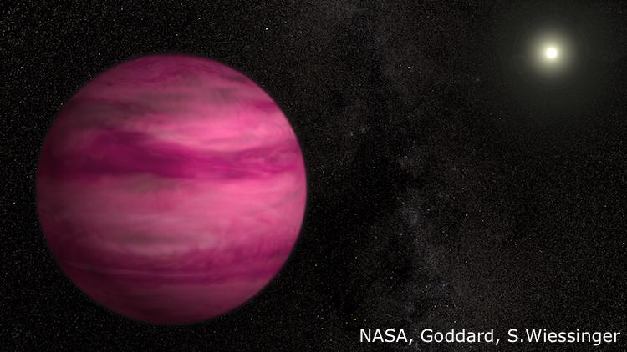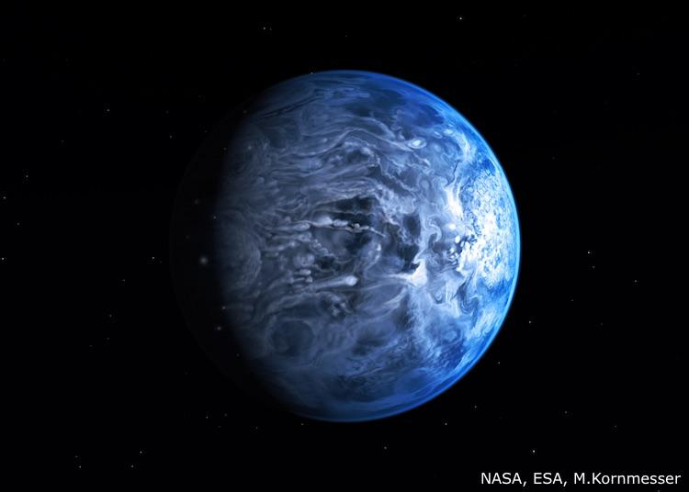

YOUR MISSION

We have been working hard helping scientists to find planets around other stars. Now let’s share with each other and the school a bit about what we have helped to find!
Find an exoplanet that interests you and learn a little about it. Then create an artist’s impression and a small fact sheet.

Artist’s impression
We have never seen an exoplanet, but we know a lot about them. This has led artists to draw ‘best guess’ images of these planets. Now it’s your turn! Copy an image you have seen or create your own – just make sure it matches the facts about your planet!
Draw it on the back of a paper plate so it ‘pops out’. This can then be attached to an A3 piece of paper that will also include a fact sheet.

Fact sheet
Create a small card with a few interesting facts about your exoplanet. This may include:
- Planet name
- Location (which constellation?)
- Size
- Temperature
- Orbital distance
- Type of star it orbits
- Other planets in its solar system
- Interesting facts

