ACTIVITY: Create a photographic periodic table

Activity idea

Students work individually, as a group or as a class to create a photographic periodic table.

By collecting images or objects that correspond to different elements and arranging these in a template, students are able to explore the periodic table in a way that makes meaning and provides multiple opportunities for discussion.
By the end of this activity, students should be able to:
- identify elements contained in some everyday objects
- use images to communicate their knowledge of elements.

For teachers

Introduction/background

Planet Earth and everything on it is made up of elements. An element is a pure substance made up of atoms all of the same type. The periodic table of elements puts all the known elements into groups with similar properties.

The periodic table is often taught within topics such as chemistry, chemical reactions or states of matter. Understanding the periodic table allows students to access a large amount of information about how chemistry works. However, many students don’t understand how the periodic table connects to their everyday life. This activity allows students to explore the elements around them and, importantly, provides prompts for discussion about why different elements are found in certain objects.

What you need

- periodic table template
- Devices that can take photos
- Access to a range of objects

What to do

- Ensure students have a basic understanding of what an element is and of the periodic table. Read and discuss articles such as Periodic table of elements and Investigating elements – introduction.

- Decide whether you want students working individually or in a group and whether you want to assign certain elements to students to find or let them select their own. The first part (collecting images or objects) could be assigned as a homework task.

- Find out what students already know about elements in everyday objects by asking students to brainstorm examples. Many students will already know that a ring of yellow metal will contain gold. If students have a lot of knowledge, you can make the activity more challenging by adding rules such as having students include additional information about the element.

- Let students know that their task is to hunt for images of objects that contain each of the elements they are assigned. This could be by taking photos or searching for images on the internet. If students are using images from the internet, make sure you discuss copyright – more support can be found here.

- Show students the periodic table template and ask if they can think of why some elements have been omitted for collection (letters are grey). Talk about keeping safe as we explore different elements, particularly if students are going to be searching at home. For example do not open cleaning products such as bleach.

- The following websites offer examples of where you can find different elements:
- http://www2.open.ac.uk/openlearn/periodictablephase2/everyday-elements.html
- https://elements.wlonk.com/ElementsTable.htm
- http://www.rsc.org/periodic-table (Select an element and click on the subheading Uses and properties)
- http://theodoregray.com/periodicTable/Elements/Walmart/index.html

- Ask students to store their images in an accessible folder, labelled with the element they represent. Insert images into the periodic table template. To do this in Google Docs, click in the box where you want the image and select Insert, then Image. This allows you to then choose where to select your image from.

- Ask students to share what they have found. You could share using a projector or by printing the periodic tables.

- Discuss which elements were hard to find examples of and which ones were easy, making inferences as to why. For students who have a good grasp of elements, this may be a good starting point for discussing the difference between pure elements and when different elements combine to create compounds. The article Chemicals everywhere may be helpful.

Here is an example of a template where some images have been added.

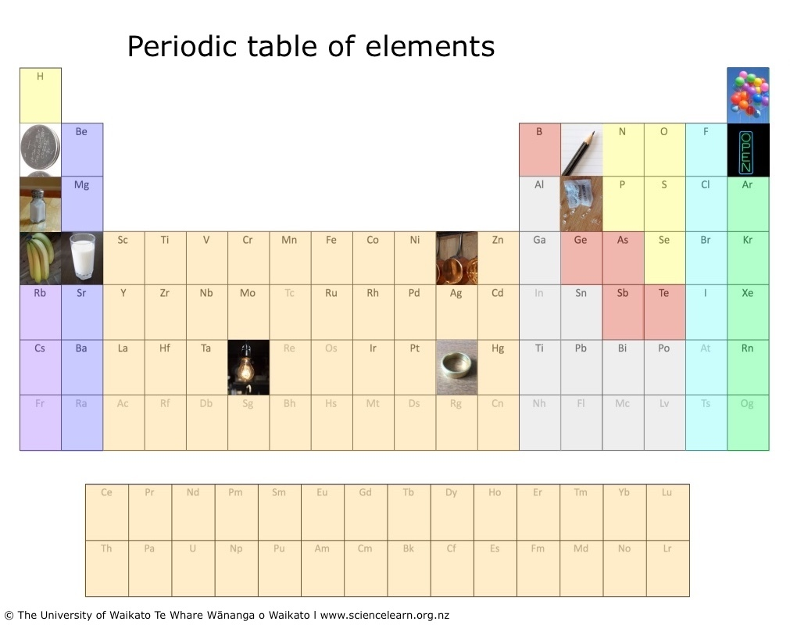

Extension ideas

- Ask students to collect actual objects and arrange these on a table in the classroom or on a chalk-drawn periodic table outside (to see an example of a bring your own Element event, click here).
- Make it competitive. Go up against another class or find as many objects and elements as possible in a given timeframe.

For students

What you need

- periodic table template (Word version)
- Devices that can take photos
- Access to a range of objects

What to do

- Make sure you can define what an element is and that you know that the periodic table puts all the elements into groups with similar properties. Read this article here if you are unsure.

- Discover where you can find different elements by exploring the following websites. Make a list of where you might find the different elements you are hunting for (for example, if you need to find an object containing Calcium, you could record chalk, milk or teeth).
- http://www2.open.ac.uk/openlearn/periodictablephase2/everyday-elements.html
- https://elements.wlonk.com/ElementsTable.htm
- http://www.rsc.org/periodic-table (Select an element and click on the subheading Uses and properties)
- http://theodoregray.com/periodicTable/Elements/Walmart/index.html

- Take photos of the objects containing the elements you need to find. Save your pictures, making sure you label the image with the element it represents. You will need one image for each element that you have been assigned. Work safely – do not open cleaning products and avoid dangerous items.

- Insert images into the periodic table template. To do this in Google Docs, click in the box where you want the image and select Insert, then Image. This allows you to then choose where to select your image from.

- Be ready to share your photographic periodic table and to discuss which elements were easy to find and which ones were difficult to find. Think about and be ready to share why that was.

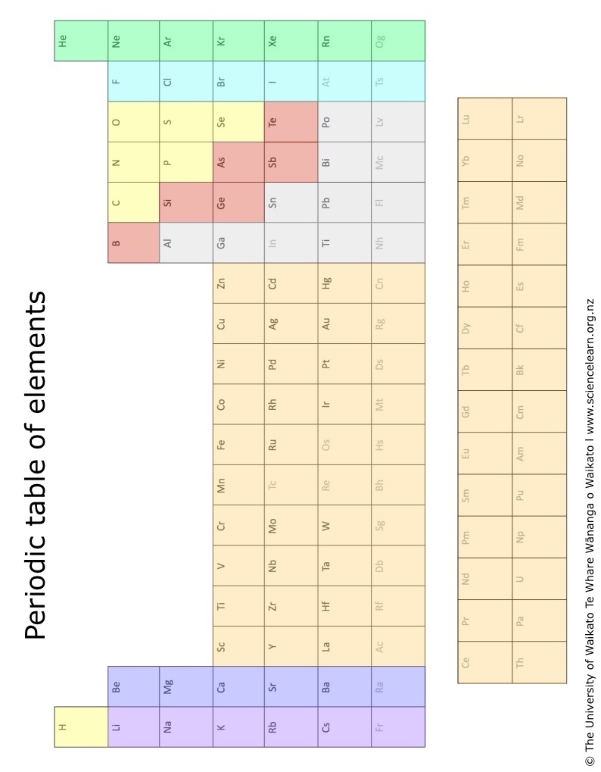

Periodic table of elements
H |  |  |  |  |  |  |  |  |  |  |  |  |  |  |  |  | He
Li | Be |  |  |  |  |  |  |  |  |  |  | B | C | N | O | F | Ne
Na | Mg |  |  |  |  |  |  |  |  |  |  | Al | Si | P | S | Cl | Ar
K | Ca | Sc | Ti | V | Cr | Mn | Fe | Co | Ni | Cu | Zn | Ga | Ge | As | Se | Br | Kr
Rb | Sr | Y | Zr | Nb | Mo | Tc | Ru | Rh | Pd | Ag | Cd | In | Sn | Sb | Te | I | Xe
Cs | Ba | La | Hf | Ta | W | Re | Os | Ir | Pt | Au | Hg | Ti | Pb | Bi | Po | At | Rn
Fr | Ra | Ac | Rf | Db | Sg | Bh | Hs | Mt | Ds | Rg | Cn | Nh | Fl | Mc | Lv | Ts | Og

Ce | Pr | Nd | Pm | Sm | Eu | Gd | Tb | Dy | Ho | Er | Tm | Yb | Lu
Th | Pa | U | Np | Pu | Am | Cm | Bk | Cf | Es | Fm | Md | No | Lr

