Student worksheet:

To be a scientist – learning activities

These learning activities use the article ‘Betty Batham: Biologist’ by Kate Hannah. You can read the article using Google slides or this PDF.

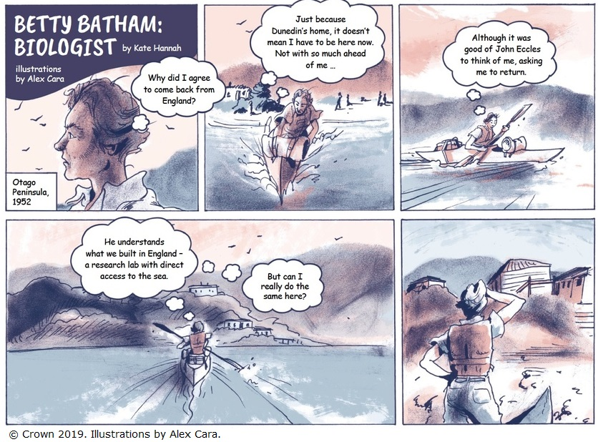

Before you read

Draw a picture of a scientist at work.

Things to think about:

- What are they wearing?
- What are they holding?
- What are they doing?
- Where are they working?

While you read

The article’s first frame shows the setting: Otago Peninsula 1952.

- Think about what was expected of women at the time.

- What challenges do you think Betty might have had?

- Does having a graphic article with lots of drawings help you as a reader?

- Would having real photographs help your enjoyment of this article? Why or why not?

After you read

Reading graphic texts means you need to make sense of the images and the text.

In science we use observations and then use those observations to make inferences.

Inferences are things that are not definite but there is enough evidence for those inferences to make sense and be pretty possible.

- Look at the first slide. What information tells you Betty is a woman?

- Slide 1 tells us about access to this place and a bit about Betty. Look at the statements in the table below. Tick the box if you think the statement is based on observation (from either the text or the images) or the statement is an inference.

Statement | Observation (it is stated or shown directly) | Inference (it is hinted at and makes sense)
Betty lives in Dunedin.
Betty was looking around the Otago Peninsula in 1952.
John Eccles thinks Betty is a good scientist.
Betty is a fit woman.
Betty knows John Eccles.
Betty helped build a research lab in England with direct access to the sea.
Betty was asked to establish a research lab in or near Dunedin.

- What parts of Betty’s childhood helped her to become a scientist?

- The text tells us that Betty’s school focused on preparing girls for marriage and motherhood. What things might have made it difficult for Betty to study science as a woman?

- Science has lots of different areas of study and learning. Betty studied zoology and botany. What do you think these areas focus on? (You might need to ask someone or use a dictionary.)

- How might the arrival of the war have helped Betty and other women interested in science?

- Betty had to work hard to start the marine research laboratory. What are the three different roles she needed to do?

- Many people imagine scientists working alone in laboratories. How did Betty work and where?

- Draw a picture of Betty at work, then make a list of the ways that your first and second drawings of scientists differ.

- Why do you think Betty’s story is important to tell?

Additional activities

Photos or drawings?

Here are some real photographs of the old research laboratory and Betty.

The photos below show the old fish hatchery that Betty saw at the start of the laboratory and some of the new buildings.

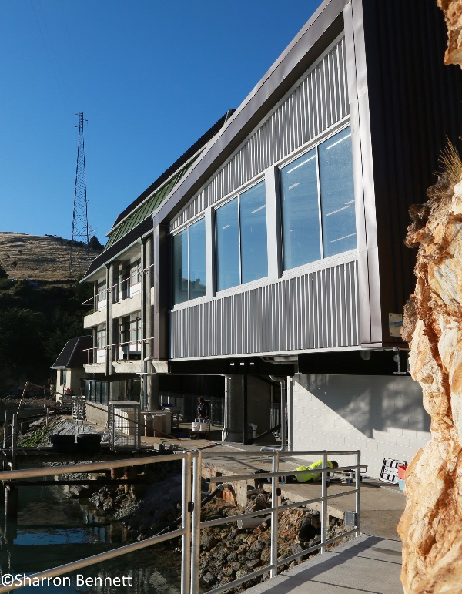
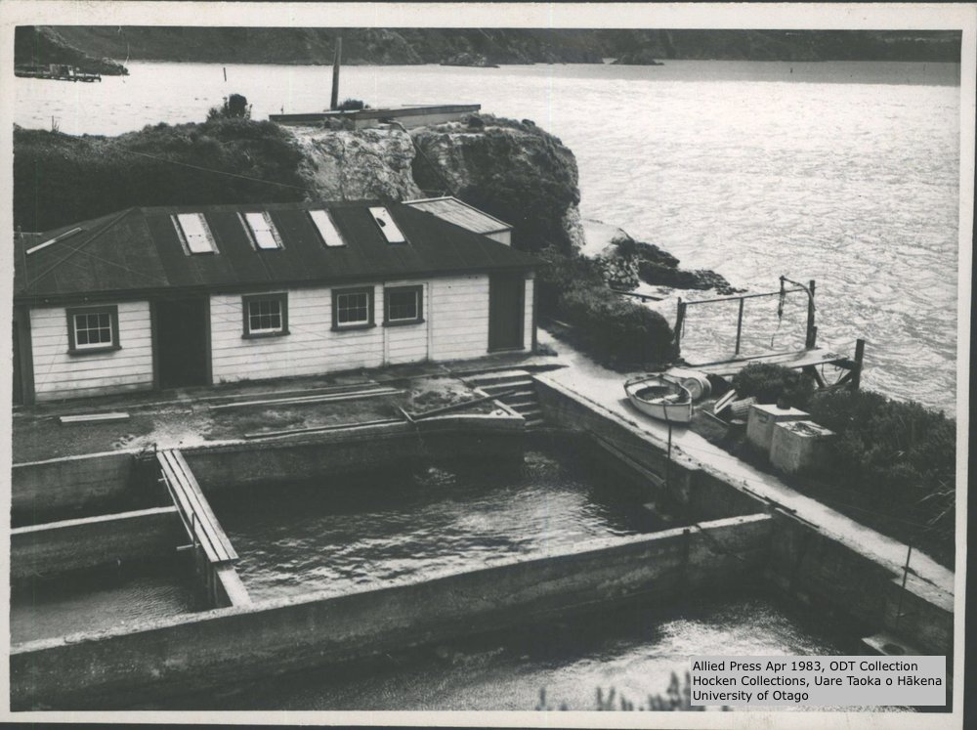

- What differences do you notice between the old fish hatchery and the new building?

- What information do you get from the photographs that you don’t get from the graphic biography?

- Ask other people whether they prefer graphic images or photos? Why?

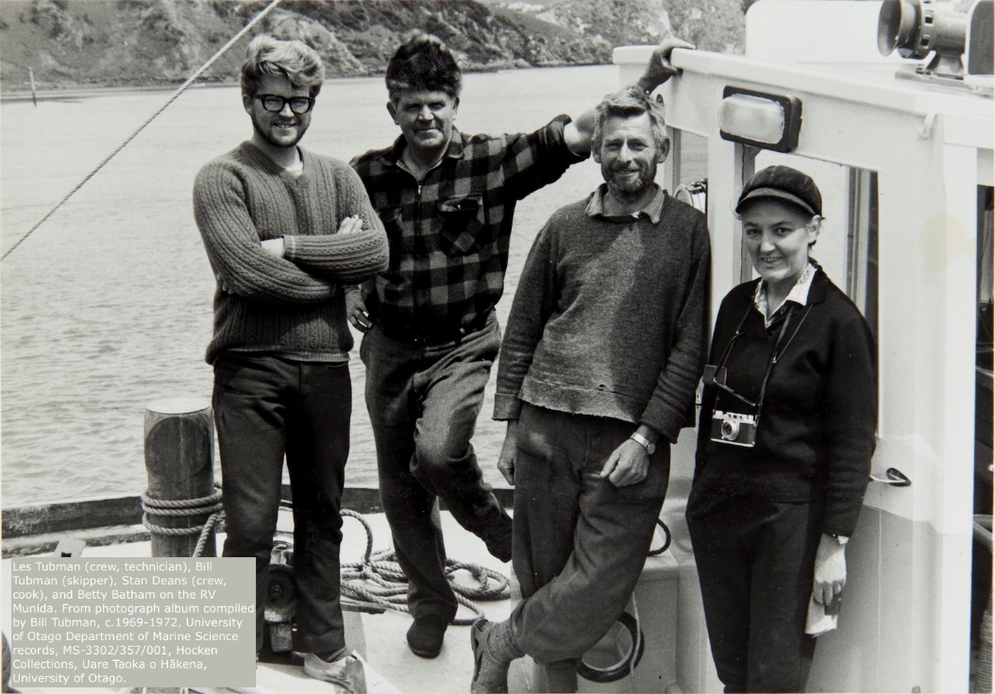

- This photo looks like one of the pictures in the story that you have just read. Which one of these people do you think is Dr Batham? How does the photo compare to the drawings in the graphic biography?

Being a scientist

Do you think you would like to be a scientist? What fascinates you?

You could investigate other New Zealand scientists and think about what they did when they were young that helped them to become scientists.

These are some famous female scientists from New Zealand:

- Beatrice Hill Tinsley
- Joan Wiffen
- Muriel Bell
- Lucy Cranwell-Smith

These are some famous male scientists from New Zealand:

- Athol Rafter
- Frank Evison
- Thomas Walker
- Alan MacDiarmid

