ACTIVITY: Climate change – challenging conversations

Activity idea

In this activity, students use concept cartoons to explore a range of viewpoints about climate change.

By the end of this activity, students should be able to:
- discuss and explore climate change issues in constructive and respectful situations
- consider other people’s thinking
- use concept cartoons to share viewpoints with whānau and others within their communities
- locate information to clarify and support their own thinking.

For teachers

Introduction/background

Concept cartoons are a visual representation of ideas. The simple cartoon-style drawings put forward a range of viewpoints. The format invites students to justify their own ideas and clarify their thinking as well as to consider others’ ideas.

Climate change is a wicked problem with the potential to affect the environment, the economy and our personal wellbeing. As a whole, climate change can be quite overwhelming. Concept cartoons are useful for exploring small bite-sized components that can be tailored for individual situations.

The concept cartoons presented in this activity are designed for use within the classroom and to support student discussions with whānau and/or others.

Concept cartoon options

The student handouts have concept cartoons that explore:
- a scientifically correct idea along with alternative ideas that people may hold about climate change
- feelings people may have regarding climate change
- actions we can take to make a difference.

There are also blank templates for you or your students to use to create your own concept cartoons.

Pedagogical help

Prior to using this activity with students, it may be useful to read the articles Climate change – a wicked problem for classroom inquiry and Using concept cartoons. Both articles provide pedagogical support and insights.

The Connected journal article Fake facts uses climate change as a context for navigating online information. Being able to filter incorrect or alarmist content benefits students’ science knowledge and their emotional wellbeing too.

The Ministry of Education has produced the Climate Change Learning Programme – Wellbeing Guide to help educators navigate the wellbeing/hauora of students.

Teacher instructions

- Begin the activity with one of the handouts, or use one of the templates to create your own concept cartoon.

- Briefly discuss the title so everyone is aware of the concept or topic being considered.

- Ask students to examine the cartoon and choose a character they agree with or a statement they support.

- Discuss the cartoon. Remind students to consider the viewpoints of others while justifying their own thinking. Responses to some of the cartoons are listed below.

- Provide time to research cartoon characters’ statements, if necessary.

- Encourage students to create their own cartoons using the blank templates.

- Provide cartoons or templates for students to take home so they can discuss climate change issues with their own communities and take action.

Concept cartoons – responses

Science concepts

Exploring impacts of climate change on ecosystems
- Extra CO₂ helps the plants grow, doesn’t it? (Yes, but other climate change effects such as drought or higher temperatures can have the opposite effect.)
- Temperature changes disrupt native habitats. (Accurate scientific concept.)
- Plants and animals can adapt. (It takes long periods of time for this to happen.)
- Longer summers mean more time to grow things. (True, there are benefits to a longer growing season, but some crops require cold temperatures for fruit to set.)

Exploring the causes of climate change
- The climate is always changing anyway.(Climate does change, but not at the rate we are experiencing now.)
- Volcanoes are responsible for lots of CO₂. (Volcanoes release less than 1% of the CO₂ released currently by human activities.)
- The data clearly shows humans are responsible. (Accurate scientific concept.)
- CO₂ has always existed in the atmosphere. (True, but humans are adding significant amounts.)

Exploring ideas about a local cold snap
- What global warming? It’s freezing outside! (An observation.)
- Maybe climate change is reversing? (An opinion.)
- A cold day has more to do with weather than climate. (Accurate scientific concept.)
- Warmer winters are better for everyone! (An opinion.)

Exploring feelings about climate change

- Relax – it will take a long time to happen.
- I’m scared for my future.
- It makes me angry when someone says climate change isn’t real.
- I worry it will upset the maramataka.

- It’s okay to feel concerned. The problem is real.
- I feel guilty when Dad drives me to school.
- Taking small actions every day gives me hope.
- Old people started it – it’s their problem – not mine.

Actions we can take to make a difference

- It’s hopeless unless the rest of the world changes too. (This needs a global effort, but doing something to reduce your carbon footprint either on your own or with friends or whānau does make a difference.)
- Biking or walking to places reduces emissions. (Transportation is a key driver of Aotearoa’s carbon emissions.)
- Buying from op shops keeps stuff from the landfill. (This reduces carbon emissions and landfill gases.)
- Spread the message! Get others involved. (Climate change is a local and global issue.)

- I can offer to cook a vegetarian meal at home. (Plant-based meals have lower emissions.)
- I can help with community planting and weeding. (Trees are a way to sequester CO₂.)
- I can think whether I really need something before I buy it. (This reduces carbon emissions and landfill gases.)
- I marched, but nothing happened. (Climate change is a generational issue and will take time to solve.)

For students

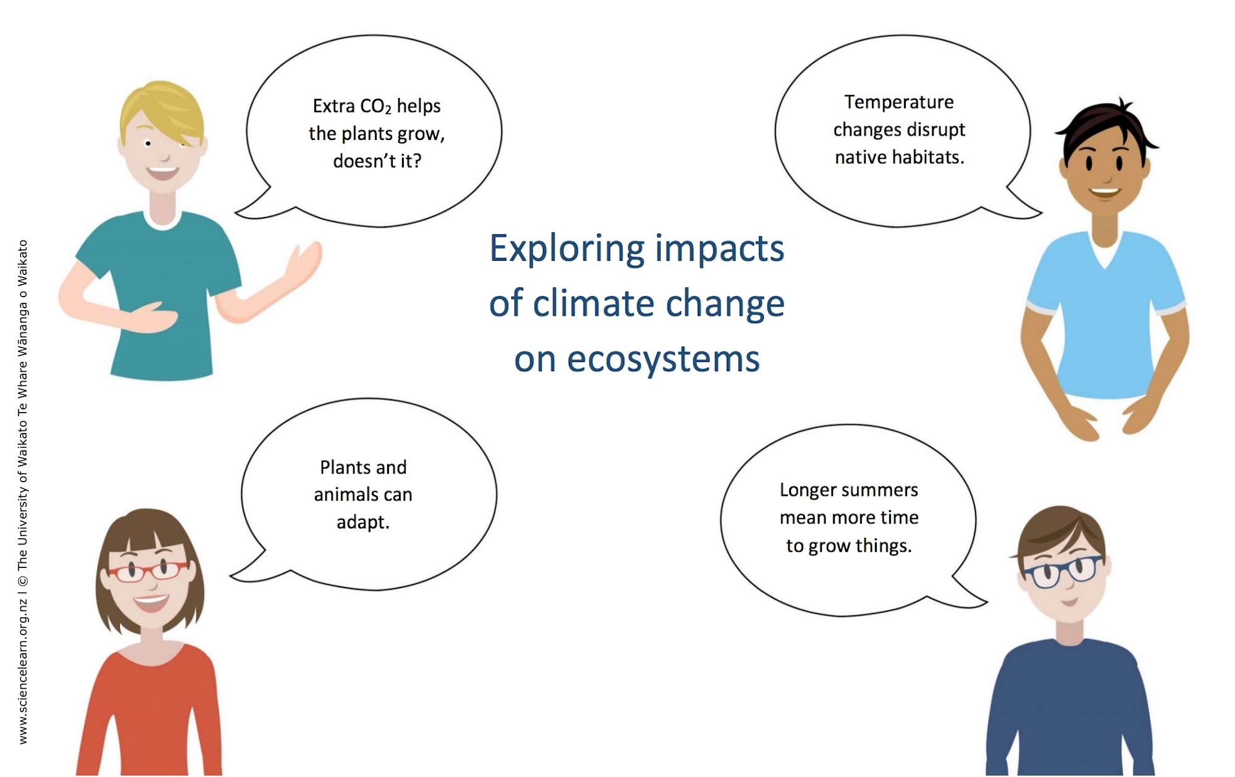
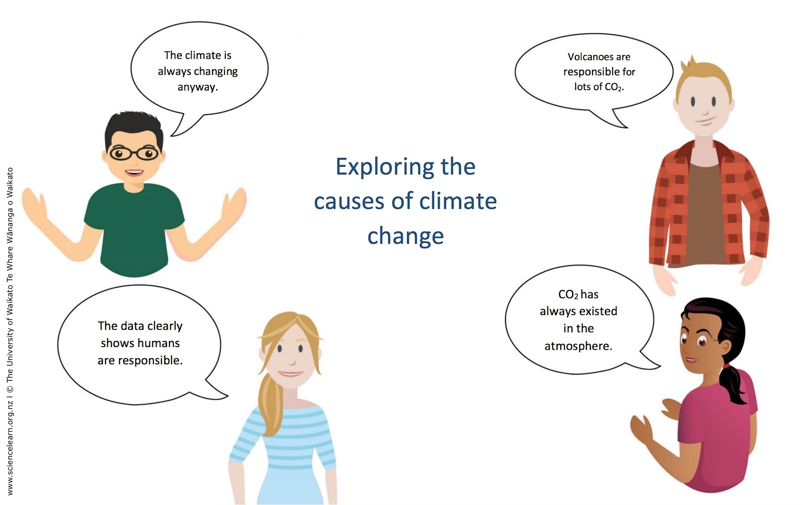
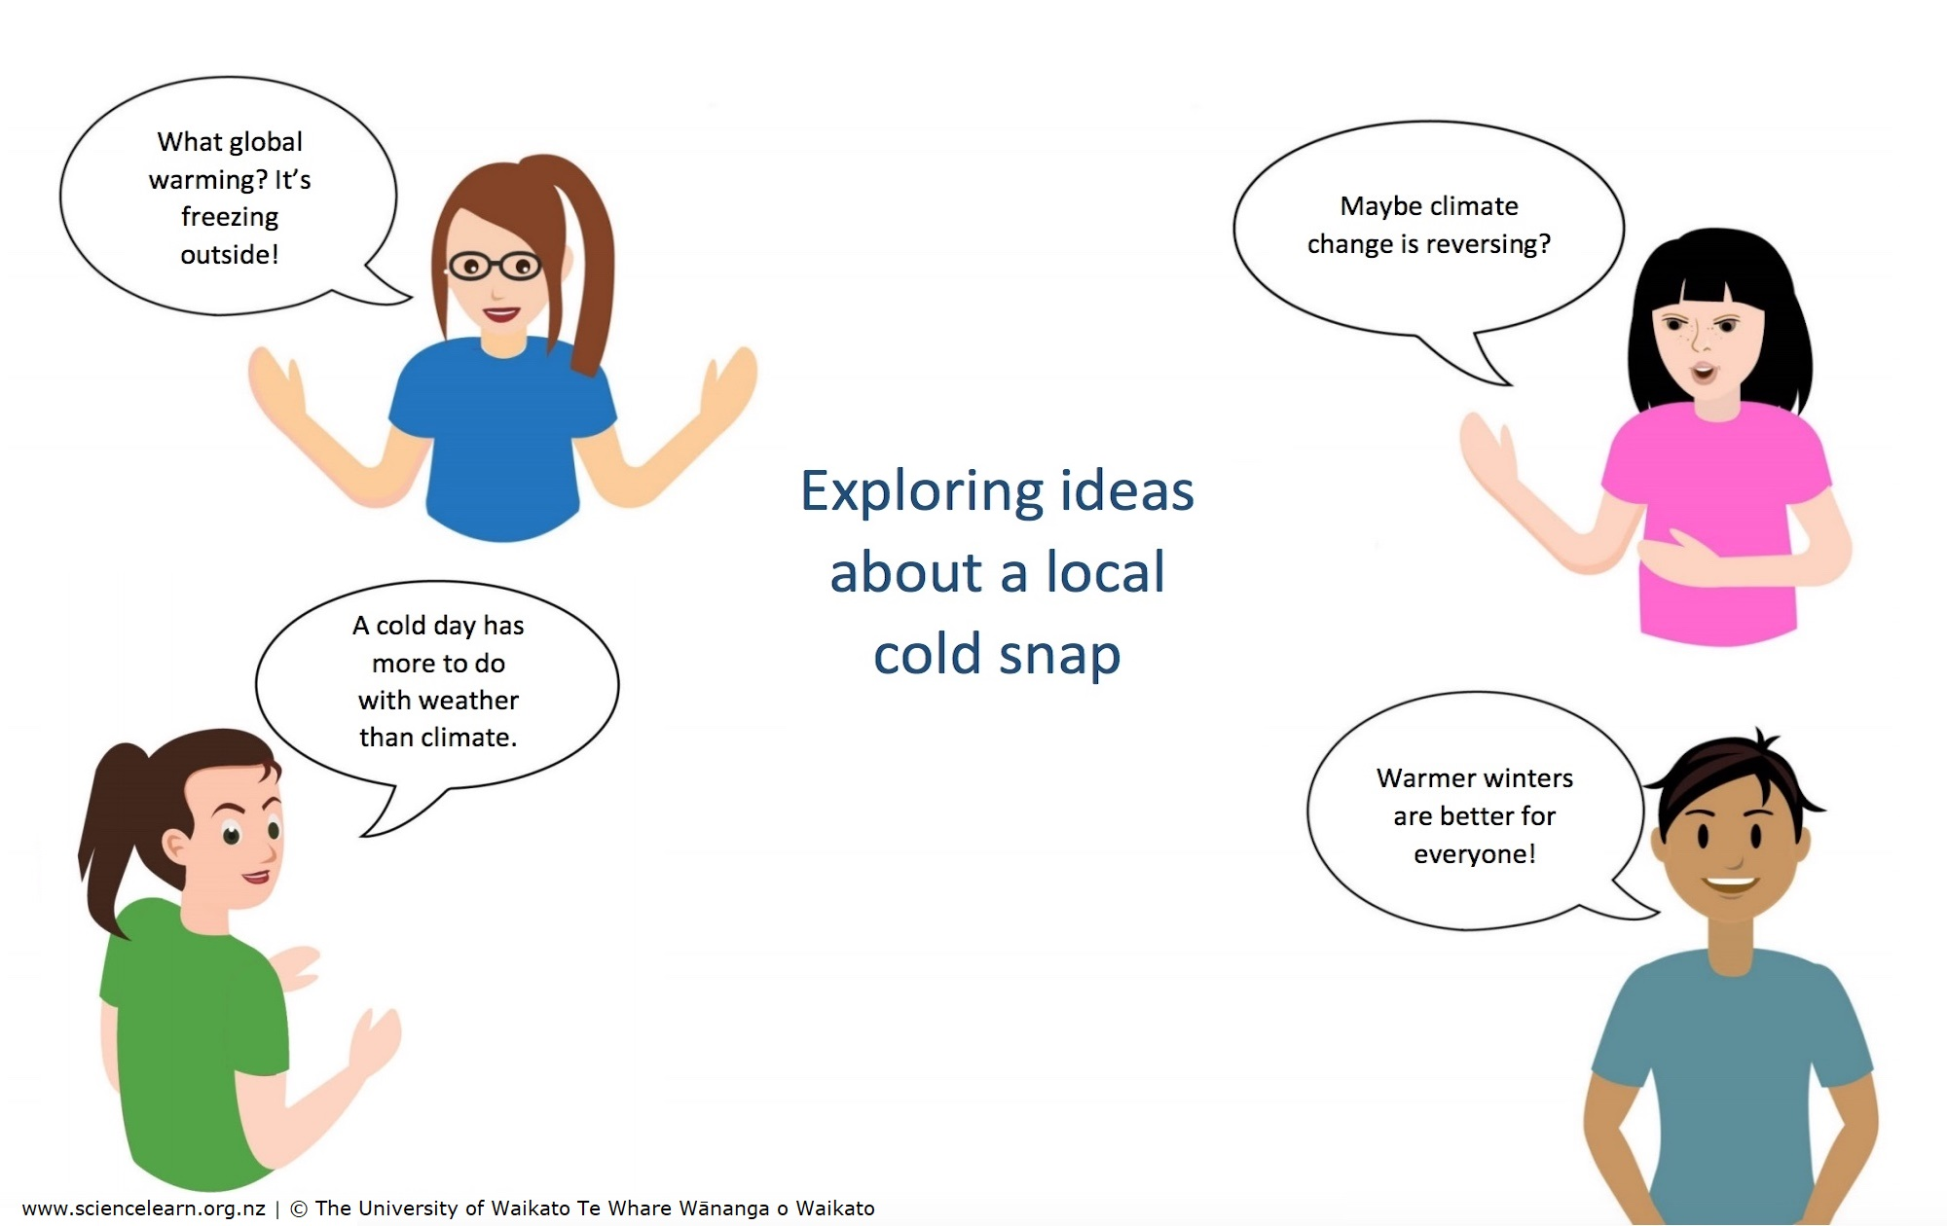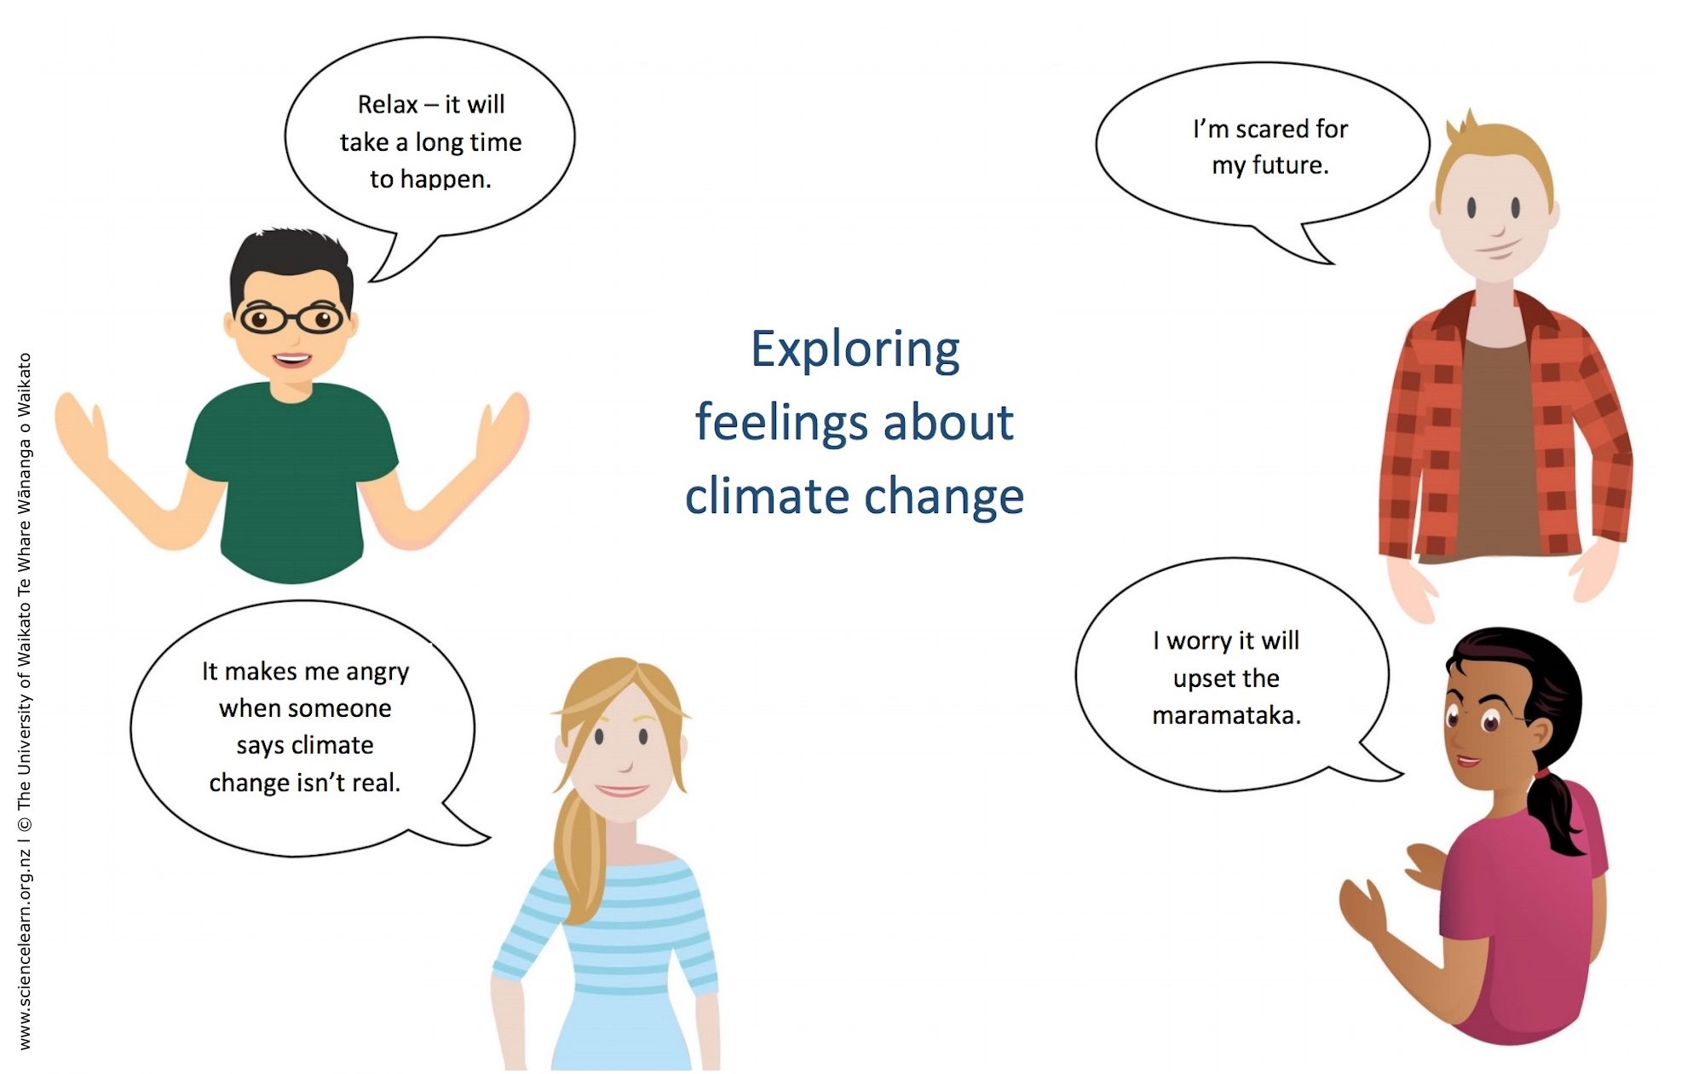
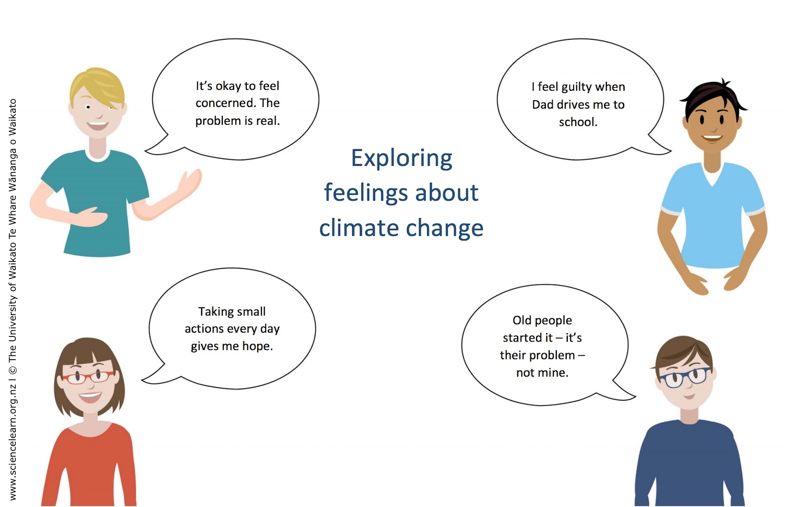
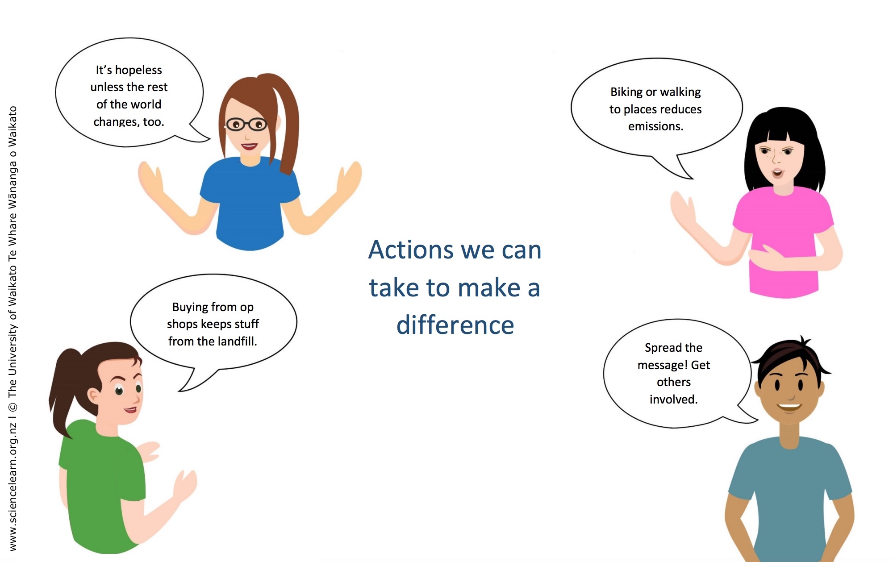
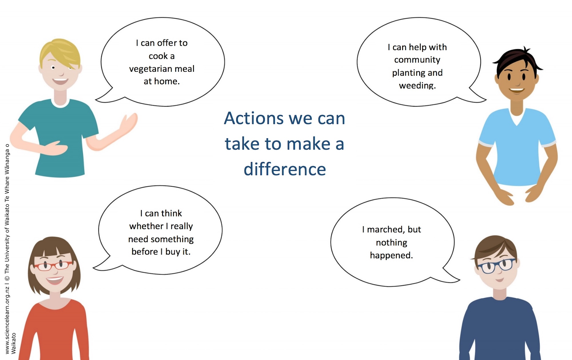
Concept cartoons – blank templates
