ACTIVITY: Using infographics

Activity idea

In this activity, students observe and interpret infographics from the Ministry for the Environment and Stats NZ’s Our atmosphere and climate 2020 report. The activity includes probing questions to help students understand the ways in which infographics present information. It also includes a simple framework for creating an infographic.

By the end of this activity, students should be able to:
- develop literacy skills for interpreting the information in an infographic
- discuss the purpose of an infographic
- discuss how an infographic gets the message across
- use this information to design and create a simple infographic.

For teachers

Introduction/background

Science knowledge is often communicated through visual representations – graphs, diagrams and infographics. Each type of visual representation has literacy components that students may need support to understand. The science capability ‘Interpret representations’ encourages students to think about how data is presented, what the representation tells us and how it gets the message across.

Tables and graphs present data in an organised manner. Interpreting information from these types of visual representations requires the reader to draw a conclusion from the data.

Infographics also provide visual representations of data, but they are designed to tell a story or guide the reader to a particular conclusion. Learn more about infographics in the article Understanding infographics.

Interpreting infographics

In the first part of this activity, students gain practice with understanding and interpreting infographics, using examples from the Ministry for the Environment and Stats NZ’s Our atmosphere and climate 2020 report.

A second activity, Interpreting representations using climate data, provides practice in understanding and interpreting graphs and other visual representations from the report.

Creating infographics

Infographics contain three components – the visual component, the content component and the knowledge component. The visual component includes things like graphics, colour, font and layout. The content component features information – for example, text, figures, lists and statistics. The knowledge component is the insight that comes from the information.

In the second part of this activity, students consider these components while creating their own infographic.

Questions to deepen student understanding

Use the following questions to support students to develop literacy skills when interpreting infographics.

- Generic questions for all infographics:
- Who created the infographic?
- Who is the intended audience?
- Infographics have a central theme – what is this infographic trying to communicate?
- Are there subthemes within the infographic?
- Does the infographic show relationships or connections between the subthemes? How does it do this? (For example, through arrows, colour or repeated graphics/images.)
- What is the infographic communicating – general information, statistics, comparisons, processes or something else?
- Is there a starting point for reading the infographic?
- Does the infographic have a specific pathway that you need to follow? (For example, top to bottom, left to right as when reading text.)
- Does this affect the message?
- How is colour used to present information?
- How do the graphics present information?
- What makes the message credible?
- What might have been left out?
- What other information might you need to understand the infographic?
- Where can you find the information that might fill in these gaps?

- Questions for the infographics from Our atmosphere and climate 2020:
- How do the graphics help to place these infographics within an Aotearoa New Zealand context?
- What is the significance of some of the graphics?
- What is the significance of the kererū and pig graphics in the infographic about the threats to Māori identity and mana?
- The Māori identity and mana infographic includes a glossary. How would a glossary benefit the other infographics? Would one be necessary?
- Where can you find the information that might fill in these gaps? (Useful articles: Climate connections – why climate change matters, Evidence of climate change in Aotearoa, Aotearoa’s contributions to climate emissions, Why climate change matters to Māori and Māori ways of knowing – weather and climate.)

For students

Infographics from Our atmosphere and climate 2020

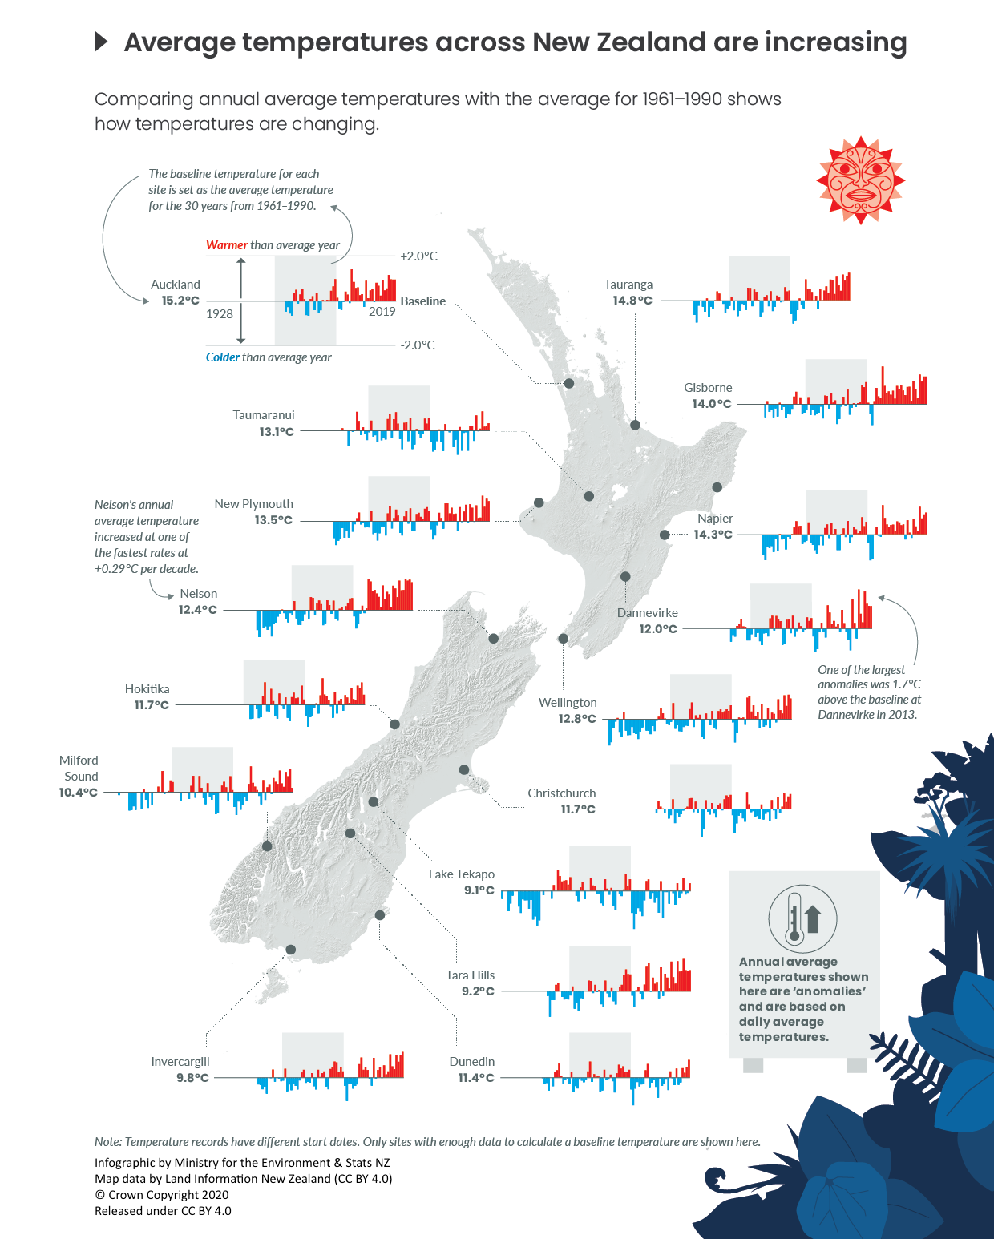

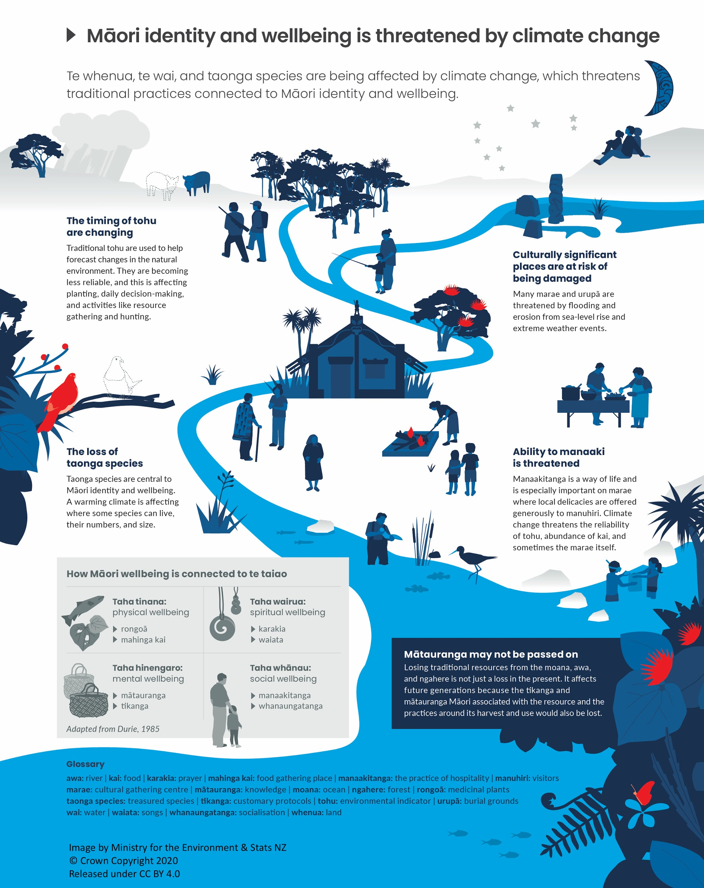

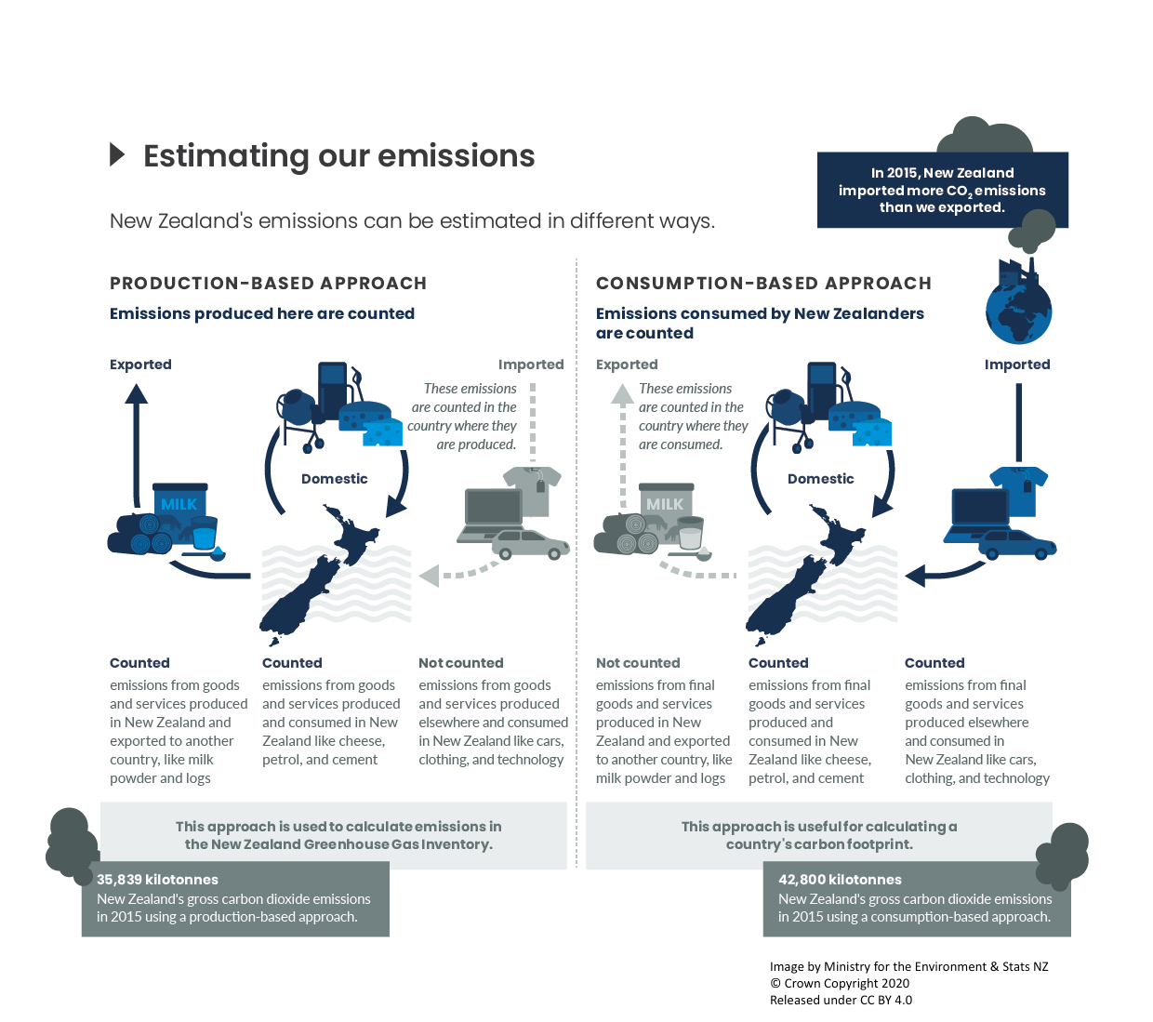

Creating an infographic

An infographic is a visual representation of information using graphics and text. In a science setting, infographics are often used to present information in simplified form. This makes it easier for an audience to read and understand the information.

An infographic contains three components:

- visual component – the graphics, colour, font and layout
- content component – information in the form of text, figures, lists or statistics
- knowledge component – the insights that come from the information.

Use the following information to create your own infographic.

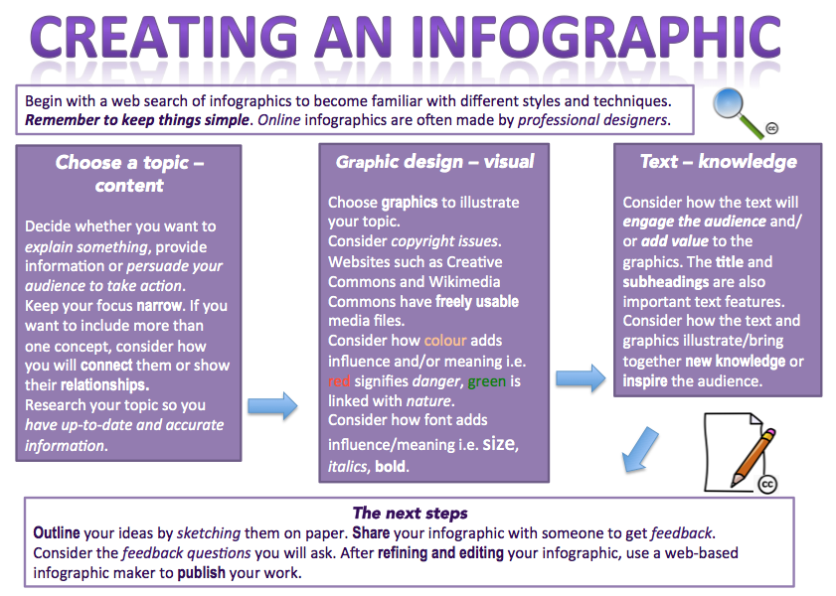
Creating an infographic (text version)

Begin with a web search of infographics to become familiar with different styles and techniques.

Remember to keep things simple. Online infographics are often made by professional designers.

Choose a topic – content
- Decide whether you want to explain something, provide information or persuade your audience to take action.
- Keep your focus narrow. If you want to include more than one concept, consider how you will connect them or show their relationships.
- Research your topic so you have up-to-date and accurate information.

Graphic design – visual
- Choose graphics to illustrate your topic.
- Consider copyright issues. Websites such as Creative Commons and Wikimedia Commons have freely usable media files, with information on how you can use the files.
- Consider how colour adds influence and/or meaning i.e. red signifies danger, green is linked with nature.
- Consider how font adds influence/meaning i.e. size, italics, bold.

Text – knowledge
- Consider how the text will engage the audience and/or add value to the graphics. The title and subheadings are also important text features.
- Consider how the text and graphics illustrate/bring together new knowledge or inspire the audience.

The next steps
- Outline your ideas by sketching them on paper.
- Share your infographic with someone to get feedback.
- Consider the feedback questions you will ask regarding the different components of the infographic.
- After refining and editing your infographic, use a web-based infographic maker to publish your work.

A final thought

This handout is an efficient but rather dull framework for creating simple infographics. Consider how much more engaging it would be with graphics, colour and a more creative layout!

