ACTIVITY: Pitfall traps – monitoring ground-dwelling insects

Activity idea

In this activity, students place pitfall traps in various locations around the school, check the traps daily and record their observations.

By the end of this activity, students should be able to:
- construct simple pan traps
- identify areas of vegetation/habitats to place the pan traps
- collect and record data about the types of insects caught in the traps
- collect and record data about the numbers of insects caught in the traps
- use an identification sheet to name some common insects
- make inferences based on their observations.

For teachers

Introduction/background

Pitfall traps are simply containers dug into the ground so the top of the container is level with the ground. Sometimes a small roof can be erected over the trap to keep rain out. Insects that are active on the ground are caught by falling into the trap, from which they cannot escape. Scientists often use pitfall traps to create an inventory of the insects present in an area.

Things to consider

The traps need to be checked and cleared each day – insects are living and need to be treated with respect. If some of the traps remain empty, this still provides valuable monitoring information.

What you need

- Small containers such as baby food jars or tins, yoghurt pottles or paper cups
- Permanent felt to number containers
- Garden trowels
- Catching ground-dwelling insects using pitfall traps worksheet for each student or group
- What Is This Bug? guide

What to do

- Decide where to place the pitfall traps. Suggested locations are:
- vegetable, herb or flower garden
- near an area with shrubs or trees
- in a grassy area.

- Decide on the number of traps to use in each location and number the containers.

- Dig the containers into the ground in each of the chosen locations. The top of the container must be flush with the ground level.

- Have students monitor the traps daily and use the Catching ground-dwelling insects using pitfall traps worksheet to record the data. Use a separate worksheet for each trap.
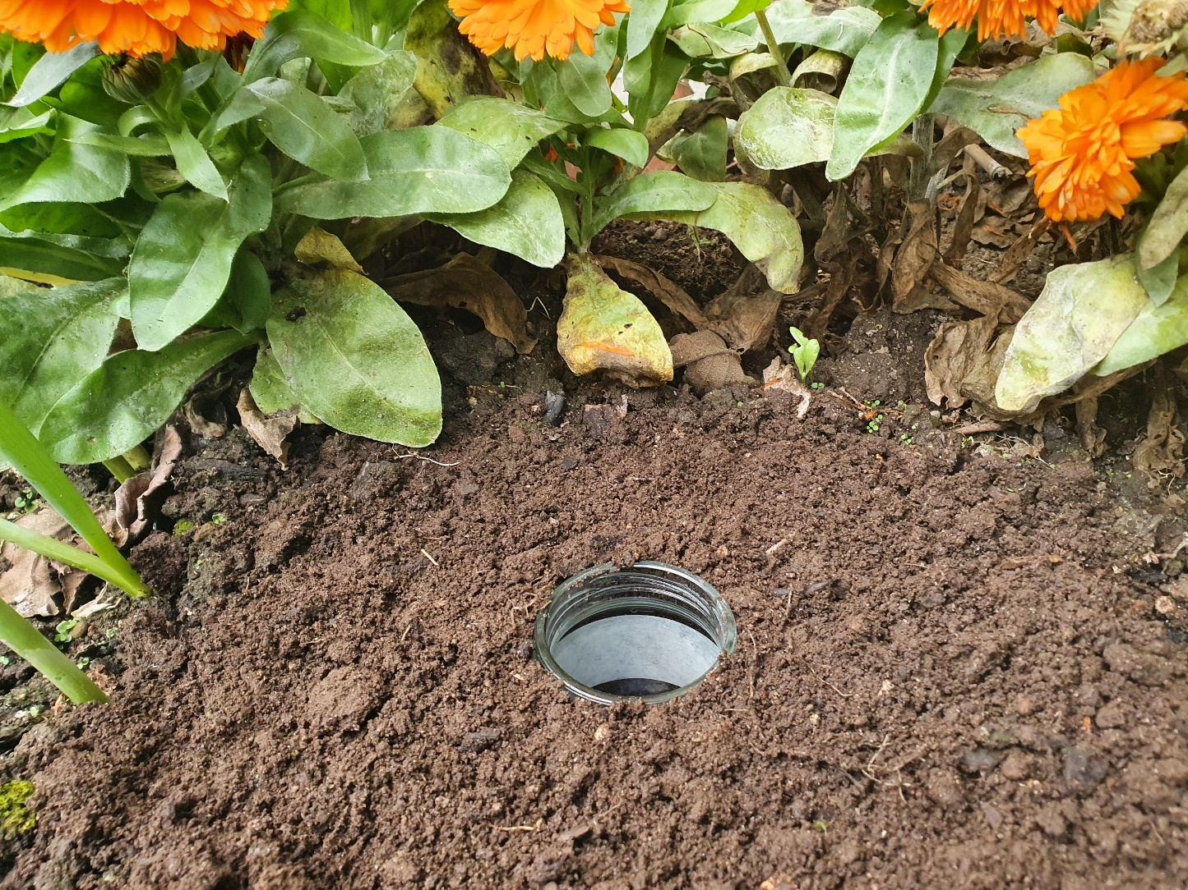
- Students can use the What Is This Bug? guide for help with identification. If the insect cannot be identified, they can write down notes on its size, colour, etc.

- Release the insects back into the habitat.

- Discuss the observational data using some of the questions below.

Questions to deepen student understanding

- What types of insects were in the pitfall traps?
- How do you think the insects ended up in the pitfall traps?
- How do you think these insects move around?
- Why did we record the weather? What difference might this make?
- Which types of insects did you find in the pitfall traps placed in the garden?
- Which types of insects did you find in the pitfall traps placed near the shrubs and trees?
- Which types of insects did you find in the pitfall traps placed in the grassy areas?
- How many were there? Were there any differences in the numbers collected on certain days or at different locations? Why do you think that might be?
- What inferences can you make about these locations as habitats for crawling insects?
- What similarities and differences are there in the types of insects in the different locations?
- Why do you think things are similar or different? What inferences can you make?
- Why might people be interested in monitoring the number and diversity of insects over time?
- Scientists call pitfall traps passive traps. What do you think this means?
- How might scientists use this information?
- What are some ethics to consider when catching animals for observation or data collection?

Extension ideas

Investigate the time of day and the role this might play in the type of insects that get trapped. Set up the traps either for a full day or overnight to see if the different groups of insects that get caught are diurnal or nocturnal.

For students

Catching ground-dwelling insects using pitfall traps

Name:
Date and time the trap was set:
Date and time the trap was collected:
Weather conditions (sunny? windy?):
Pitfall trap number:
Location (circle): | In the garden |  | Near shrubs and trees |  | In the grass
Type of insect |  | How many of that kind did you find? (use tally marks) |  | Notes

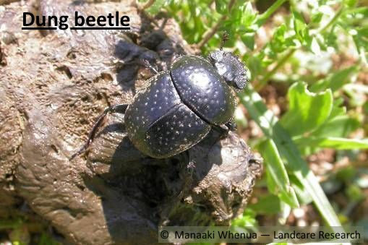 | 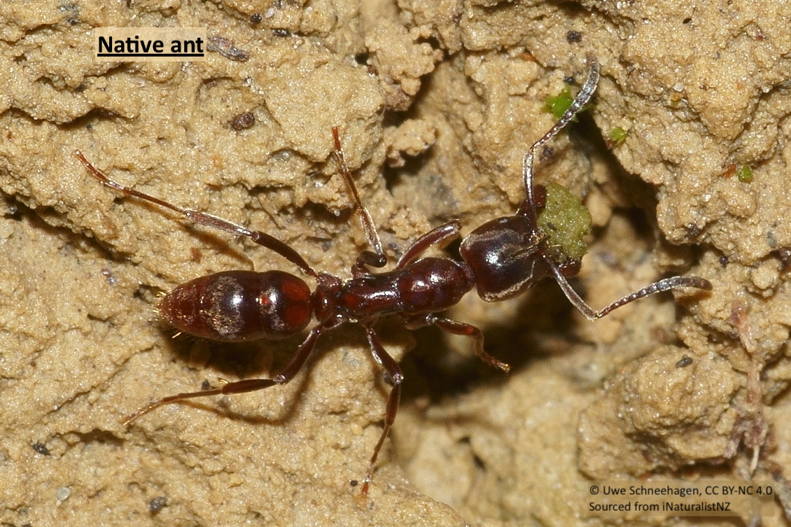 | 