ACTIVITY: Yellow pan traps – monitoring flying insects

Activity idea

In this activity, students monitor flying insects by using yellow and black containers and record their observational data on an activity sheet.

By the end of this activity, students should be able to:
- construct simple pan traps
- identify areas of vegetation/habitat to place the pan traps
- collect and record data about the types of insects caught in the traps
- collect and record data about the numbers of insects caught in the traps
- make inferences based on their observations.

For teachers

Introduction/background

Insect vision is quite different to human vision, but insects do see colours, and they use their colour vision to get around and find food. We can exploit their preference for different colours in order to catch them to study their biology or monitor their abundance and diversity. Yellow pan traps are made from yellow plates filled with water and a drop of detergent. The detergent breaks the surface tension of the water so that any insects landing in the water will sink and be caught.

In addition to investigating flying insects and colour, this activity helps students practise the science capability ‘Critique evidence’. Students will need to consider the methodologies they use to set up and place the traps and whether these methodologies allow for robust results.

Things to consider

If it is not possible to find yellow plates and black plates of identical sizes or if you need to use jar lids or ice cream containers, consider how to make this investigation a fair test.

Capturing insects in a pan trap may present an ethical dilemma for students and educators, as the trapped insects will not survive. This article outlines a process one school uses when trapping and studying insects.

What you need

- 3 yellow plastic plates – if these are difficult to source, substitute jar lids, ice cream containers or other yellow containers capable of holding water
- 3 black plastic plates – as above
- Water
- Dishwashing detergent
- 3 locations to place the pan traps – vegetable/herb garden, near trees or shrubs and in an area of grass
- Catching flying insects using pan traps worksheet for each student or group
- What Is This Bug? identification guide.

What to do

- Number the yellow traps 1–3. Do the same for the black traps.

- Choose three sites to place the pan traps.

- Place a pair of traps at each site. Leave the pans to sit for an hour or longer.

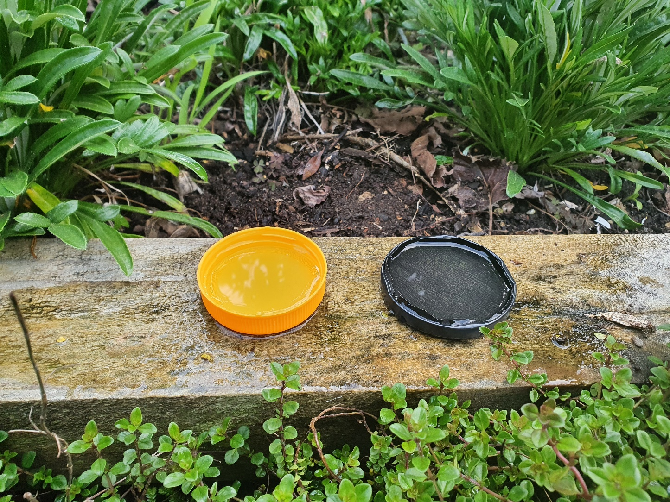

- Have students use the Catching flying insects using pan traps worksheet to record the data (insects) found in the trap. Use a separate worksheet for each trap.

- Students can use the What Is This Bug? guide for help with identification. If the insect cannot be identified, they can write down notes on its size, colour, etc.

- Discuss the observational data using some of the questions below.

- Discuss the investigation and critique the evidence using some of the questions below.

Questions to deepen student understanding

- What types of insects were trapped in each pan trap?
- What differences do you notice about the types and numbers of insects in each pan trap?
- What inferences can you make from these observations regarding the location of the pan traps?
- What inferences can you make from these observations regarding the colour of the pan traps?
- Was this an investigation a fair test?
- What makes it a fair test?
- Why did we record the weather? What difference might this make?
- Are you able to repeat the investigation?
- Would the results be the same or different? Why?
- How confident are you that the results are accurate?
- Are there any surprises in the results?
- Are there any things you might do differently if we were to repeat the investigation?
- What other ways might scientists monitor flying insects that respects their mauri?
- Why might people be interested in monitoring the number and diversity of insects over time?
- Scientists call pan traps active traps. What do you think this means?
- How might scientists use this information?
- What ethical dilemmas did your class discuss?

Extension ideas

This activity uses dishwashing detergent to break the surface tension of the water so that the insects fall to the bottom of the trap. Explore surface tension and how some insects manage to walk on water. Begin the discussion with this image: ‘Stretched’ water – insects and surface tension.

For students

Catching flying insects using pan traps

Name:
Date and time the trap was set:
Date and time the trap was collected:
Weather conditions (sunny? windy?):
Pan trap number and colour:
Location (circle): | In the garden |  | Near shrubs and trees |  | In the grass
Type of insect |  | How many of that kind did you find? (use tally marks) |  | Notes
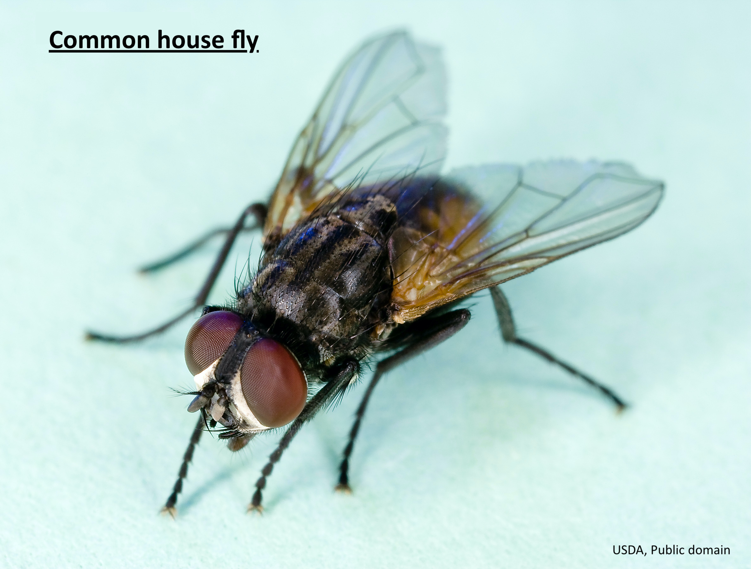 | 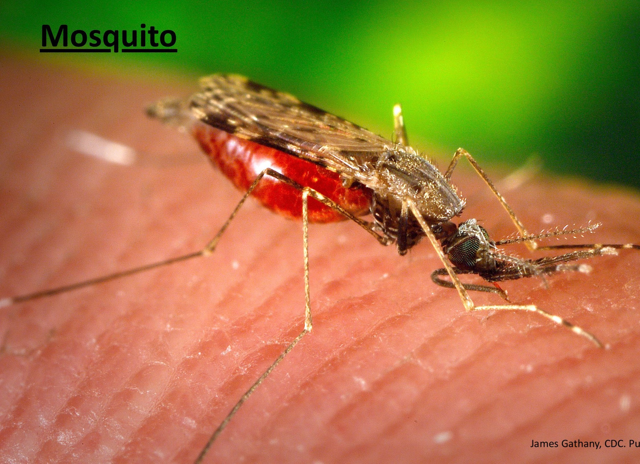 | 