ACTIVITY: Pollinator counts – insects and flowers

Activity idea

In this activity, students directly observe pollinators on flowering plants and record their observational data on an activity sheet.

By the end of this activity, students should be able to:
- collect and record data about the kinds of pollinators they observe visiting a flower
- collect and record data about the numbers of pollinators they observe visiting a flower
- discuss what they’ve observed and make inferences based on their observations.

For teachers

Introduction/background

Pollinators are insects that visit flowers to drink nectar or feed on pollen. During this process, they get covered in pollen grains and then transport the pollen from one plant to another. Through their actions, they help the plant to reproduce sexually by fertilising the female reproductive part of the plant (ovule) with the male reproductive part of the plant (pollen). This in turn causes the fertilised plants to form seeds and fruits.

Around a third of the plants used by humans require animal pollination to reproduce. Bees are well known as pollinators, but many other insects are also involved, particularly flies, wasps and butterflies.

For more information on pollination, check out these pollination resources.

This activity encourages students to observe flowering plants and attempt to identify pollinators in action. Students use an insect guide to help them identify the insects they observe and make notes about insect behaviour.

It is possible that students won’t see anything due to weather conditions, for example, on cold, overcast days. This is completely fine. It is still scientific data, and collecting this information is a very important part of the process

What you need

- Access to an area with flowering plants – a herb or vegetable garden or a flower garden
- Timing device
- Pollinator counts – insects and flowers worksheet for each student or group
- What Is This Bug? identification guide

What to do

- Allocate a pair or group of students to a single flower (e.g. marigold) or a clump of smaller flowers (e.g. rosemary bush).

- Students should observe the flower for 5–10 minutes.

- Have students use the Pollinator counts – insects and flowers worksheet to record the kinds of pollinators (and how many) that visit the flowers. Any pollinators already on the flower(s) when timing begins can be counted immediately.

- Students can use the What Is This Bug? guide for help with identification. If the insect cannot be identified, they can write down notes on its size, colour, etc.

- Discuss the observational data using some of the questions below.

Questions to deepen student understanding

- What kinds of pollinators were visiting the flower?
- How long did the pollinator spend on the flower?
- Are the times similar for each type of pollinator?
- Why did we record the weather?
- How might the weather affect the pollinators we see or don’t see?
- What part of the flower did the pollinator visit?
- Does the flower use colour, shape or scent to attract insects?
- If pollination is required for some plants to produce seeds and fruit, what would happen if we didn’t have pollinators?

For students

Pollinator counts – insects and flowers

Name: |  | Date:
Location: |  | Start time:
Weather (sunny? windy?): |  | Finish time:
Plant type: |  | Flower colour:
Type of insect | How many of that kind do you see? (use tally marks) | Notes: (insect behaviour, time spent visiting flower)

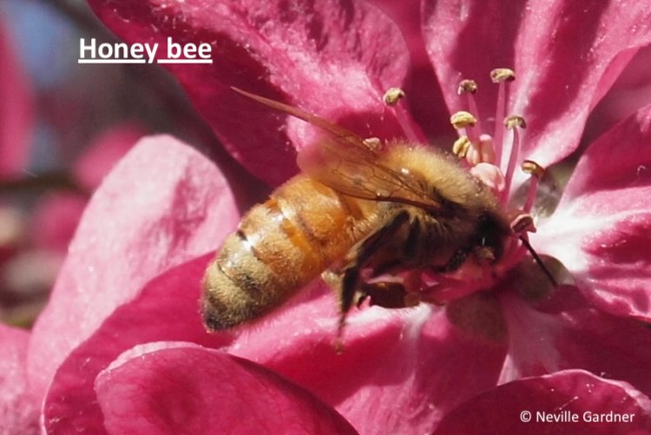 | 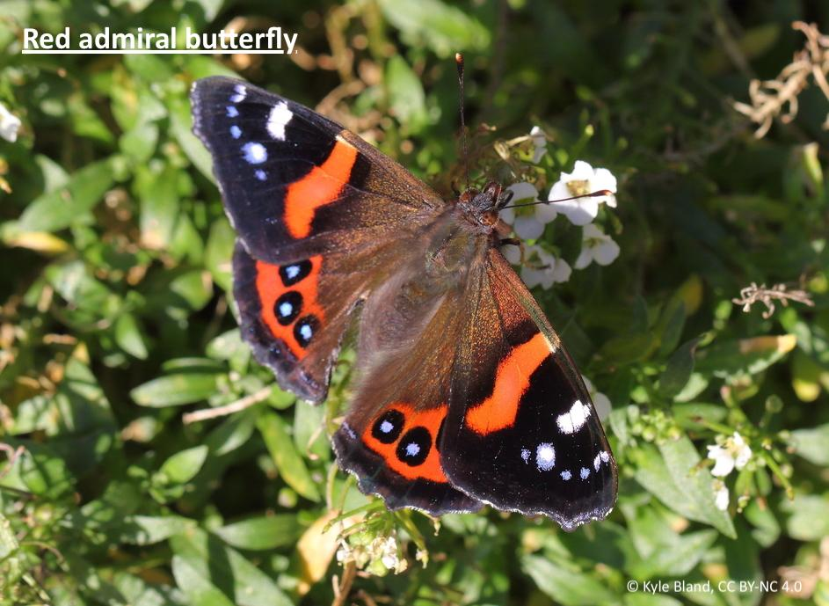 | 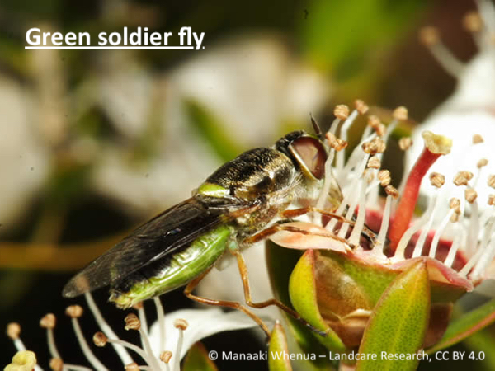 | 