ACTIVITY: Titiro – observing my environment

Activity idea

In this activity, students have the opportunity to actively use all five senses to make observations in an outdoor school setting.

By the end of this activity, students should be able to:
- make an observation using one or more senses
- make an inference from an observation
- share a question that arises from the observation
- transfer skills learned in a school-based observation to other outdoor settings.

For teachers

Introduction/background

Humans learn via our senses. We use particular senses to gather particular types of information. Using multiple senses can provide a lot of information about what we are observing.

Observation is fundamental to science and mātauranga Māori. It is a skill that improves with practice and knowledge.

Students learn to observe more scientifically when:
- observations are prompted by appropriate questioning
- observations are connected with growing background knowledge on the subject or object under observation
- they are given the opportunity to share, discuss and debate observations.

Observation in the curriculum

Levels 1–4 of the New Zealand Curriculum’s ‘Investigating in science’ strand directs students to extend their experiences of the natural world through exploration, asking questions and finding evidence. The science capabilities have an emphasis on making careful observations and drawing inferences from them. Providing opportunities for students to make observations is key to their development in science.

Alternative conceptions about observation

Students may hold the alternative conception that scientific observation is a visual activity. While many scientific observations do use sight and extensions to sight such as microscopes and telescopes, the other senses also provide important information.

Observation and te ao Māori

Tangata whenua and those who work in ecosystem restoration often speak of te reo o te awa or te reo o te repo or te reo o te whenua – the voices of the river, the wetlands and the land. Understanding ecosystems and restoration processes involves listening as well as seeing and, in some cases, smelling, touching and tasting what is present and considering what may be missing.

Observation in an outdoor setting

Rather than set out prescribed instructions, this resource identifies ways in which students can explore and develop their observation skills in an outdoor setting. Use them at school and/or as a practice session before visiting a wetland, forested area or other natural habitat.

Questions to focus observations
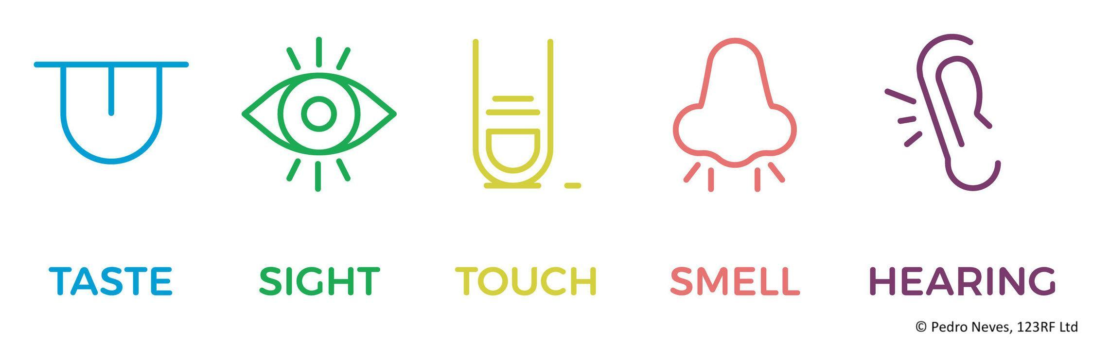
Observing sounds

- What sounds do you hear?
- Are there sounds made by nature?
- Are there sounds made by humans?
- Are there sounds made by machines?
- Are there sounds you don’t recognise?
- Are there sounds that you hear occasionally? Regularly? Are there patterns of sound?
- Are there sounds that you don’t hear but you think should be heard in this location?
- Are there sounds that surprise you by being heard in this location?
- If you use your eyes, can you see where the sounds are coming from?
- What do the sounds tell you about where you are? (These are your inferences.)
- Why is it important to listen for sounds in a natural environment?

Observing with sight

- What do you see? Far away, close up, at your feet, above your head?
- What colours, shapes or sizes do you observe?
- Are the things you are observing moving or still?
- Are there things you think you should be able to see but aren’t at this location?
- Are there things that you see that surprise you by being in this location?
- Are there other senses you can use to observe what you are looking at? For example, can you hear sounds coming from what you are observing? Can you touch, smell or taste what you are observing?
- What inferences can you make and why? For example, if something is alive or not, natural or created by a human, belongs in the location or not.

Observing smells

- What do you smell?
- Do the smells change if you move your nose close to the ground or hold your head high?
- Is it easier to observe smells if your eyes are closed?
- Do your other senses help you identify where the smell comes from?
- What inferences might come from the smells? For example, animals might be close by, the rubbish has not been emptied or flowers are using scents to attract insects.
- Why is it important to notice smells in a natural environment?

Observing with touch

- What do you feel when you touch something?
- Does the feeling/texture change if you move your fingers around the object? (For example, a makomako (wineberry) leaf has a slightly furry feel to the upper side, a bumpy, veined underside and serrated edges.)
- Are there things that you can feel without touching them with your fingers?
- What words can you use to describe the way something feels?
- Does using your other senses help you understand why an item may feel different if you touch it in different places?
- What inferences can you make about the way something feels? Why does it feel cold or rough or slick? What are the advantages for a plant or animal?

Observing with taste

Note: This type of outdoor observation requires significant safety precautions and close supervision. Clearly mark the items to be tasted i.e. kawakawa leaves, karamū berries, fruits or vegetables from a garden. Consider whether the foods need to be washed prior to tasting.

- What does the item taste like?
- What words can you use to describe the taste?
- What other senses do you use when you taste something? Does your tongue touch it? Does your nose smell it? Do your eyes see it? What difference do you think this makes? What other information comes from using other senses?
- What inferences can you make about the taste? Does colour or sweetness or bitterness encourage/discourage you from eating something?
- What tastes should be part of an ecosystem – for humans or for animals?

Suggested activities

Observation stations

- Set up stations around the school environment and mark them with a ribbon, a sign or use a hoop to mark off an area.

- If there is a specific sense you want students to use, include images of the body part(s)/sense(s) they should use.

- Use oral or written instructions regarding what or how to observe.

- Encourage students to record questions that arise while they are observing something.

- Encourage students to record words or images about the observations.

- Discuss the observations after the activities.

Natural treasure hunts

- Create natural treasure hunts:
- Provide paint colour swatches and find a plant or item that matches the colour.
- Circle colours on a magazine picture and find plants or items that match the colours.
- Provide leaves and find the plants they come from.
- Listen for sounds – soft, loud, whistling, from humans, from nature.
- Find textures to touch – rough, smooth, soft, hard, prickly, sticky, furry, moist.
- Find smells – sweet, unpleasant, earthy.
- Find tastes – whatever can be sourced safely.

- Use a method to record what is found – tick chart, bingo card, camera, paper bag or ice cream container for collections.

Observations in a non-school setting

When students have learned the basics of observation, arrange to visit a natural area. Spend some time learning about the plants and animals that are part of the ecosystem, including those that shouldn’t be there – weeds and pests. If it is a site under restoration, invite local kaumātua, grandparents, elderly neighbours and others to share their memories and observations of the plant and animal species that once occupied the site. Ask them about smells or tastes of things like matamata (whitebait) and wātakirihi (watercress), because changes to land use and water quality can affect these. Ask them what they once saw and heard. Plant and animal species may have disappeared or introduced species may have taken over. After the visit, use the observations to plan for change and/or as a starting point for monitoring.

