ACTIVITY: Building a tau kōura

Activity idea

In this activity, students learn about tau kōura history and design and how to build whakaweku to monitor kōura.

By the end of this activity, students should be able to:
- discuss what is meant by the terms taonga, keystone and indicator species when referring to kōura
- discuss why the tau kōura design is fit for purpose
- build a whakaweku from rarauhe/bracken fern fronds
- use whakaweku to monitor kōura in a local waterway.

For teachers

Introduction/background

Kōura (freshwater crayfish) are a taonga species for Māori, a keystone species for ecosystem dynamics and an indicator species for ecosystem health. They are also a species that have been difficult to monitor using conventional scientific methods such as baited traps.

Te Arawa iwi have used a traditional method known as tau kōura for hundreds of years. The chief component of tau kōura is rarauhe/bracken fern, which grows in open places throughout Aotearoa. The fronds have woody stems and tough, stiff leaflets. Fern fronds are bound together to make whakaweku and then submerged in a waterway. The whakaweku resemble the vegetated habitats that are attractive to kōura. A tau kōura has several whakaweku tied onto a long rope and can extend up to 200 m.

The article Monitoring kōura has background information about tau kōura and the value of kōrero in wetland restoration. The level 1 2007 Connected article ‘Counting kōura’ also has useful information about kōura and the work of biologist Dr Ian Kusabs and Te Arawa kaumātua Willie Emery. The Connected teacher notes focus on the technological aspects of tau kōura.

Things to consider

For safety reasons, this activity has background information about tau kōura, but it has instructions for making whakaweku that can be secured to the bank or edge of a waterway. Water is an inherently dangerous environment. Tau kōura may involve deeper water as it lays along a larger stretch of open water.

Kōura defend themselves with pincers. Take care when handling them so that you don’t get nipped.

If whakaweku remain empty after the monitoring period, this still provides valuable monitoring information.

What you need

- Rarauhe/bracken fern fronds – approximately 10 per whakaweku
- Three 250 mm industrial cable ties per whakaweku
- Sisal or jute baling twine – length will depend on location and how many whakaweku are made
- Tumu (post) to attach the whakaweku to the bank of the waterway (optional)
- Punga (weight) such as a rock to weight the whakaweku (optional)
- Kōrapa – length of shade cloth formed into a net
- Ice cream or other plastic containers
- Callipers (optional)

What to do

- Use the article Monitoring kōura and the information in the student worksheet to learn about the history of tau kōura and why it is now used for monitoring purposes.

- Use the instructions in the student worksheet to create whakaweku. If desired, use the whakaweku to build a tau kōura.

- Use some of the following questions to deepen student understanding.
- Kōura are taonga, keystone and indicator species. What do these words mean?
- How do whakaweku work as a means to either monitor or harvest kōura?
- Why do you think more-conventional methods of trapping kōura are not as effective?
- Tau kōura, as an ongoing method to catch kōura, was only being used by a couple of families from Ngāti Pikiao. Why do you think this method, which was widely used in the past was not in wider use?
- What is mātauranga?
- How is this knowledge helping scientists in Aotearoa and in other parts of the world learn more about kōura/freshwater crayfish?
- From a technological point of view, how is the tau kōura design fit for purpose?
- How do you think the design has changed from hundreds of years ago to the present day?
- Why do scientists need to monitor kōura?
- What are some of the reasons that kōura may no longer be in the waterways they once thrived in?
- What can we do to restore these habitats?
- Female kōura bear eggs from April to November. Why is it best not to monitor, disturb or harvest females during these months?
- If you made whakaweku and/or tau kōura, what were your results?
- Did any of your results surprise you?
- If you repeat the monitoring activity, do you think the results would be the same? Why?
- If there were no kōura in your whakaweku, what does this tell you?
- Are there any modifications you would make to your design or the location you chose?

For students

Kōura are freshwater crayfish. They are a taonga species for Māori and were once an important food source for iwi in the central North Island. Kōura are a keystone species – they have a significant impact in aquatic ecosystems. They are also an indicator species – their presence or absence tells us about environmental conditions like water quality.

Te Arawa iwi harvested kōura for food and for trade. Over hundreds of years of mātauranga and rangahau (research), iwi developed and tested a number of harvesting methods – pouraka (baited traps), hīnaki (funnel nets), pae pae (dredge nets), rama kōura (hand nets) and tau kōura.

The tau kōura involves placing whakaweku (bundles of bracken fern) on the bed of a lake, stream or wetland. The whakaweku (also known as koere and tāruke) provide a refuge for kōura.
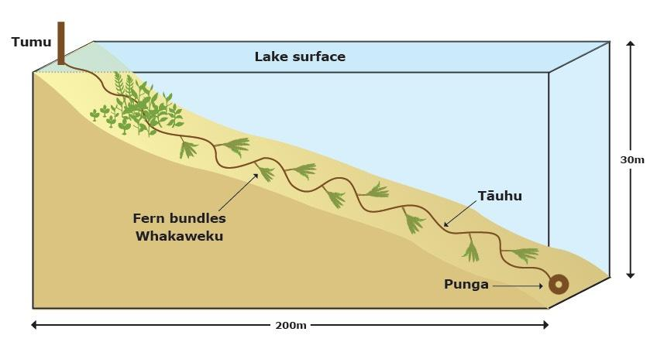

Whakaweku are made by binding 10 bracken fern fronds together. Whakaweku can be set together as in a traditional tau kōura, which is used in lakes and large ponds, or used individually.

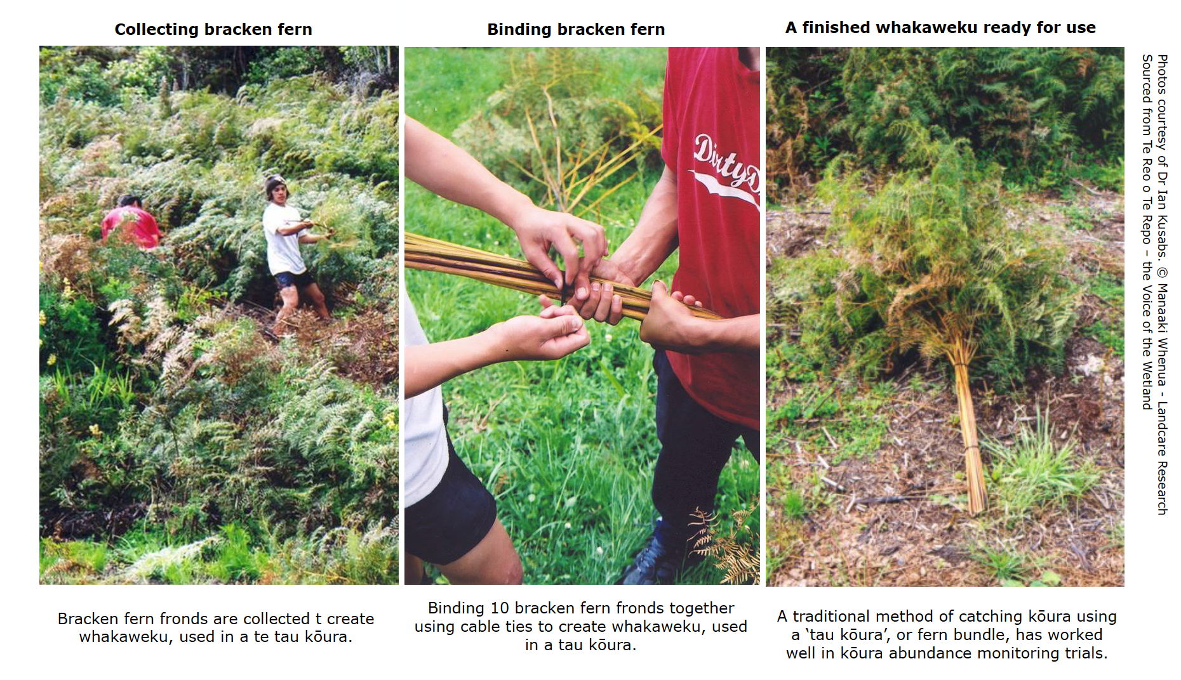

Leave the whakaweku in a lake or stream for 2–6 weeks. This should be enough time for kōura living in the waterway to colonise the fern fronds. When it’s time to check the whakaweku, lift it onto a net made from a length of shade cloth to prevent the kōura from escaping. Observe and/or measure the kōura before returning them to the waterway.

Whakaweku can also be used for sampling small bottom-living fish such as bullies as well as freshwater snails and insects.

What you need

- Rarauhe/bracken fern fronds – approximately 10 per whakaweku
- Three 250 mm industrial cable ties per whakaweku
- Sisal or jute baling twine – length will depend on location and how many whakaweku are made
- Tumu (post) to attach the whakaweku to the bank of the waterway (optional)
- Punga (weight) such as a rock to weight the whakaweku (optional)
- Length of shade cloth formed into a net
- Ice cream or other plastic containers
- Callipers (optional)

What to do

- Gather rarauhe/bracken fern fronds. Cut the fronds close to the ground.

- If necessary, strip the ends of the stems of the leaflets (pinnae). Use the images above as a guide.

- Use the cable ties to bind 10 fronds together. This will make one whakaweku.

- Insert one end of the baling twine through the stems and tie securely.

- Continue building the desired number of whakaweku.

- Place the whakaweku in the stream or waterway.

- Submerge it by placing a weight on it or pushing it under a log.

- Tie the whakaweku to a post, tree branch or a bunch of grass.

- Leave the whakaweku in the stream for 2–6 weeks.

- When you are ready to monitor the whakaweku, lift it onto the kōrapa and bring it to the shore.

- Gently shake the kōura onto the kōrapa and put any you find into ice cream containers.

- Choose a means of monitoring and counting them. Callipers are useful for measuring their length.

- After observing the kōura, gently return them to the waterway.

Information in this activity was sourced from Kōura – the ancient survivor written by Ian Kusabs (Te Arawa, Ngāti Tūwharetoa).

