ACTIVITY: Climate data analysis

Activity idea

In this activity, students use Google Data Studio datasets to explore climate data.

By the end of this activity, students should be able to:
- discuss components of selected Data Studio pages
- discuss and interpret data presented in selected pages
- discuss why the information is important
- ask questions about data of interest
- consider how the data can be used to inform people about changes in New Zealand’s climate and the effects we are beginning to see
- consider how the data can be used to inform people about New Zealand’s greenhouse gas emissions.

For teachers

Introduction/background

Our atmosphere and climate 2020 is an environmental report produced by the Ministry for the Environment and Stats NZ. The report uses extensive long-term datasets to demonstrate some of the observed physical changes and broadscale effects in New Zealand that have been caused by climate change. Stats NZ makes these datasets available to the public. This activity uses Google Data Studio to enable students to visualise and filter datasets of interest: New Zealand climate data analysis.

There are 27 datasets to choose from:
- Rainfall per day
- Analysis of rainfall
- No rain days
- Extreme rainfall
- Drought by location
- Drought conditions per year
- Analysis of temperature – maximum, average and minimum
- Analysis of temperature by season
- Extreme weather patterns – heat versus extreme heat
- Extreme weather patterns – heat daily analysis
- Analysis of growing days
- Fire risk
- Wind
- Frost
- Frost by year
- Greenhouse gas concentration trend
- Greenhouse gas concentration emissions levels 1–10
- Ozone analysis – maximum, average and minimum

You can access the datasets from Our atmosphere and climate 2020 on the Ministry for the Environment Data Service. Select ‘Recently added’ from the settings menu to access the datasets used in this report.

Navigating pages in Data Studio

There are two ways to access the datasets/pages: use the arrows on the upper left-hand side of the screen to navigate through the pages or click onto the title to access a drop-down menu.
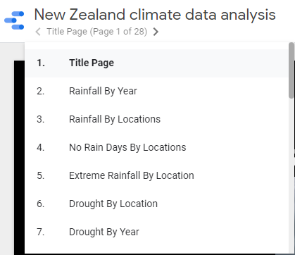

To filter the date range, double click on the month in the start and/or end dates. This shows a range of years. Double click on the month/year button to quickly find a particular year.
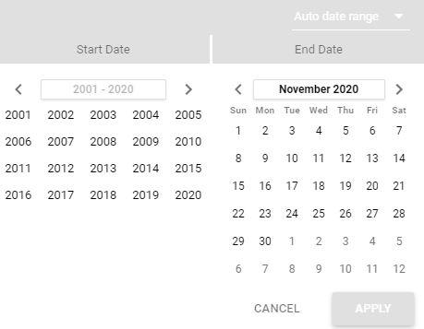
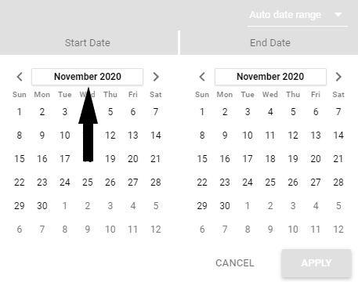
Use the drop-down menus on each page to find and filter locations or specific indicators. The embedded maps function as Google Maps. Use the more button to download the data as CSV or Excel files or export to Google Sheets.

Users may wish to watch the informal videos, filmed and narrated by educator Jason Morgan, that introduce the New Zealand climate data analysis datasets and explain how to filter, visualise and explore data. Please note that the videos show an earlier iteration of the New Zealand climate data analysis, so the title pages are different.

Climate data analysis – an introduction
Climate data analysis – ways of representing data
Climate data analysis – specific weather data
Climate data analysis – greenhouse gas and ozone data

Our atmosphere and climate 2020 – background information

Our atmosphere and climate – introduction provides an overview of the resources created to support the Our atmosphere and climate 2020 report. Climate change resources – planning pathways provides pedagogical advice and links to the New Zealand Curriculum. It includes an interactive planner that groups Hub resources into key science and teaching concepts.

Teaching suggestions

Sample approaches
There are multiple approaches teachers can take when using the climate data. The datasets fall into three categories – weather-related, greenhouse gas concentrations and atmospheric ozone. One suggestion is to use an inquiry-based approach aligned to a contextual theme.

Weather
Students can make comparisons by region or look for trends through time. They can explore weather data, including extreme weather, and consider the impacts on primary production, human health and human geography.

Greenhouse gases
Students can explore greenhouse gas emissions by sector from 1990–2019. 10 levels of data enable users to drill up or down through the data.

Atmospheric ozone
Students can observe changes to atmospheric ozone, measured in Dobson units, from 1979–2019.

Using the science capabilities
Regardless of the context, the datasets are useful for practising many of the science capabilities. Students can interpret the data and make and critique inferences about what the data may be showing. Students can also interpret representations using data in maps, graphs and tables.

Student worksheet
The student worksheet has links that provide information about some of the measures and indicators used to produce the datasets. Each link includes what is measured and why it is important, key findings, where the data comes from and how it was collected, access to the data tables and references. The worksheet also has key terms that students will encounter while working with the datasets.

For students

Our atmosphere and climate 2020 is an environmental report produced by the Ministry for the Environment and Stats NZ. The report uses data to demonstrate some of the observed physical changes and broadscale effects in New Zealand that have been caused by climate change.

The following links provide information about some of the measures and indicators used in the report. Each link includes what is measured and why it is important, key findings, where the data comes from and how it was collected, access to the data tables and references.

Atmospheric ozone
Drought
Extreme rainfall
Extreme wind
Frost and warm days
Greenhouse gas concentrations
Growing degree days
New Zealand’s greenhouse gas emissions
Rainfall
Temperature
Wildfire risk

Key terms

The following terms are used in some of the Data Studio pages. This article has additional weather and climate terms and concepts.

Atmospheric ozone | Total column ozone (TCO) is a measurement of the total amount or thickness of atmospheric ozone in a column extending from the Earth’s surface to the top of the atmosphere. It is measured in Dobson units. TCO measurements are observed above Lauder, Otago.
Autumn | The season March, April, May in the southern hemisphere. This season is characterised by decreasing temperatures in most areas of New Zealand.
Extreme heat | Extreme heat conditions are defined as weather that is much hotter than average for a particular time and place. A heatwave is when the daily maximum temperature exceeds the average maximum temperature by 5°C or more for 5 consecutive days.
Growing degree days (GDD) | A heat accumulation index related to crop development, typically calculated as the daily accumulated temperature above a base temperature. As this threshold varies widely between plant species, NIWA routinely calculates GDD totals for base temperatures of 5°C and 10°C.
Rain | Liquid precipitation in the form of water droplets.
SPEI | Standardised Precipitation Evapotranspiration Index (SPEI) is commonly used as a drought index. SPEI is calculated using daily temperature and rainfall data. The scales used in this dataset range from extremely dry to extremely wet. NIWA posts daily Standard Precipitation Index and Soil Moisture Deficit maps for New Zealand.
Spring | The season September, October, November in the southern hemisphere. This season is characterised by enhanced westerly winds over New Zealand.
Summer | The season December, January, February in the southern hemisphere. This season is characterised by an increase in temperatures to the late summer maximum in many places in New Zealand.
Temperature | The temperature of the ambient air at the surface of the Earth. In New Zealand, temperature is reported in °C.
Very wet days | Days where the daily rainfall exceeds the 95th percentile of daily precipitation totals during the period 1981–2010.
Weather | The state of the atmosphere at a specific time and refers to short-term variations in sunshine, cloudiness, humidity, rainfall, temperature, wind and visibility.
Wind | Air that flows around pressure systems such as highs and lows or due to heating and cooling of land and sea (the sea breeze, the land breeze). Wind is measured by its speed and direction.
Wind days above the 99th percentile | A count of the number of days where the maximum wind gust was greater than the 99th percentile wind gust speed. NIWA calculates the 99th percentile wind gust speed from all available daily wind gust data at each of the 30 nationally representative locations. On average, the p99 daily maximum wind gust will be exceeded on approximately 3.6 days per year.
Winter | The season June, July, August in the southern hemisphere. This season is the coldest season in most places in New Zealand.

