ACTIVITY: Explore a cow's digestive system

Activity idea

In this activity, students will learn about the structural and functional aspects of a cow’s digestive passage.

By the end of this activity, students should be able to:
- identify structures in a cow’s digestive system
- understand the functions of the parts of a cow’s digestive passage.

For teachers

Ruminants are mammals with specialised digestive systems that use fermentation processes to gain nutrients from plant material. Cattle, sheep, horses, deer, goats and camels are all ruminants. They are also called herbivorous or secondary producers in food chains and have adaptations to allow them to thrive on a plant-only diet.

The Ruminant digestion article and image map will give additional support for your students’ learning about a cow’s digestive system.

Activity 1: Cow digestion mix and match will help students understand the functions of the parts of a cow’s digestive passage.

Activity 2: Label a cow’s digestive passage will help students identify the different parts of a cow’s digestive passage. It can be completed online or use the paper-based version in the student handout.

It can also be used as a formative or summative tool for learning.

Deepen student thinking

Explore the differences and similarities between:
- primary and secondary producers in a food chain
- adaptations of different herbivores
- a ruminant and human digestive system.

Activity 1: Cow digestion mix and match – answers

Component |  | Function description
Mouth |  | Cows regularly regurgitate a food bolus for rechewing. This is called rumination. Saliva helps lubricate the food and provides a medium for bacteria to attach to food particles. Methane gas is a byproduct of the fermentation process that occurs in the rumen. It is burped out by the cow through this part.
Reticulum |  | This part is not physically separated from the rumen. Its main role is to act as a filter, trapping larger feed particles that require further digestion. These larger food particles are regurgitated and rechewed – a process called rumination.
Rumen |  | This is the fermentation vat. It is the largest part of the stomach. It contains a large number of microbes – bacteria that digest the cellulose in the plant material. This releases the sugars and nutrients within plant cells.
Abomasum |  | This is called the true stomach and has a similar function to stomachs of other animals, like humans. It has a low pH – an acidic environment that kills the bacteria that pass from the rumen. It is where the digestion of microbial and dietary proteins begins.
Omasum |  | This part of the digestive system is made up of lots of folds of tissue, almost like a leaf. This creates a large surface area to absorb water. It also acts as a filtration system and only allows fine particles and small amounts of fluid into the next part of the digestive tract.
Small intestine |  | This part of the digestive passage is about 40 metres long. It’s pH increases due to secretions from the pancreas, and there is a lot of enzymatic digestion of nutrients.
Large intestine |  | This is the final part of the digestive tract. It is made up of the caecum and the colon. The main function is to absorb water and minerals.
Anus |  | This is a circular muscle that controls the expulsion of waste from the digestion process.

Activity 2: Label a cow’s digestive passage – answers
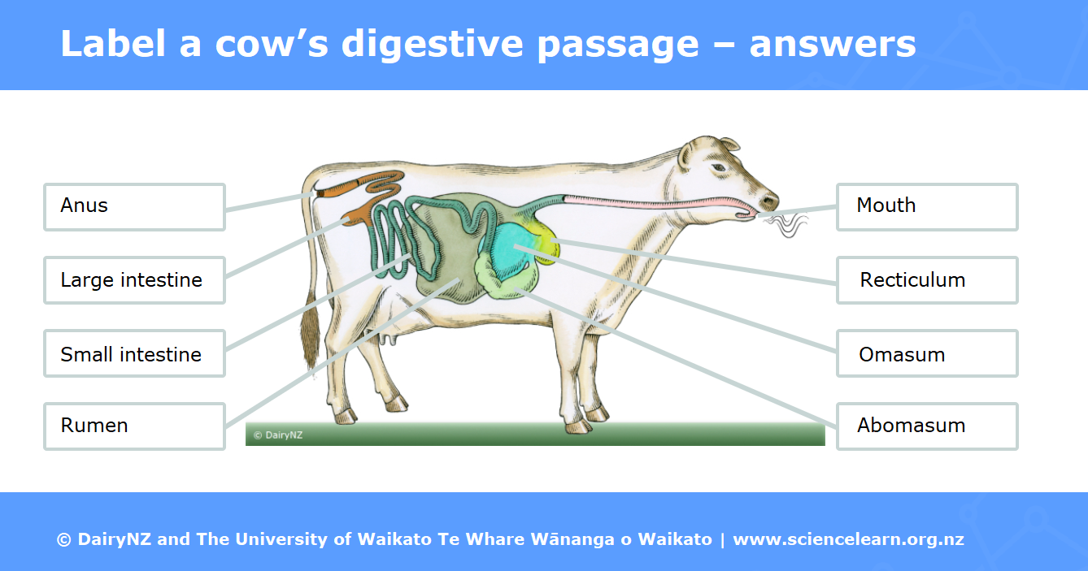

For students

Ruminants are mammals with specialised digestive systems that use fermentation processes to gain nutrients from plant material. Cattle, sheep, horses, deer, goats and camels are all ruminants. They are also called herbivorous or secondary producers in food chains and have adaptations to allow them to thrive on a plant-only diet.

The Ruminant digestion article and interactive image map will provide some information about a cow’s digestive system.

Activity 1: Cow digestion mix and match

Match the parts of the cow’s digestive passage to the correct function description.

Component |  | Function description
Mouth |  | This is called the true stomach and has a similar function to stomachs of other animals, like humans. It has a low pH – an acidic environment that kills the bacteria that pass from the rumen. It is where the digestion of microbial and dietary proteins begins.
Reticulum |  | This is the final part of the digestive tract. It is made up of the caecum and the colon. The main function is to absorb water and minerals.
Rumen |  | This part of the digestive passage is about 40 metres long. It’s pH increases due to secretions from the pancreas, and there is a lot of enzymatic digestion of nutrients.
Abomasum |  | This is a circular muscle that controls the expulsion of waste from the digestion process.
Omasum |  | Cows regularly regurgitate a food bolus for rechewing. This is called rumination. Saliva helps lubricate the food and provides a medium for bacteria to attach to food particles. Methane gas is a byproduct of the fermentation process that occurs in the rumen. It is burped out by the cow through this part.
Small intestine |  | This is the fermentation vat. It is the largest part of the stomach. It contains a large number of microbes – bacteria that digest the cellulose in the plant material. This releases the sugars and nutrients within plant cells.
Large intestine |  | This part of the digestive system is made up of lots of folds of tissue, almost like a leaf. This creates a large surface area to absorb water. It also acts as a filtration system and only allows fine particles and small amounts of fluid into the next part of the digestive tract.
Anus |  | This part is not physically separated from the rumen. Its main role is to act as a filter, trapping larger feed particles that require further digestion. These larger food particles are regurgitated and rechewed – a process called rumination.

Activity 2: Label a cow’s digestive passage

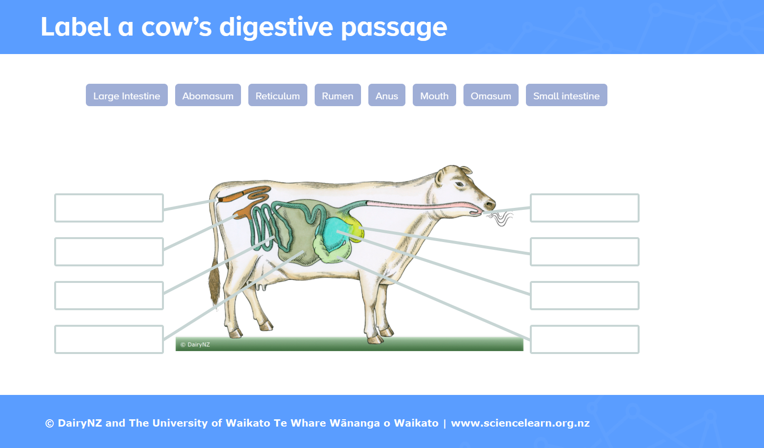
Use the labels to identify the main parts of a ruminant digestive system

