ACTIVITY: Beach visits – habitats and food webs

Activity idea

In this activity, students engage in purposeful research before visiting a local beach environment and then apply it while making close scientific observations. On return to school, students can use their evidence to position their organism within a food web of the overall ecosystem.

By the end of this activity, students should be able to:
- identify where and how an organism is positioned within an ecosystem diagram
- accurately describe an organism’s ecological niche including food, shelter, any known adaptations and survival challenges
- make close observations of their organism and record these for reporting back.

For teachers

Introduction/background

This research task supports students to consider the different elements that impact on an organism’s survival.

The beach provides each type of living thing found there with food and shelter. This activity involves students in researching and observing a range of organisms to understand the interconnected nature of ecosystems.

After the beach visit, students can use their evidence to position their chosen organism within a food web within the overall ecosystem.

This links to the science capabilities and the Living World contextual strand. Strategic teacher talk can highlight the nature of science connections whilst the capabilities help to identify student functional understanding of the nature of science.

What you need
- Resource material on living things from your chosen beach environment
- Materials to create a large mural
- Identification checklist
- Observation notes
- Food web diagrams
- Clipboards
- Camera
- Drawing materials

Teaching suggestions

Before the field trip

- With the students working in pairs or small groups, allocate to each group one type of living thing typically found in the chosen beach environment. (Ensure you cover producers, herbivores, carnivores and decomposers so that food webs can be built up later.) The selection of their species might come from the appropriate seashore ID guide and activity books. Useful Marine Metre Squared resources include:
- Primary school resources
- Seashore ID guides and activity books
- Other marine resources
- Links to resources
- Identification

- Have each group complete an identification checklist for their organism. The student handout is in Word, so students can edit the checklist to suit their needs. To support students and teachers, there is a completed identification checklist model answer for an oyster to see the sorts of information that may be included.

During the field trip

- Challenge students to find as many different types of living things as they can and record numbers and possible identification at the top of their observation notes.

- Ask them to use their Marine Metre Squared seashore ID guides plus any other appropriate guide to identify each living thing (without removing anything from its habitat).

- Ask students to choose three living inhabitants of the beach to make more detailed records on their observation notes.

After the field trip

- Have all the groups combine information from their research and observations from the field trip to create a large collaborative classroom mural that summarises key information on all the living things they found at the beach and to form a plan of the beach.

- Using the food web diagrams, have students identify the food webs across and around their researched organisms. This could be shown using string or wool to connect and include attachable arrows to show the direction of the energy flow through the ecosystem.

- The mural and food webs can be used as a reference for subsequent activities.

Identification checklist

Organism name

Appearance (could include a diagram, text, measurements, photograph)

Habitat (what part of the beach – high-tide mark, low-tide mark – and on what sort of substrate?)

Likely food (look at mouth parts or habitat)

Likely enemies

Forms of protection

Adaptations that help this living organism survive at the beach

Other interesting points

Identification checklist model answer

Organism name
Oyster, tio, Saccostrea glomerata
Appearance (could include a diagram, text, measurements, photograph)
Longest dimension approx. 7 cm. White shell with small splodges of black or dark grey, often around the edges of the shell. Oval in shape with some corrugations at the edge. These can break off when stood on with strong shoes. A bivalve – one shell is stuck to the rock and the other nestles inside the lower shell.
Habitat (what part of the beach – high-tide mark, low-tide mark – and on what sort of substrate?)
Found between high tide and low tide – in the intertidal zone but towards the low-tide mark.
Likely food (look at mouth parts or habitat)
As this organism is stuck or cemented to a rock, I think it would be a filter feeder. Research tells me it eats phytoplankton that it filters from the water. This happens at high tide when the oyster is covered by water. It closes its shell tightly at low tide to protect it from predators and from drying out.
Likely enemies
Oysters are eaten by whelks, crabs, worms, starfish and fish.
Forms of protection
An oyster’s shell will protect it from a lot of predators, but if they get through this, it can secrete a fluid that will cover up an irritant such as a small grain of sand. This fluid solidifies to become the beginning of a pearl.
Adaptations that help this living organism survive at the beach
The oyster has a strong shell to protect it from waves, drying out and predators. It has sharp edges to parts of the shell that can cut feet. It is strongly attached to the rock so it doesn’t get washed away or taken away for eating by a predator.
Other interesting points
- Oysters make pearls.
- Humans have learned how to implant grit that will trigger oysters to start the pearl-making process.
- Archaeologists have found evidence that suggests humans were eating oysters in Australia approximately 10,000 years ago.
- Oysters are thought to have been around during the Triassic period along with dinosaurs.
Observation notes

Organism name

Drawing

Photographs

Location of organism

Sketch and notes to show:
- above high tide, high tide, mid-tide or low tide
- substrate type – rock, sand, mud
- position of any rock pools

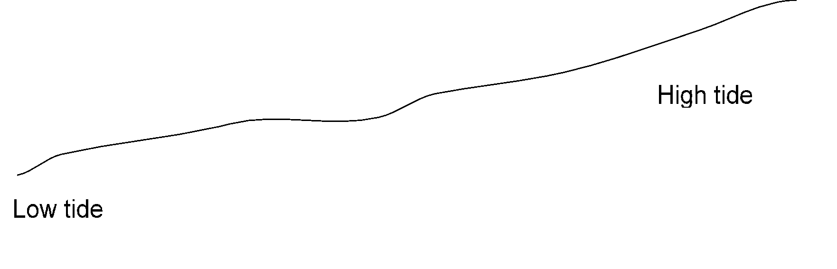

Food webs of rocky shore, sandy shore and mudflat (estuarine) environments

