ACTIVITY: Reading graphs in science

Activity idea

In this activity, students work step by step to interpret a scientific data display.

By the end of this activity, students should be able to:
- use a series of steps to approach scientific data displays
- locate appropriate information from the data display in order to answer questions
- make sense of multiple datasets from within the single data display.

Introduction/background
Using discussion as a pedagogical approach
Phases of reading a data display
What you need
What to do
Extension ideas

Introduction/background

At first glance, some data displays in science can seem overwhelming. Both students and teachers may be unsure of how to approach the task of understanding and making sense of graphs. This activity uses a graph that displays the vertical structure of the atmosphere as the context for exploring and interpreting graphic representations. Students and teachers can transfer the approaches used to make sense of other types of graphic information. Learning to understand the symbols of science is an important part of communicating in science and forms part of the interpreting representations capability. Reading graphs can be treated as a comprehension exercise in both English and science literacies.

Using discussion as a pedagogical approach

While learning to interpret a graphic representation, allow time for peer-to-peer discussions. Taking the time to do this supports students to see the benefits of sharing their thinking and developing collaboration. It also enables them to develop their understanding of the nature of science – it is about making sense of data, thinking about what the author’s purpose is and also whether the data makes sense.

Phases of reading a data display

As with other literacy skills, there are logical steps when reading a data display.
- Read the title or legend.
- Read the axis titles, labels and units and any other information.
- Follow any lines that show movement.
- Read other text or symbols that form part of the data display.
- Look at images that form part of the data display.
- Look at the colours of the text or graph lines and consider the author’s purpose.

Example:
- Title – vertical structure of the atmosphere.
- Horizontal x-axis, label and units – temperature in °C (degrees Celsius).
- Vertical y-axis, label and units – height in km (kilometres).
- Red line – changes in the air temperature as the altitude increases.
- Air layers named – the characteristics of air change with altitude.
- Images within the graph – provide visual context for altitude.
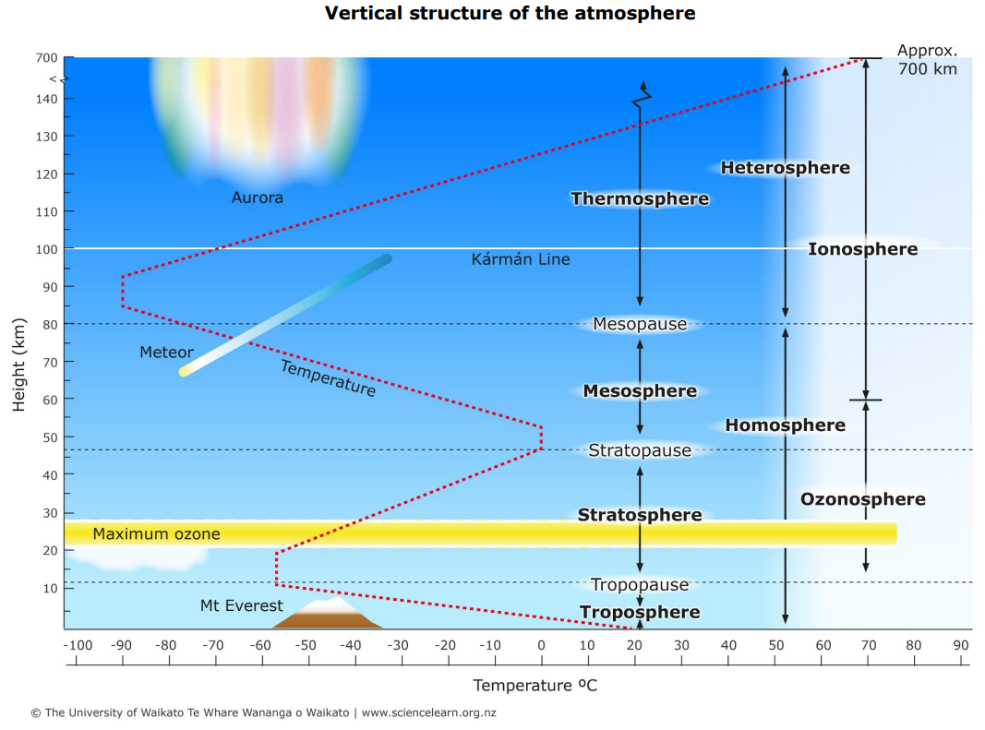

What you need

- Colour copies of the graph including the title, devices to display the graph or a means to project the graph onto a data display so all students have clear vision of the graph Access the graph here or use the PDF option under the image.
- Post-it notes (optional)

What to do

- Discuss the title of the graph. Invite students to share their thoughts on what sorts of information they might get from the graph.

- Discuss the axis titles. Invite students to share if their thoughts on the information in the graph have stayed the same or changed.

- Discuss other components of the data display – text, images, lines, arrows and colours.

- Invite students to look at the graph and share their ideas with a partner:
- What is this data display showing?
- What was the author’s purpose?

- Ask each pair to share their ideas with another pair of students.
- Do they agree or disagree?
- Can they come up with a shared explanation and story that makes sense of what the display is showing?

- Invite each group to share their ideas with the rest of the class and see if other groups agree.

- Practise comprehension skills using some of the questions below either through discussion or with online tools such as a Kahoot or Google quiz:
- What is the lowest temperature showing on the graph?
- What sphere does this occur in?
- Where does the temperature remain the same?
- At what height does the maximum ozone occur? What sphere is this in?
- In what sphere do auroras occur?
- In how many spheres does Mt Everest occur?
- Is the temperature rising or falling in the mesosphere?
- In the thermosphere, is the temperature rising or falling?

- Invite students to think about the data scientifically and to consider why the temperature changes at different heights.
- Students can use Post-it notes to place their questions or explanations at the appropriate place on the display. Encourage them to use tentative language at this stage as they will need to do research to check their ideas and gather data to support their meaning making. Using tentative language allows other students to have different interpretations of the data.
- Answer/explanation stems could include:
  - Perhaps the temperature rises in the stratosphere because …
  - I think that the temperature decreases in the mesosphere because …

Extension ideas

- Invite students to create a different representation of this information where the height runs along the x-axis and the temperature goes up the y-axis. What is gained or lost if this type of representation is used?

- Challenge older students to describe how the representation works as a graph and a diagram.

- Etymology is a great tool in science. Unpacking the origins and what the various prefixes mean often gives a good hint as to what the word might mean.

Prefix | Origin | Meaning | Term used in the graph
tropo | Greek | A turn or change | The troposphere is closest to the Earth where the weather changes.
meso | Greek | Middle | The Mesosphere is the middle atmosphere.
thermo | Greek | Heat | The temperature steadily increases in the thermosphere.
homo | Greek | Same | The composition of the atmosphere is mostly uniform – the gases are homogeneously mixed. This prefix is often a ‘point of interest’ for students – in Latin, homo means man as in Homo sapiens.
hetero | Greek | Other or different | The composition of the atmosphere changes and is less uniform – the lighter gases tend to concentrate in the upper layers.

