ACTIVITY: Water use challenge

Activity idea

In this activity, students take part in a water challenge to investigate how much water we need for our essential daily tasks. Students will experience how people make decisions about their water use according to how much is available.

By the end of this activity, students should be able to:
- investigate their daily water use at school and at home
- calculate water use using numeracy skills
- participate in a water challenge, making decisions about how to prioritise water use.

For teachers

Introduction/background

Many people around the world live with huge water challenges and have to prioritise their water uses every day.

In Aotearoa New Zealand, we are lucky to not have to think about water priorities often, with reliable supplies of clean treated water provided to our taps. We currently have few water challenges, but what if it wasn’t this way? Carrying out a water challenge with limited water amounts is useful to help students appreciate that our priorities for water use may change according to how much water we have available.

During summer, we often face more restrictions on how water can be used – for example, sprinkler and hose bans. To find out about any current water restrictions in the Waikato area, see the Smart Water alert levels webpage.

What you need

- Student handout Water use for one day
- Student handout Water for a day challenge
- Student handout Water use priorities

Introducing a daily water use challenge

- Discuss daily water use with students. Make predictions about how much water they use per day. Would this change according to the alert level? See Smart water alert levels webpage.

How much water do we use?

- This table shows how water use has changed in the Waikato over the last 10–15 years.

District | 2010 water use  Litres per person, per day (L/pp/d) | 2021 water use  Litres per person, per day (L/pp/d)
Hamilton | 250 | 214
Waipā | 250 | 180

- Consider and discuss possible reasons for these changes. Questions to deepen student understanding:
- How has the amount of water used in each district changed over time?
- Why do you think this is?
- Is the amount of water we use related to how much water is available?

Calculating daily water use

- Use the student handout Water use for one day to help calculate all the water individuals use in one day. Individuals are encouraged to take the sheet with them to record their personal use over the day. This can include the water used both at school and at home. After recording the water use for 24 hours, add up each table to find the total water used. Ensure students are aware that the water use amounts are estimates – the volume of water will vary due to the water pressure within the building, whether the tap is opened fully etc.

Water use challenge

- Use the student handout A water for a day challenge to raise awareness of what it is like to live with low water availability. Use the information and data on the student handout Water use for one day to plan how an individual could achieve a goal of either 50 litres, 80 litres or 100 litres of water use per day. Which water uses could they do without?

- Use the student handout Water use priorities to help to plan water use for the day or to reflect on the experience. Example answers are given in Possible answers: Water use priorities.

Thinking about water-saving actions

- Discuss actions that everyone can take to save water.

Easy water saving actions:
- Turn the tap off when I brush my teeth.
- Use hand sanitiser.
- Take a shorter shower.
- Have a bath half full instead of full.
- Use a watering can instead of a hose or sprinkler.

More difficult/expensive actions:
- Have a low-flow shower head.
- Have a dual-flush toilet.
- Have a new dishwasher instead of an old one.
- Have a front loader washing machine instead of a top loader.

Reflection questions

- Calculate how much water you would use in a week, a month and a year – what are your totals?
- Did this amount surprise you? Give reasons for your answer.
- Which water uses could you live without in the short term and long term?
- How might your water use change as a result of doing this activity?

This activity is part of a suite of resources that support Smart Water – a context for learning, which provides students and teachers with opportunities to connect with water and learn more about drinking water in the Waikato region. The science and mātauranga concepts that underpin Smart Water are transferable to other locations in Aotearoa New Zealand. Smart Water is a partnership between Hamilton City Council, Waipā District Council and Waitomo District Council. It aims to foster a greater understanding and appreciation of water from source to tap and supports schools, organisations and communities to use water sustainably.

For students
Water use for one day

Record your water use over one day. You don’t need to record drinking water.

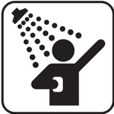
Bathroom and personal hygiene
Water use | Amount (L) | Tally | Total water used
Washing hands or face | 6 L per minute of tap on
Brushing teeth | 6 L per minute of tap on
Shower (low-flow shower head) | 6 L per minute
Shower (standard) | 12 L per minute
Bath (full) | 140 L
Bath (half full) | 80 L
Toilet (half flush) | 3 L per flush
Toilet (full flush) | 6 L per flush
Total bathroom/ personal hygiene use

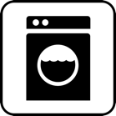
Laundry
Water use | Amount (L) | Tally | Total water used
Washing machine (top loader) | 150 L per wash
Washing machine (front loader) | 80 L per wash
Running tap | 6 L per minute
Total laundry use

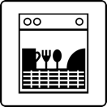
Kitchen
Water use | Amount (L) | Tally | Total water used
Dishwasher (new) | 12 L
Dishwasher (old) | 40 L
Dishes by hand (in sink)
Washing vegetables etc., running tap | 6 L per minute
Total kitchen use

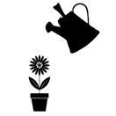
Outdoor use
Water use | Amount (L) | Tally | Total water used
Watering garden or using hose | 30 L per minute
Sprinkler | 17 L per minute
Watering can | 5–10 L per watering can
Leaks | Estimate the amount of water leaking per day
Other

Total outdoor use

Total water use

Category | Amount total (L)
Drinking | 2
Bathroom and personal hygiene
Kitchen
Laundry
Outdoor
Total water use in one day

Water for a day challenge

Choose a water challenge to complete for one day from the list below.

Water for a day challenges:
- should not include drinking water – drink as much water as you need without counting it in your challenge
- must include good personal hygiene – keeping your hands and body clean and flushing toilets for health and wellbeing.

Terrific water challenge

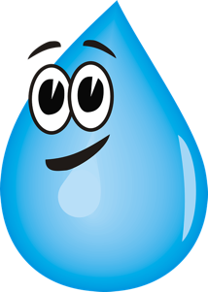
Challenge level: Medium

Water you can use for one day: 100 litres per day

(10 buckets full)

Challenge yourself to save some water from your regular daily use. You’ll need to think about which water uses you could do without.

Tips: Don’t be wasteful with water, have a short shower, flush the toilet only when necessary.

Super water challenge

Challenge level: Difficult

Amount you can use in one day: 80 litres per day (8 buckets full)

Take a bigger challenge by reducing your water use in half! You’ll need to think carefully about what you will use water for throughout the day. People in most western countries use more than 80 litres per day, so it might require going without a few things, just for the day. Think carefully about how you might wash yourself and keep clean.

Tips: Have a short shower, use hand sanitiser, avoid water wastage, flush the toilet only when necessary.

Mega water challenge

Challenge level: Very difficult

Amount per day: 50 litres per day

(5 buckets full)

Are you up for a big challenge? Use your water saving superpowers to conserve water by the litre!

This may require going without some water uses, just for the day. You’ll need to plan your water use and be strict with the amounts you use for each task you need it for. This amount of water is used by people who don’t have easy access to a water source.

Think carefully about how you might wash yourself and keep clean.

Tips: Have a very short shower, use hand sanitiser, avoid water wastage, reuse your water if possible, have low water use meals, flush the toilet only when really necessary.
Water use priorities
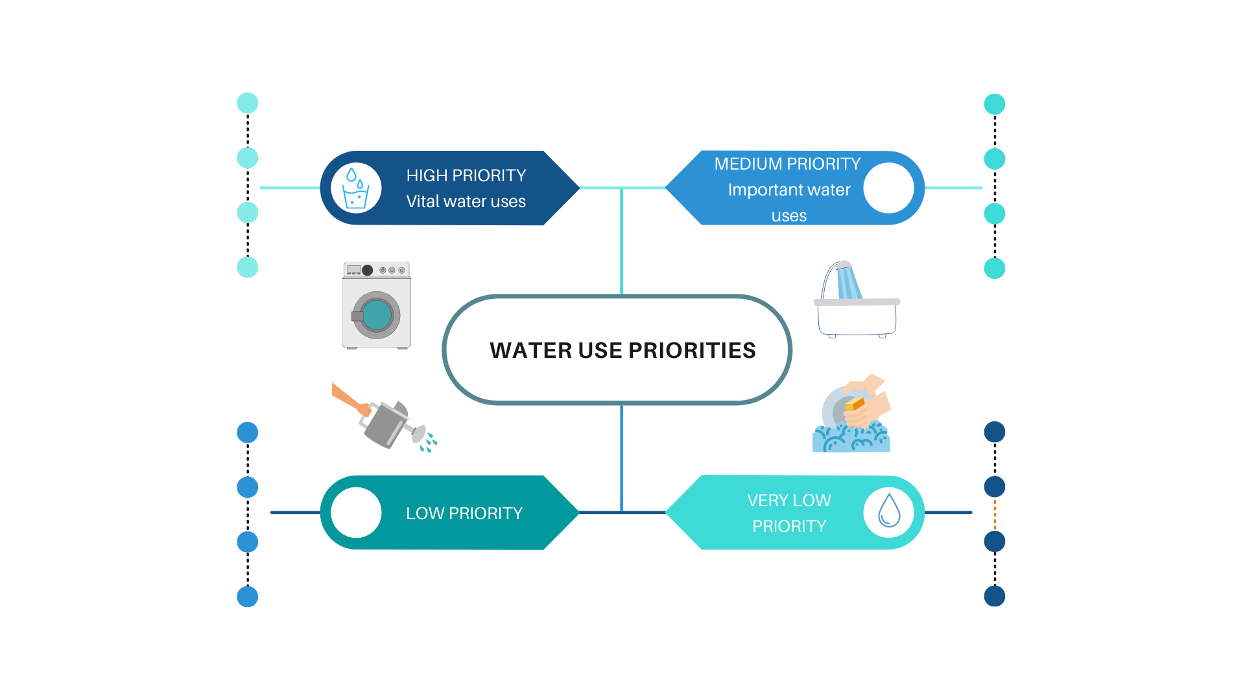

Possible answers: Water use priorities

