ACTIVITY: Exploring the images and whakataukī connecting to Te Kāhui o Matariki

Activity idea

In this activity, students consider the written and visual components of representations created for Environment Aotearoa 2022 and create a bespoke representation of their own.

By the end of this activity, students should be able to:
- discuss the purpose of the representation
- discuss how the representation presents its message via written word
- discuss how the representation presents its message via visual images
- create an illustration, whakataukī or poem to represent their own thinking or feeling regarding an aspect of te taiao.

For teachers

Introduction/background

Each whetū in Te Kāhui o Matariki – the Matariki star cluster – is associated with an aspect of wellbeing and the environment. The Ministry for the Environment and Stats NZ use the whetū to report on the health of the environment in Environment Aotearoa 2022. Read about the report’s unique framework in the article Environment Aotearoa 2022 – introduction.

The report introduces each whetū with a personified image and a whakataukī. This interweaving of te ao Māori, Matariki narrative and environmental science offers new ways for us to consider the state of te taiao.

This activity interweaves literacy and science to explore:
- how images and texts are shaped for different purposes and audiences
- scientific and figurative vocabulary
- how vocabulary choices communicate meaning in language and science.

The activity also interweaves visual literacy and science. The images and whakataukī are designed to communicate information about the stars and their environmental and/or wellbeing domains. The science capability ‘Interpret representations’ encourages students to think about how data is presented, what the representation tells us and how it gets the message across.

Each whetū is supported by an article that explores the environmental domain that it represents, connections to our wellbeing, environmental indicators of its present state and mātauranga and te ao Māori perspectives. Access the articles here.

What you need

- Access to the representations – the online versions are listed below:
Matariki
Pōhutukawa
Tupuānuku
Tupuārangi
Waitī
Waitā
Waipunarangi
Ururangi
Hiwa-i-te-rangi
- Access to the representations – PDF versions are available for download here.
- Access to the representations – the paper versions are in the student handout Te Kāhui o Matariki
- Images of whetū – to illustrate personal whakataukī or poetry

Teaching suggestions

- Look at some or all of the representations of the whetū. Discuss:
- What are your thoughts when you observe the representations?
- What are the different components of the representations?
- Who created the representations?
- Who is the intended audience?
- How is the representation getting its message across to the audience?
- What makes the representations effective forms of science communication?

- Explore the written components of an image. Discuss:
- What is the name of the whetū?
- What environmental domain does it represent?
- How does the whakataukī connect with the environmental domain?
- Does the whakataukī use scientific terms? (For example – germinate or deluge.)
- Does the whakataukī use descriptive words or phrases? (For example – the simile ‘with many wings like thunder’.)
- Does the whakataukī use words or phrases that help to create a picture in your mind? (For example – Waitī and the phrase ‘reflecting water’.)
- Does the whakataukī evoke a feeling? (For example – Ururangi and the phrase ‘a wind to caress my skin’.)
- How does the whakataukī represent the science that underpins the environmental domain?
- How does the whakataukī represent the wellbeing aspects that underpin the environmental domain?
- How does the whakataukī represent human connections to the environmental domain?

- Explore the visual components of the representations. Discuss:
- How does the image illustrate or represent the whetū?
- How does the image link the whetū to an environmental domain?
- How is colour used to present information?
- What else would you add to the image to illustrate the environmental domain it represents?

- Revisit the questions/discussion points posed at the beginning of the activity to review students’ thinking and/or understanding.

- Choose a whetū/domain of personal or local interest and create an illustration, whakataukī or poem. If desired, students can use images of individual whetū from Environment Aotearoa 2022.

Extension idea

Explore the environmental issues that may be relevant to your students. Using an inquiry approach, build curiosity and knowledge and create opportunities for action and reflection. Use this inquiry and action learning process as a platform for planning.
For students

Te Kāhui o Matariki

The various whetū in the Matariki star cluster are associated with different domains of the natural world – the land, forests, freshwater, saltwater, wind and rain. The images and text of each whetū are from the Ministry for the Environment and Stats NZ report Environment Aotearoa 2022.

This activity invites you to take a closer look at the words and images used to represent each whetū.

Think about the way the words create pictures in your mind or help you think about different aspects of the environment and your connections to the environment. Look at the images to observe how they reflect the whetū and their environmental domains.

Challenge yourself to create a whakataukī or poem for one of the whetū.

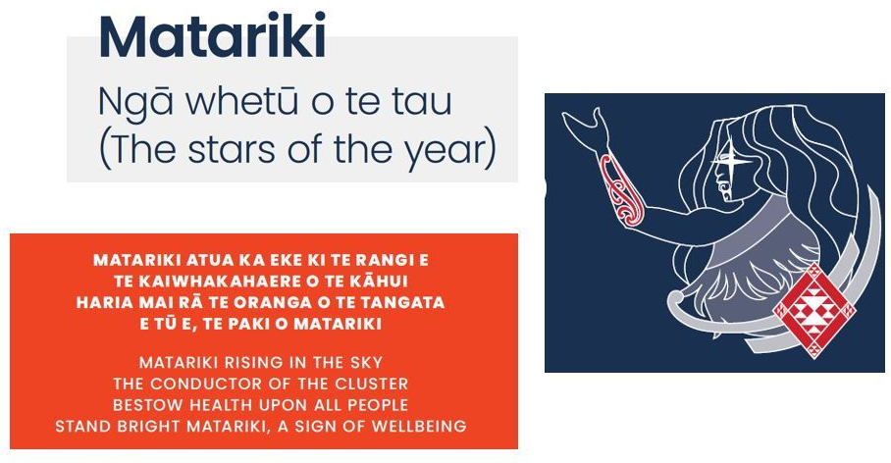

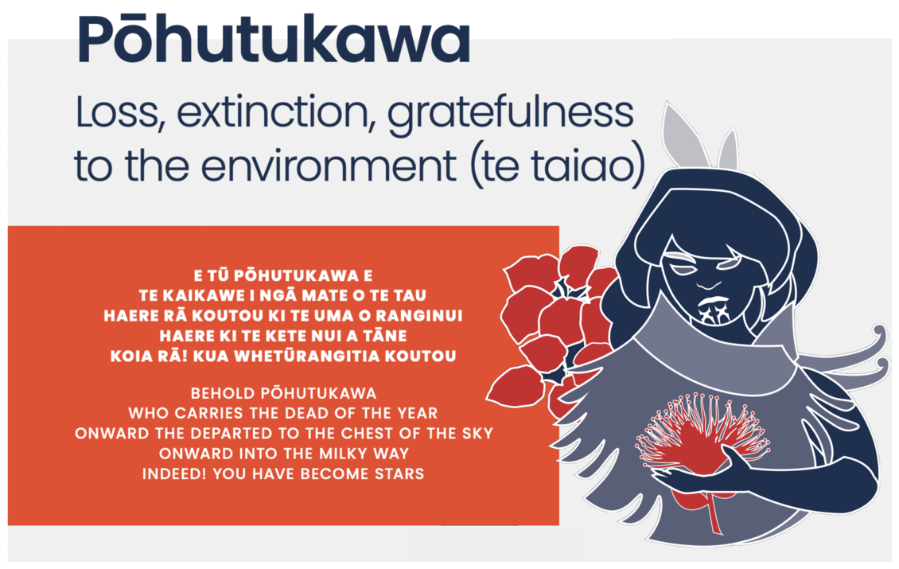

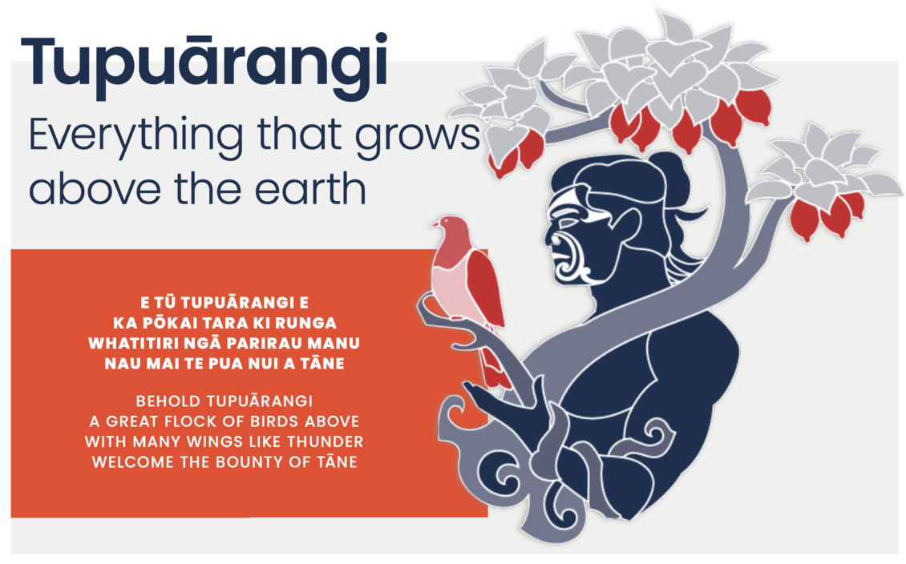

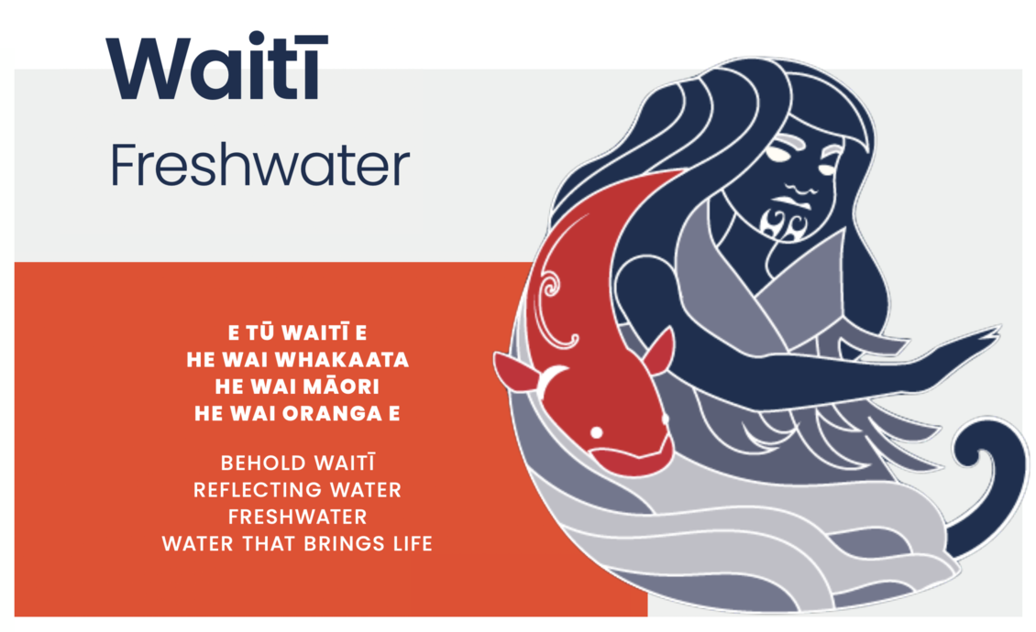

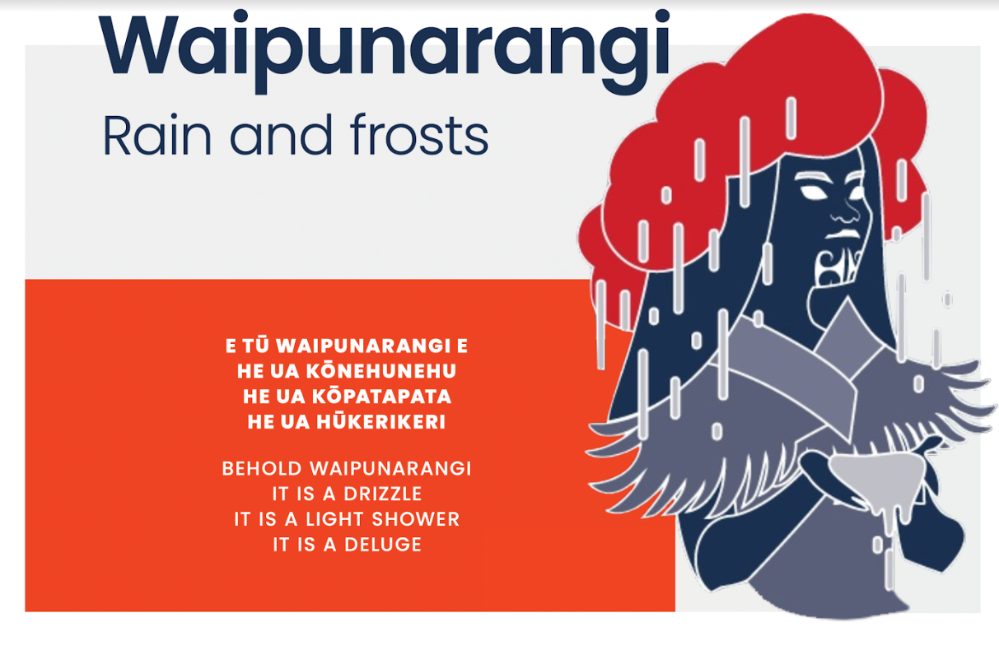

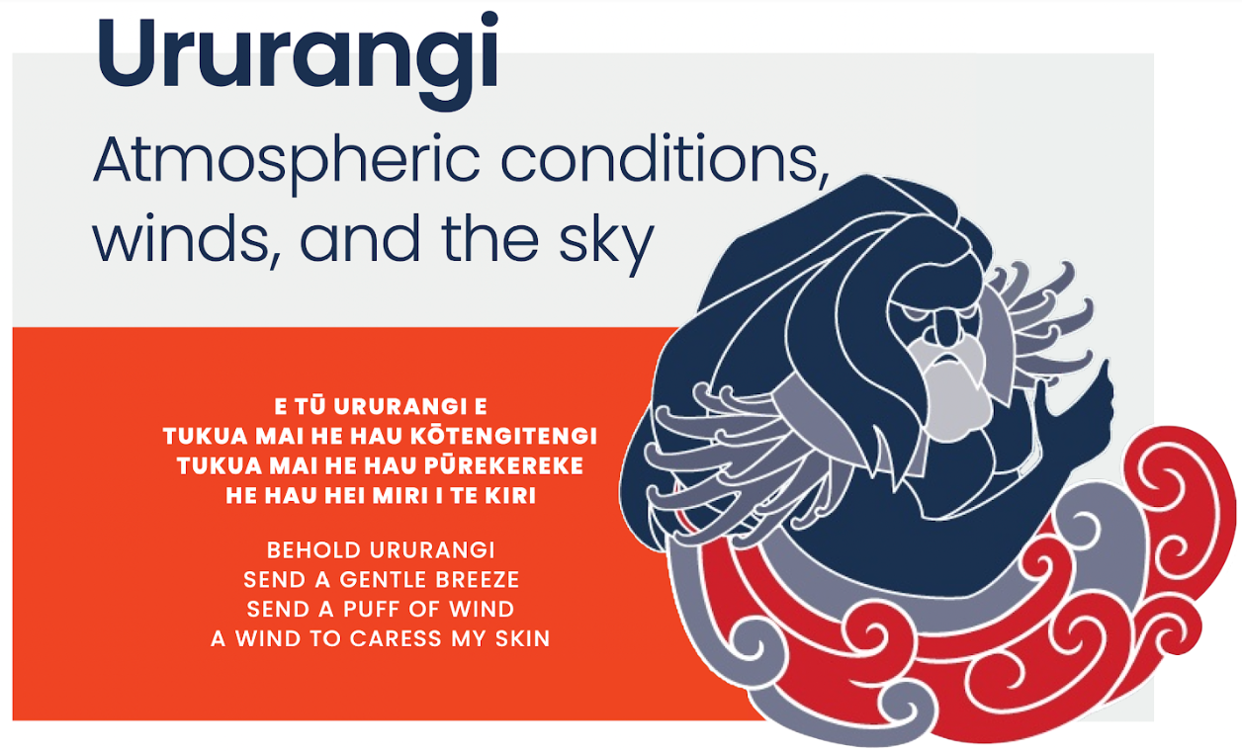

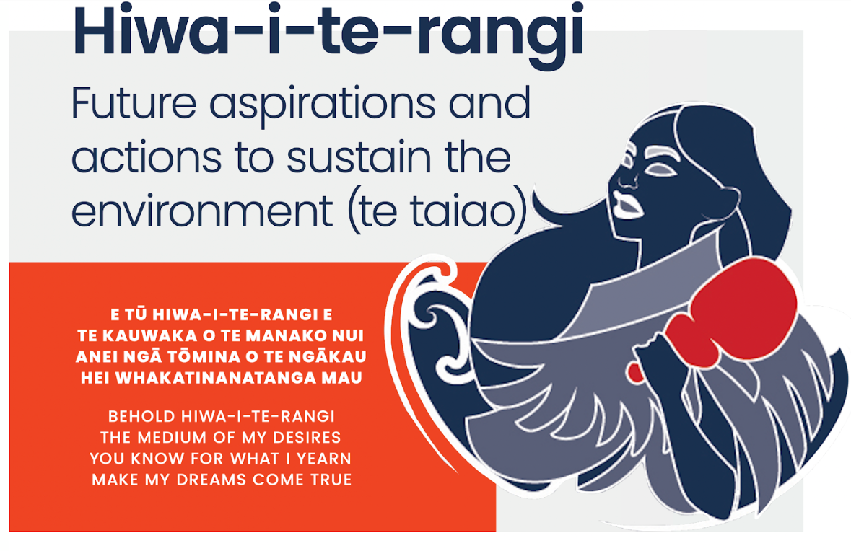

Images of whetū

Use these images to illustrate your whakataukī or poem.

