**ACTIVITY: Analysing satellite data to track Earth movements**

**Activity idea**

This activity uses actual data from the Institute of Geological and Nuclear Sciences (GNS Science), which shows small slip Earth movements near the East Coast’s Māhia Peninsula. It is part of a suite of activities that support the [Build a satellite](https://www.sciencelearn.org.nz/embeds/149-build-a-satellite) interactive. These activities support students to engage with the science capabilities ‘Gather and interpret data’, ‘Critique evidence’ and ‘Interpret representations’.

By the end of this activity, students should be able to:

* discuss why scientists have established a monitoring system to track slow slip earthquakes
* discuss how GPS instruments and satellites are used to track very small Earth movements
* use their science capabilities to explore information about monitoring sites and the data they collect.

**For teachers**

***Introduction/background***

Aotearoa New Zealand is a geologically active country. We feel the big jolts from earthquakes, but there are some minute movements that we didn't know were taking place beneath our feet until about two decades ago. [Slow slips are very, very slow movements](https://www.sciencelearn.org.nz/resources/3109-how-do-we-know-the-earth-has-moved) – just a few millimetres over days, weeks or months. These small movements are monitored by a network of very sensitive [GPS](https://www.sciencelearn.org.nz/resources/1609-global-positioning-system-gps) instruments placed around the country and in the Chatham Islands. Satellites send microwave signals to the receivers at these sites, enabling the instruments to record very precise positions on the Earth’s surface. This continuous sending and receiving of data allows scientists to measure even the smallest of sideways and up and down movements.

This activity uses actual data from GNS Science to show Earth movements over time for Māhia Peninsula, near the Hikurangi subduction zone. This location is of significant national and international interest as scientists consider this area to be one of the best places in the world to observe and study slow slips. Scientists are interested in slow slips because the small movements relieve stress in some fault lines but increase stress in others. They want to know how slow slip earthquakes and normal earthquakes are related.

This activity is designed to introduce students to the concept that we can track very small Earth movements along tectonic plate boundaries rather than expecting them to fully analyse data captured by GNS Science.

***Satellite data and the science capabilities***

This activity enables students to build their understanding of the science capabilities. The most obvious capabilities are ‘Gather and interpret data’ and ‘Interpret representations’. However, students will also be critiquing and using evidence and engaging with science if they want to delve more deeply into an inquiry about tectonic plate movements, natural forces or the science research helping to improve infrastructure resilience. It may be helpful to choose the science capability you would most like to build and focus on this rather than trying to cover multiple capabilities.

***What you need***

* Access to the article [How do we know about Earth movements?](https://www.sciencelearn.org.nz/resources/3109-how-do-we-know-the-earth-has-moved)
* Access to the image [Tectonic plate boundaries](https://www.sciencelearn.org.nz/images/350-tectonic-plate-boundaries)
* Access to the video [Slow slip event – an animation](https://www.sciencelearn.org.nz/videos/1756-slow-slip-event-an-animation)
* Student handout GNS Science data on slow slips in the Māhia Peninsula region

***What to do***

1. Use the article [How do we know about Earth movements?](https://www.sciencelearn.org.nz/resources/3109-how-do-we-know-the-earth-has-moved) to review information about slow slips and how they are detected.
2. Observe the image [Tectonic plate boundaries](https://www.sciencelearn.org.nz/images/350-tectonic-plate-boundaries). Locate Aotearoa’s position on this map. Discuss why the two red arrows are pointing towards each other. (This is due to the plates colliding and pushing against each other causing the Pacific plate to be forced – subducted – under the Australian plate.)
3. Use the prompting questions to explore the map portion of Location of global positioning system (CGPS) stations (map of New Zealand).

*Gather and interpret data*

* What do you observe while looking at the map? Begin your observations with the words ‘I see’.
* What inferences can you draw? Begin your inferences with the words ‘I think’.
* What visual clues are there in the image to help your observations and inferences?

*Critique evidence*

* How was this data collected?
* How has the data been recorded?
* How do we know the data is reliable?
* How confident are you that the blue triangles mark GPS receiving stations? Why?
* How confident are you that the yellow triangle marks the Māhia Peninsula GPS receiving station? Why?

*Use evidence*

* Who might be interested in using this evidence?
* How might this evidence help them?

*Interpret representations*

* What type of representation is this?
* What purpose does this representation serve?
* Are there components to help you interpret the representation? What are they?
* Is there information missing from this representation?
* Is there anything that you’d like to know more about but cannot get the information from this map?

*Engage with science*

* How important is this information?
* How can information gathered from these locations influence people’s decisions or actions?

1. Watch the video [Slow slip event – an animation](https://www.sciencelearn.org.nz/videos/1756-slow-slip-event-an-animation). There’s a good deal of visual information in this video, so pause it to discuss the visual aspects represented by the arrows, zones and the ‘scrunch and release’ animation at 1:25.
2. Use the prompting questions to explore the Graphs showing land movements to the east, north and up and down. These questions are generic and can be used for each graph.

*Interpret representations*

* What type of a representation is this?
* Are there components to help you interpret the graphs?
* What is the title?
* What does displacement from initial position mean? (land movement)
* What does the x-axis represent? (years)
* What does the y-axis represent? (e = movement to the east, n = movement to the north and u = movement up; each movement is represented in mm; movements can be positive or negative)
* Is this data qualitative or quantitative?
* Is there anything that you’d like to know more about but cannot get the information from the graph?

*Gather and interpret data*

* While answering these questions, have you been making observations or inferences?

*Critique evidence*

* How was this data collected?
* How has the data been recorded?
* How do we know the data is reliable?

1. Use these prompting question with the top graph – displacement (movement) to the east:

* Compare this graph with what you saw in the video [Slow slip event – an animation](https://www.sciencelearn.org.nz/videos/1756-slow-slip-event-an-animation). Can you identify parts of the graph that match up with ‘scrunch and release’ slow slip events?
* Look at the slow slip events – are some slips slower than others? How can you tell?
* Why do you think some of the data points show positive movement while some show negative movement? (This is showing horizontal movement: positive is movement to the east and negative is to the west.)

1. Use these prompting question with the middle graph – displacement to the north:

* What do the data points show in this graph?
* How far has the GPS monitor moved in the time represented on the x-axis?
* How far is this distance on a ruler?

1. Use these prompting questions with the lower graph – displacement up (and down):

* What do the data points show in this graph?
* Why do you think some of the data points show positive movement while some show negative movement? (This is showing vertical movement; positive is movement upwards and negative is downwards.)

**For students: GNS Science data on slow slips in the Māhia Peninsula region**

Note that each monitoring station is identified by a four-letter code: MAHI is code for Māhia Peninsula.

***Location of global positioning system (CGPS) stations***

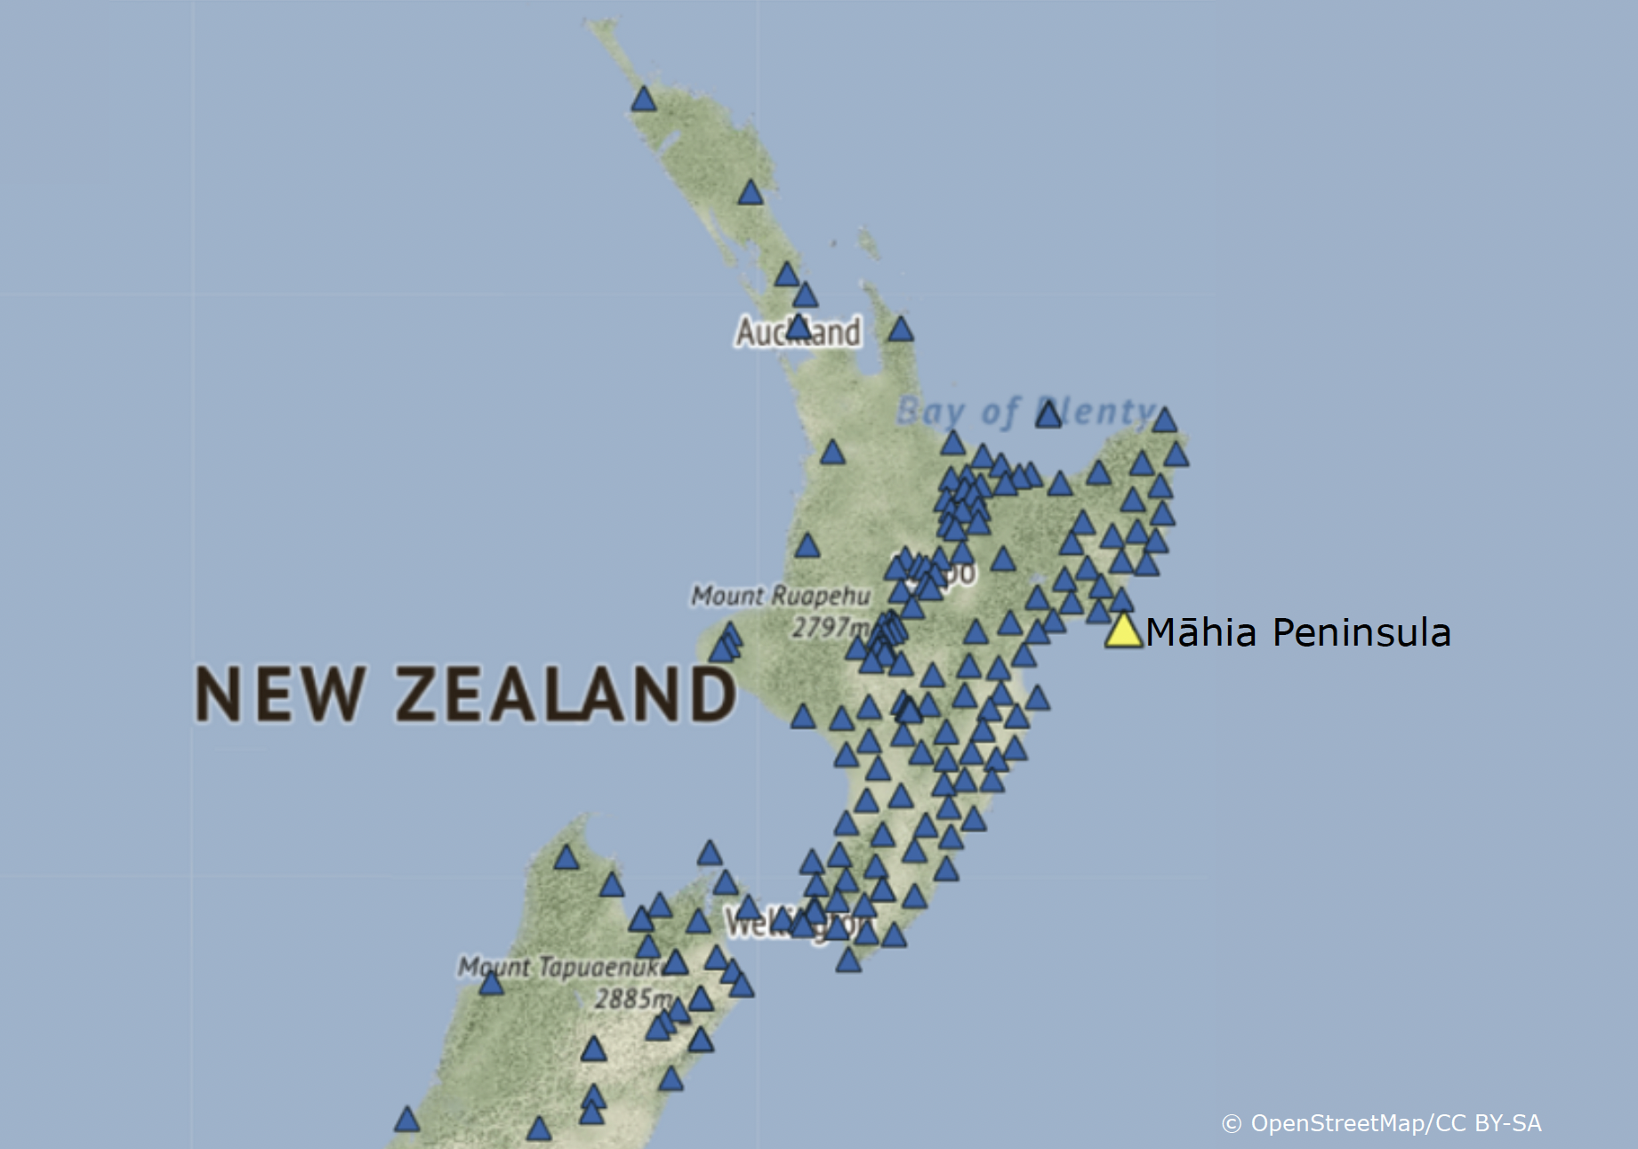

***Graphs showing land movements to the east, north and up and down***

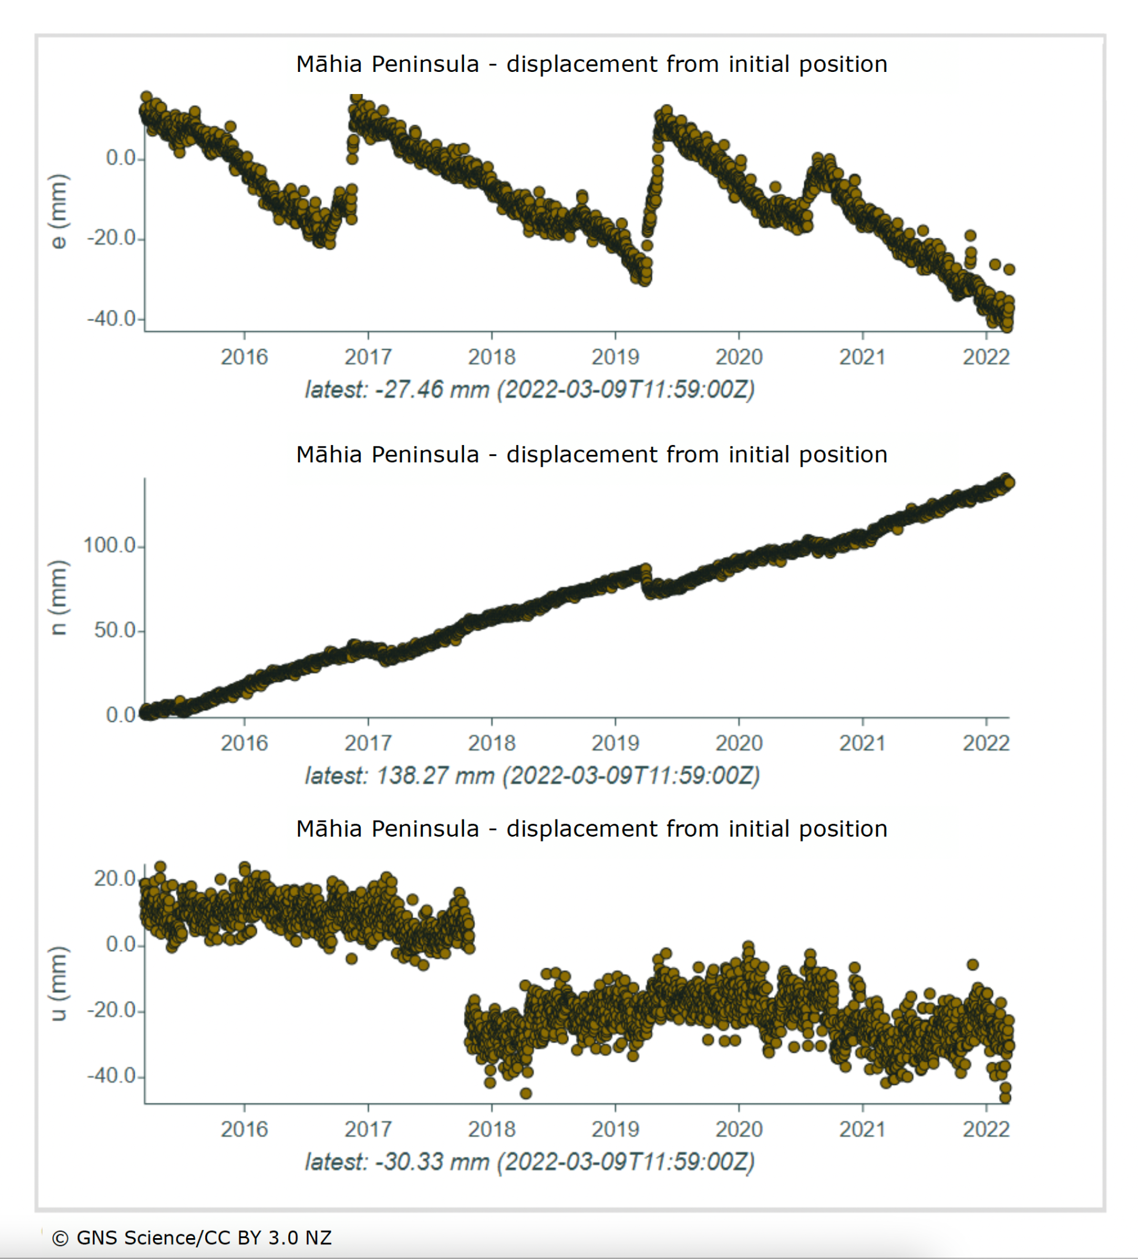

Graphs supplied by Geonet. © GNS Science. Released under [CC BY 3.0 NZ](https://creativecommons.org/licenses/by/3.0/nz/) licence. Please read the [disclaimer](https://www.geonet.org.nz/disclaimer) before any reuse.