He pūnaha whakarōpū

Me pēwhea tātou e whakarōpū i ngā rauropi koiora?

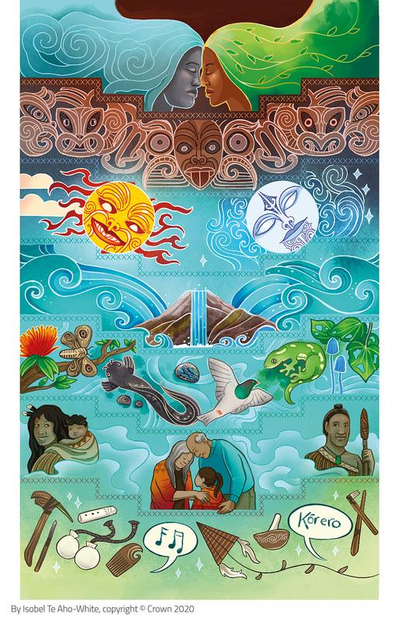
Whakapapa
Kua tīkina tēnei pikitia whakaari nā Isobel Te Aho-White, i tētahi ātikara Te Tapa Ingoa, nā Priscilla Wehi rāua ko Hēmi Whaanga, nō roto i te rauemi ipurangi, i Connected. He ātikara tērā e whakatewhatewha ana i tā te Māori nao atu i te whakapapa hei pou tarāwaho māna e whakatapa, e whakarōpū hoki i ngā tupu me ngā kararehe o tōna ao.

He pūnaha whakarōpū
Mātāmuatanga
Pori
Karangatanga
Pūtoi
Whānau
Puninga
Momo

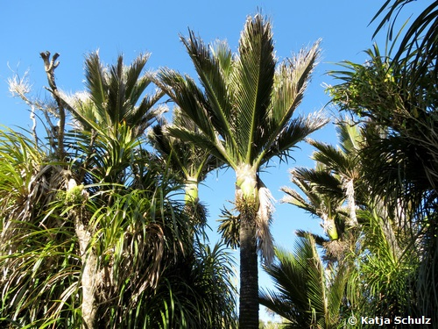
Ngā nīkau
Rhopalostylis sapida.
Image sourced from iNaturalistNZ. CC BY 4.0.

He pūnaha whakarōpū – te nīkau hei tauira:
Mātāmuatanga | Planta (ngā tupu)
Pori | Spermatophyta (he tupu whai kākano)
Karangatanga | Magnoliopsida (he tupu whaipua)
Pūtoi | Arecales (he momo ‘palm tree’)
Whānau | Palmae (he momo ‘palm tree’)
Puningana | Rhopalostylis (he karapu te āhua o te taihema uwha)
Momo | sapida (he reka ki te tangata – e pā ana ki te rito)

He maha ngā āhuatanga e hāngai ana ki te whakarōputanga o ngā rākau me ngā tupu.

Āe rānei e whai kākano ana te rākau, kāo rānei?
Āe – he rākau whai kākano.
Kāo – he rākau aruhe.
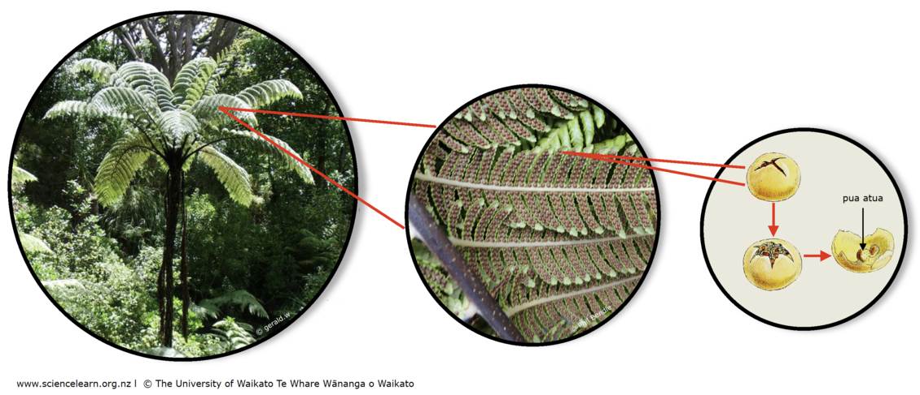
Ngā rākau aruhe – te mamaku hei tauira
Ko tā te rākau aruhe, he tuku i ngā pua atua hei taipūwhenua i nga wāhi e tawhiti atu ana i te rākau whaea, mā reira tipu matomato mai ai ngā tupu hou.

Image acknowledgements: Tree fern, gerald.w, CC BY 2.5; Sporangia, Phil Bendle, CC BY-SA 3.0.

Āe rānei e whaipua ana te rākau, kāo rānei?
Āe – he rākau whaipua.
Kāo – he rākau koroī.
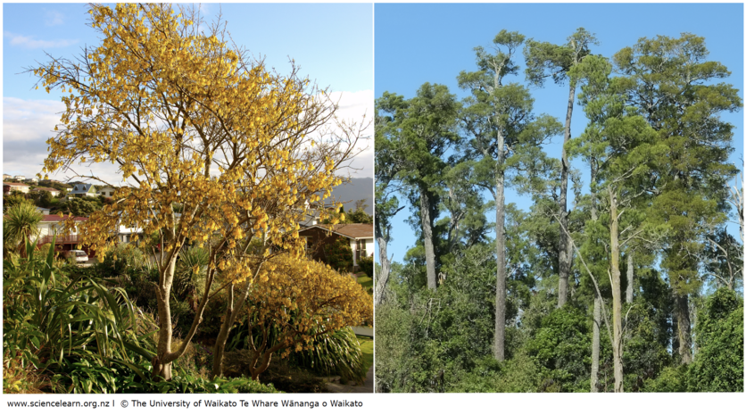Ngā rākau whaihua me ngā rākau koroī
He rākau whaipua te kōwhai, engari anō te kahikatea.
He maha ngā momo rākau whaipua kei roto i ngō tātou ngahere.
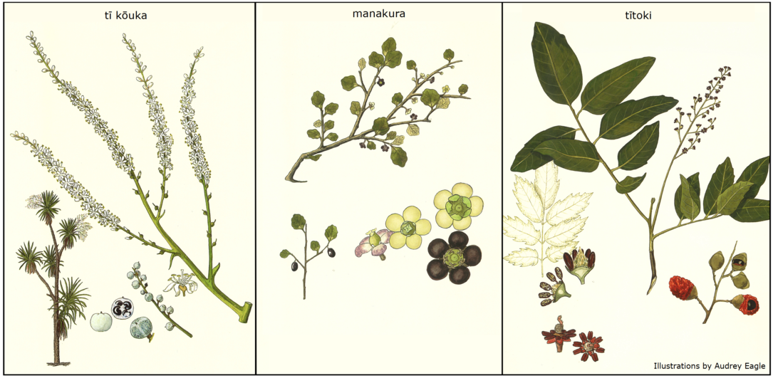Ko ngētehi rākau whaihua i Waharoa
Ka whakaahuatia ngētehi tauira ki runga ake: arā, ko te tī kouka (Cordyline australis), te manakura (Melicytus micranthus) me te tītoki (Alectryon excelsus).
Botanical illustrations from Eagle’s Complete Trees and Shrubs of New Zealand by Dr Audrey Eagle. Te Papa Press.

He āhuatanga anō e whakarōpu ai i ngā tupu
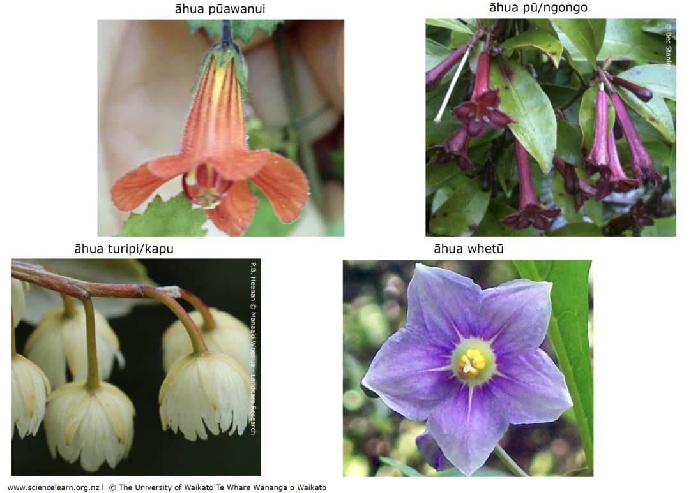
Te āhua o ngā pua
Kei tēnei whakaahua ka kitea he tauira o ngā āhua kē o ngētehi pua. Ka whakaahuatia ngētehi tauira ki runga ake: arā, ko te taurepo (Rhabdothamnus solandri), te toropapa (Alseuosmia macrophylla), te hīnau (Elaeocarpus dentatus) me te poroporo (Solanum aviculare).

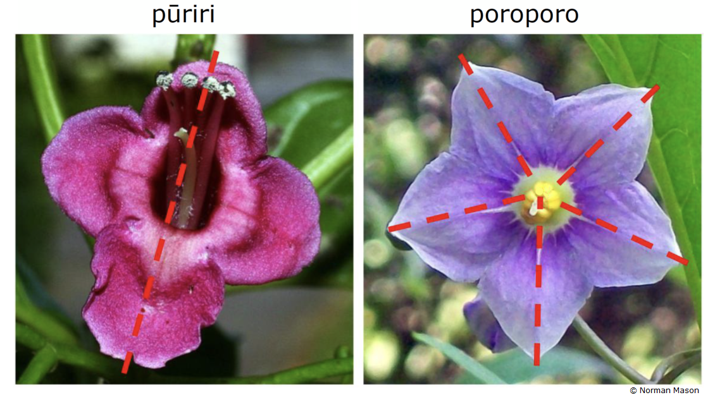Ngā rārangi hangarite o ngā pua kē
Kei tēnei whakaahua ka kitea ngētehi tauira o ngā rārangi hangarite o te pua o te pūriri (Vitex lucens) o te poroporo (Solanum aviculare) hoki.

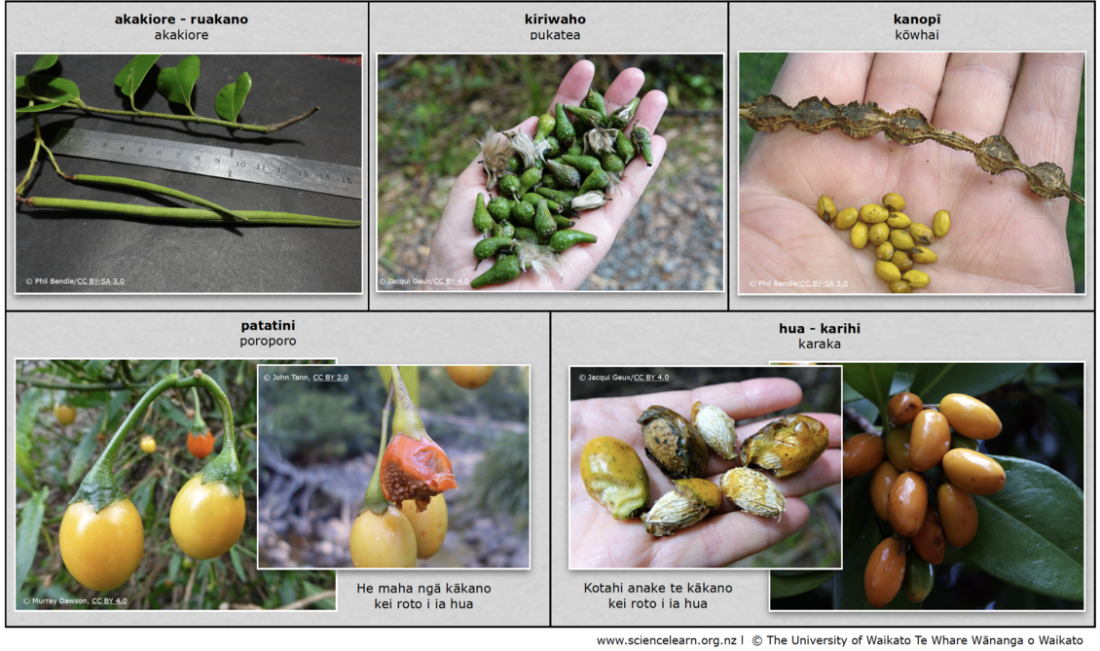Ngā āhuatanga o ngā hua
Ko ētahi hua, pērā i te kānga me te pī, he maroke; ko ētahi hua, pērā i te āporo me tōmato, he tuawhiti kē.

Image acknowledgements: Karaka nut and pukatea capsule, Jacqui Geux, CC BY 4.0, Poroporo fruit, Murray Dawson, CC BY 4.0. Both sourced from iNaturalistNZ. Poroporo seeds, John Tann, CC BY 2.0; Akakiore follicle and kōwhai, Phil Bendle, CC BY-SA 3.0.

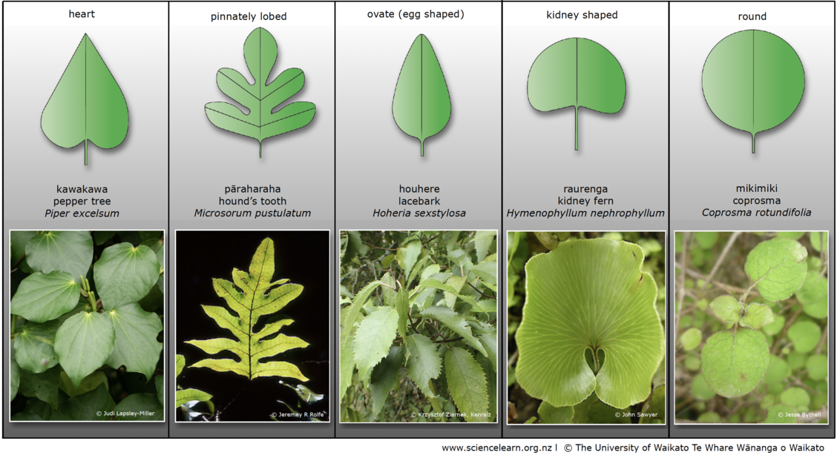Te āhua o ngā rau
He tini hoki ngā āhua kē o ngā momo rau. Kei tēnei tēpu ka kitea ngētehi tauira o te āhua kē o ngā rau o te kawakawa (Piper excelsum), te pāraharaha (Zealandia pustulata), te houhere (Hoheria populnea), te raurenga (Hymenophyllum nephrophyllum) me te coprosma (Coprosma rotundifolia).
Image acknowledgements: Kawakawa, Judi Lapsley-Miller, CC BY 4.0, Hound’s tooth, Jeremy R Rolfe, CC BY 4.0, Lacebark, Krzysztof Ziarnek, Kenraiz, CC BY-SA 4.0, Kidney fern, John Sawyer, CC BY-NC 4.0, Coprosma, Jesse Bythell, CC BY-NC 4.0.
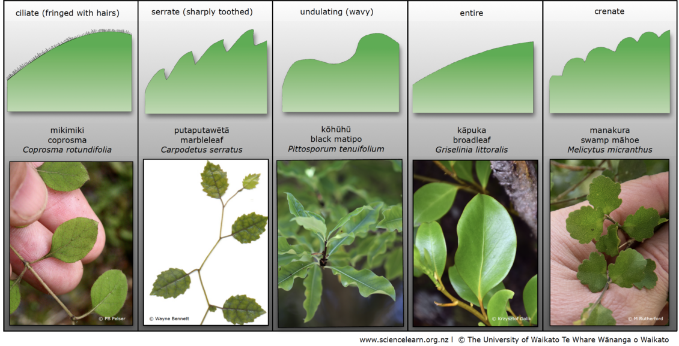Ngā tauira me ngā āhua kei te tapa o ngā rau
Kei tēnei tēpu ka kitea ngētehi tauira o ngā āhua kei te tapa o ngā rau o te coprosma (Coprosma rotundifolia), te putaputawētā (Carpodetus serratus), te kōhūhū (Pittosporum tenuifolium), te kāpuka (Griselinia littoralis) me te manakura (Melicytus micranthus).
Image acknowledgements: Coprosma, kawakawa and swamp māhoe, M Rutherford, CC BY 4.0, sourced from iNaturalistNZ; Broadleaf, Krzysztof Golik, CC BY-SA 4.0; Marbleleaf, Wayne Bennett, CC BY-NC 4.0; Coprosma, P.B. Pelser.

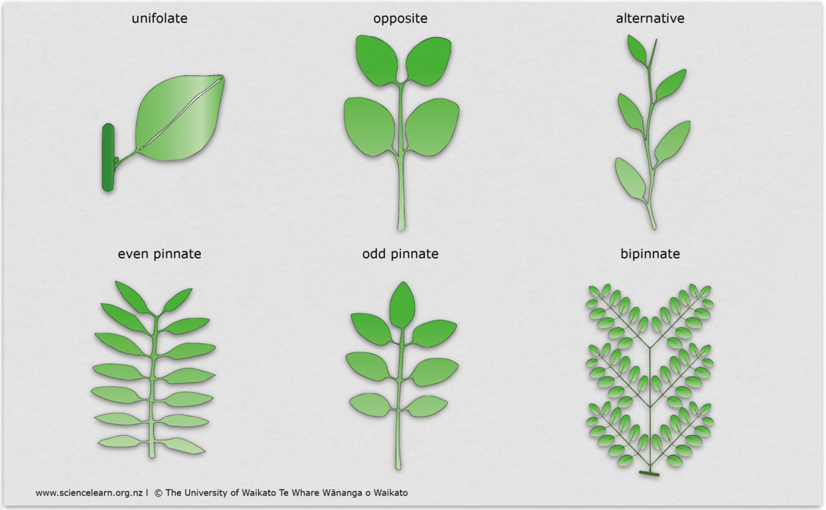
Te whakatakoto i ngā rau
Kei tēnei tēpu ka kitea ētahi tauira o ngā momo whakarārangi rau.
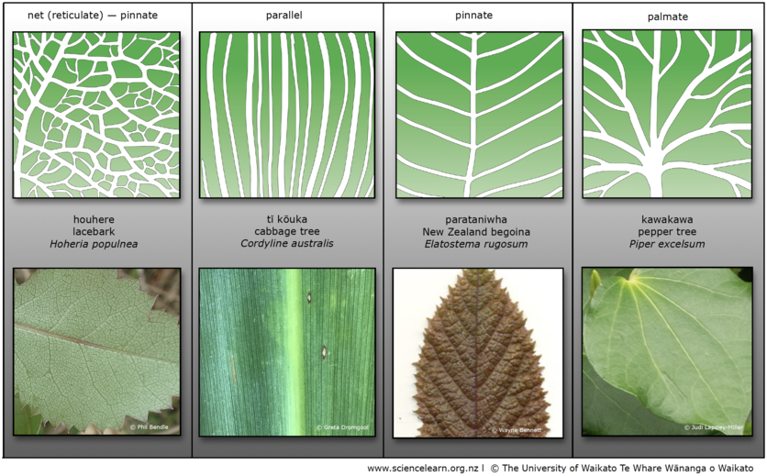
Te whakarārangi i ngā iarau
Kei tēnei tēpu e kitea ana ngētehi tauira o ngā iarau, pērā i tō te houhere (Hoheria populnea), te tī kōuka (Cordyline australis), te parataniwha (Elatostema rugosum) me te kawakawa (Piper excelsum).
Image acknowledgements: Lacebark, Phil Bendle, CC BY-SA 3.0, New Zealand begonia, Wayne Bennett CC BY-NC 4.0, Kawakawa, Judi Lapsley-Miller, CC BY 4.0
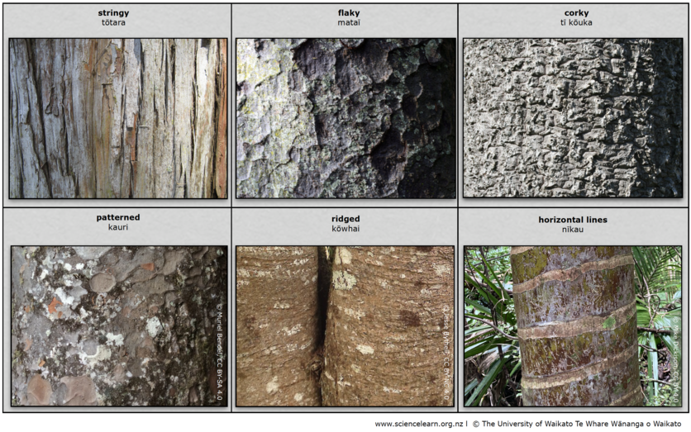
Te kakano o te kiri – tāpā, rauangi rānei
Kei tēnei tēpu ka kitea ētahi tauira o te kakano o te kiri o te tōtara (Podocarpus totara), te mataī (Prumnopitys taxifolia), te tī kōuka (Cordyline australis), te kauri (Agathis australis), te kōwhai (Sophora microphylla) me te nīkau (Rhopalostylis sapida).
Image acknowledgements: Nīkau, Mike Dickison, CC BY 4.0, Kōwhai, Jesse Bythell, CC BY-NC 4.0, Kauri, Muriel Bendel, CC BY-SA 4.0.
Ahakoa te maha o ngā āhuatanga kia āhei ai te tangata ki te tautuhi i ngā tupu me te tini o ngā momo rākau kei ō tātou ngahere, mā te whakawhanaungatanga tātou katoa ērā āhuatanga o te te tautuhi rākau e tohunga.
Ka mutu, ka taea rānei pea e tātou ētehi tikanga whakarōpu, ētahi tikanga tautuhi rākau hoki e pai ai ki a tātou, ki ngō tātou hoa, ā, ki ngō tatou whānau anō hoki.

He kōrero kōpūtahi
- Ngā rākau
- He aha hoki tērā rākau?
- Te haenga me te ruinga o te kākano
- Ngā kākano
- Ngā rau o te rākau
Mō te tūpono he ngākau whakapuke koe ki ēnei kaupapa:
Activities
- Native plant leaves – DIY classification system
- DIY fern classification
Videos:
- Whakapapa and biodiversity – similarities between biodiversity and whakapapa from a Māori perspective.
- Plants and whakapapa – eco-sourcing from a Māori perspective.
- Ruru, restoration and whakapapa – why we need to consider the function of exotic trees during repo restoration.

Ngā hono
- Flora Finder – Department of Botany, University of Otago, Te Tari Huaota te Whare Wānanga o Otāgo
- Experiencing native trees in your green space – Department of Conservation Te Papa Atawhai
He whakamihi
Tēnei te mihi nui ki a Mokoro Gillett (Tumuaki o Te Wharekura o Te Rau Aroha) rāua ko Norman Mason (Manaaki Whenua – Landcare Research).

