ACTIVITY: Labelling a cockle/tuangi

Activity idea

In this activity, students use online and/or paper resources to identify and label parts of a cockle/tuangi.

By the end of this activity, students should be able to:
- identify and label some of the structures of a cockle/tuangi
- consider the function of these structures
- discuss how these functions help the cockle/tuangi survive
- use literacy skills to learn about and discuss the functions of the structures.

For teachers

Introduction/background

The New Zealand cockle, also known as tuaki or tuangi, is endemic to Aotearoa New Zealand’s coastal areas. They are filter feeders and are well adapted to their preferred habitat of soft mud and fine sand in subtidal areas – living just a few centimetres under the sediment surface. The shellfish perform key ecosystem services and are a source of mahinga kai.

Structural adaptations

Cockles are useful for exploring the concept of structural adaptation. They have specific structures that allow them to feed and stay safe within a dynamic marine environment.

Following are some examples of their structural adaptations.

External anatomy:
- Cockles have a sturdy shell that is made of several layers and protects the soft inner parts from predation and/or damage from wave action.
- The shell is watertight and able to hold a reservoir of water to sustain the cockle if it is dislodged or exposed during low tide.

Internal anatomy:
- Cockles have special structures including an inhalant siphon and gills that allow them to take in seawater and filter plant material and microscopic animals for food. Gills have a dual purpose: they obtain oxygen for respiration and direct food into the mouth.
- Cockles are able to select food filtered from the water. Indigestible food passed to the mouth is rejected by the palps and discarded as pseudofaeces.
- The foot is a muscular organ used to burrow into the sediment and anchor the shellfish. Cockles use this foot to move and even ‘jump’ by bending and straightening it.
- The exhalant siphon expels seawater after it has been filtered for food and oxygen.

What to do

- Use the articles Cockles and Adapting to marine habitats for background information on cockles, their habitat, roles within the ecosystem and adaptations for life in a tidal environment. Other helpful resources include tuangi (cockles) from NIWA’s Taonga Species Series and the FAO’s taxonomy and anatomy information on bivalves.

- Discuss what life is like in a tidal environment. What adaptations enable cockle/tuangi to live there?

- Discuss the structures of these adaptations and how they help the cockles to function.

- Complete the interactive Label the cockle/tuangi or use the paper-based version in the student handout.

Extension ideas

Tuaki/tuangi are an important food source for many people. Explore food and resource-gathering traditions practised by Ngāi Tahu whānau in Te Waipounamu – this is part of the interactive Mahinga kai – natural resources that sustain life.

Mussels are also filter-feeders. Compare the habitats and adaptations of mussels and cockles.

Label the cockle/tuangi – answers

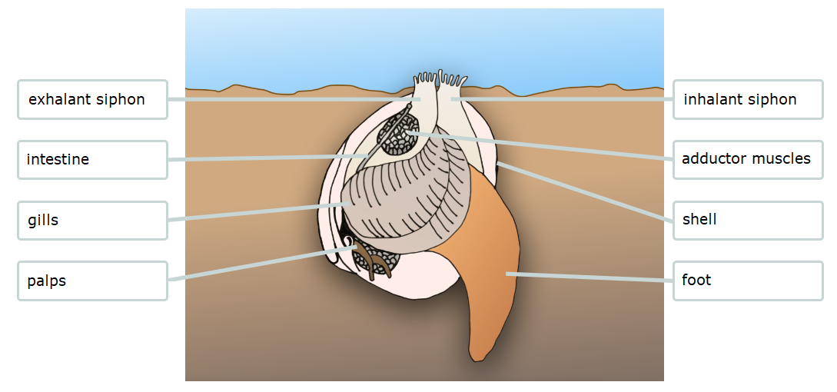

For students
Label the cockle/tuangi

Use labels to identify the parts of the cockle/tuangi.

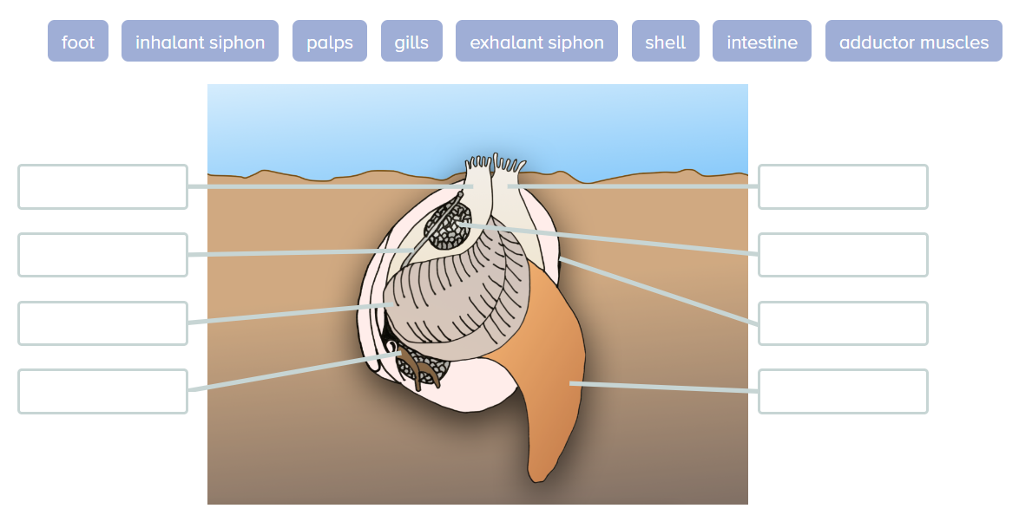

Labels | Description
adductor muscles | Muscles that close the valves of the shell when they contract.
exhalant siphon | Expels seawater and inedible matter from the body.
foot | Muscular organ used for movement and for burrowing into the sediment.
gills | Filters seawater for oxygen and to capture food.
inhalant siphon | Draws seawater into the body.
intestine | Tightly curled structure connecting the stomach with the rectum.
palps | Directs large particles, which are not ingested, into the exhalant water stream.
shell | A hard layer made mostly of calcium carbonate that protects the soft body.

