ACTIVITY: Finding out what’s in our lake using eDNA

Activity idea

In this activity, students use a magnetic fishing rod to collect information about the presence and population size of organisms living in their lake ecosystem. They use reference images to interpret and match the eDNA sequences and create a data collection chart of what’s living in the lake and the land around it and how abundant they are. Note: The activity uses simulated DNA sequences for each species.

By the end of this activity, students should be able to:
- begin to recognise that all living things have a unique DNA barcode
- begin to recognise that scientists can use these barcodes to identify what is living in a particular location
- make inferences about why the DNA of non-aquatic species like cows or pine trees might be in a lake
- make inferences about the condition of the lake as an ecosystem (its health)
- discuss some of the advantages and disadvantages of using eDNA for ecosystem monitoring.

For teachers

Introduction/background

All living things shed genetic material into their local environment. This is known as environmental DNA (eDNA) and it is found in materials like hair, scales, skin and even faeces (poo). Scientists are able to use this shed DNA to find out what lives in an ecosystem. Read more about eDNA in the article Environmental DNA.

This energetic activity simulates scientists fishing for (collecting) eDNA sequences from a lake system. Like most simulations, it’s important to identify how the simulation reflects and/or compares to the actual work involved in collecting and analysing eDNA.

Catchment land-use and its effects on water quality

Environmental DNA is a tool that helps scientists monitor species, habitats and ecosystems. Mātauranga Māori and monitoring records often provide a baseline of a particular lake ecosystem. Using eDNA enables us to note changes to the ecosystem due to changes within the catchment. The articles Water quality and Water catchments have useful background information on these concepts. Changes are not always negative. Improvements in the number of keystone species like tuna (eel) or kōura (freshwater crayfish) may be indicators that riparian planting or the removal of pest species is having the desired effect!

Species featured in this activity

Although water samples may contain eDNA from thousands of different species, this activity uses just seven: cyanobacteria, tuna, kākahi (freshwater mussels), kōura, brown trout, pine trees and cows. The abundance of these species is often linked with lake health and water quality – for example:
- the presence of eDNA from tuna, kākahi and kōura is often an indicator of good water quality and healthy lakes.
- the presence of eDNA from cows is often an indicator of nutrient run-off, which in turn can lead to cyanobacteria blooms
- the presence of eDNA from pine trees can become an issue when the trees are clear-felled and sediment is washed into the lake and clouds the water
- cyanobacteria blooms and cloudy water are in turn indicators of reduced water quality and are likely to impact on the number of kākahi and kōura in the lake.

The simulated DNA sequences for native organisms feature a green background. The simulated sequences for introduced organisms feature an orange background.

Helpful hints

The game components are in two PDF files. For best results, print the eDNA sequences and species cards PDF file and the species tokens and data collection chart PDF file as A3 (297mm X 420mm or 11.7” × 16.5”).

Each scenario uses 25 eDNA sequence strips. If your student numbers are larger than this, consider adding a few more strips to the most dominant species in the scenario or dividing the class into two teams.

As this activity involves water, laminating all of the game components is recommended. If the eDNA sequence strips are being submerged into a water-filled aquarium, they will need to be laminated.

What you need

- Scenario cards
- Images of a local lake – for example, satellite view of Google Maps
- Access to the video eDNA explorers – discovering life in the lakes of Aotearoa
- Access to YouTube videos: Illumina’s What is Environmental DNA (eDNA)? and/or World Wildlife Fund’s Environmental DNA
- Plastic container – for example, a 27 L storage container
- Water
- Sand and stones
- Paper clips
- Fishing rod – a stick with string and a magnet attached to the end
- eDNA sequences and species cards – laminating is recommended
- Species tokens and data collection chart – laminated if possible
- Container to hold the species tokens
- Blu-Tack
- Towel for emergencies

What to do

- Prior to the activity, cut the eDNA sequences into individual strips and laminate them so that they are completely enclosed in plastic. Attach a paper clip to each strip with a bit of Blu-Tack (which will help the sequence sink to the bottom). Test the magnet on the fishing rod to make sure it is strong enough to pick up the individual strips.

- Laminate and cut the species tokens to create individual pieces.

- Choose a scenario that you would like to explore. Each scenario comes with questions to explore/interpret the data the students collect and help them determine the condition of the lake ecosystem.

- Begin the activity by looking at images of the local lake. Discuss what might live in the lake and what might live in the surrounding catchment area.

- Discuss who might know this information and how they would obtain it.

- Watch the video eDNA explorers – discovering life in the lakes of Aotearoa. It provides a simple explanation of why scientists use eDNA to find out what might be living in or around a lake. Key points to discuss:
- Why does Wiremu think that kōura are in the lake?
- Why might it be difficult for Wiremu to find kōura?
- How does eDNA help people learn about the presence of living things?

- Watch the video(s) Environmental DNA and/or What is Environmental DNA (eDNA)? Key points to discuss:
- What is DNA? (DNA is in the cell of every living thing. It is the genetic information that acts like the blueprints for an organism.)
- What is eDNA? (DNA collected from the environment. It is the DNA shed by the organisms living in this environment.)
- What things in a lake or other habitat have DNA? (All living organisms have DNA.)
- How does the use of eDNA differ from conventional monitoring methods?
- How do DNA codes/sequences differ between species? (There are four different bases in DNA: Adenine, Thymine, Guanine, and Cytosine. These four chemicals (ATGC) are repeated in different orders again and again in each strand of DNA. The order in which these bases are arranged forms a unique genetic code.)

- Set up the activity in a space where there is room to run and where it is OK to have water splashes – for example, the school’s sports field or quad. Place the species cards, tokens and data collection chart at one end and the lake system at the other end.

- Fill the container with water. Add sand and rocks to the bottom of the container to create a lake floor. The sand helps make the water murky, making it more challenging to fish out the eDNA sequence strips.

- Using information from the scenario you’ve chosen to explore, add the intended number of laminated eDNA sequence strips to the container of water. Lay the rod in front of the container.

- Discuss how you will know when sampling is complete.

- Take turns running to the lake and using the rod to fish out an eDNA sequence strip.

- Run back and match the strip to the relevant species card. Lay the strip underneath the species card for peer review at the end.

- Choose the matching species token and use a small amount of Blu-Tack to secure the token to the data collection chart.

- Once all of the samples have been collected, conduct peer review to ensure the eDNA sequences are correct for each species. Match the number of sequence cards with the number of species tokens on the data collection chart.

- Review the data collection table. Use the questions on each scenario card to elicit information about the evidence and what it tells you about the condition of the lake.

Alternative conceptions

The article Alternative conceptions about genetics lists some of the common misconceptions students may hold about DNA and genetics.

Scenario cards

The following scenarios indicate the number of eDNA sequence strips required and include questions to deepen understanding.
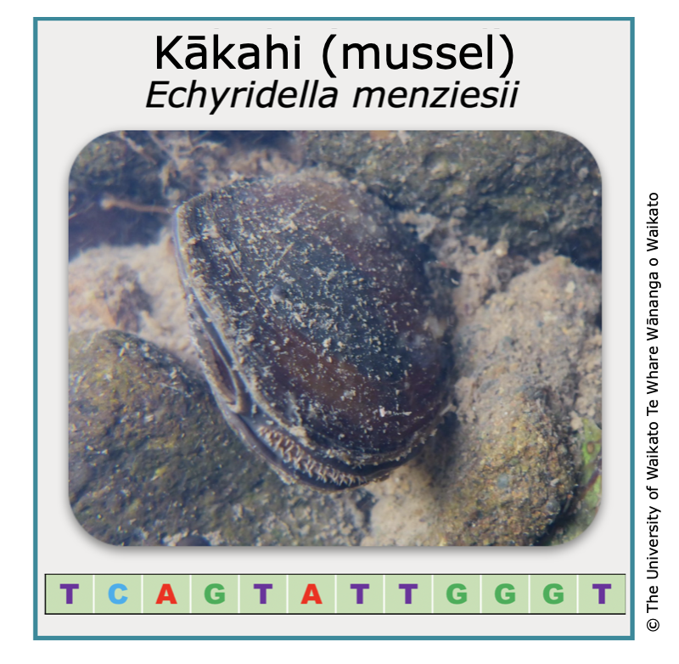
Scenario 1: Healthy lake conditions

The scenario simulates a healthy lake. eDNA shows that there are lots of tuna, kākahi and kōura living in the lake and very little cyanobacteria. Evidence also shows that there are not many cows in the catchment area.

Agriculture can lead to nutrient run-off into a lake, which causes cyanobacterial blooms and impacts native aquatic wildlife like tuna, kākahi and kōura. In addition, there are no pine plantations. Clear-felling can wash sediments into the lake and cloud the water, which also impacts native aquatic wildlife.

Species | Number of eDNA sequence strips
cyanobacteria | 2
tuna | 4
kākahi | 6
kōura | 9
trout | 2
pine | 1
cow | 1

Questions to deepen understanding

- What species did you find?
- Are there any surprises about what you found and what you did not find?
- Why might we find pine tree or cow eDNA in the lake? How did it get there?
- Which species are the most abundant?
- Which species are the least abundant?
- Can you draw any conclusions about what condition the lake is in?
- What evidence do you have to support your conclusions?
- How might the activity in the lake catchment support the condition of the lake?
- Are there steps we can take to maintain the health of this lake system?
- This activity is a simulation of eDNA sampling. What are some similarities between the way eDNA is actually collected and our simulation? What are some differences?
- In what ways were we working like scientists to collect and record data?

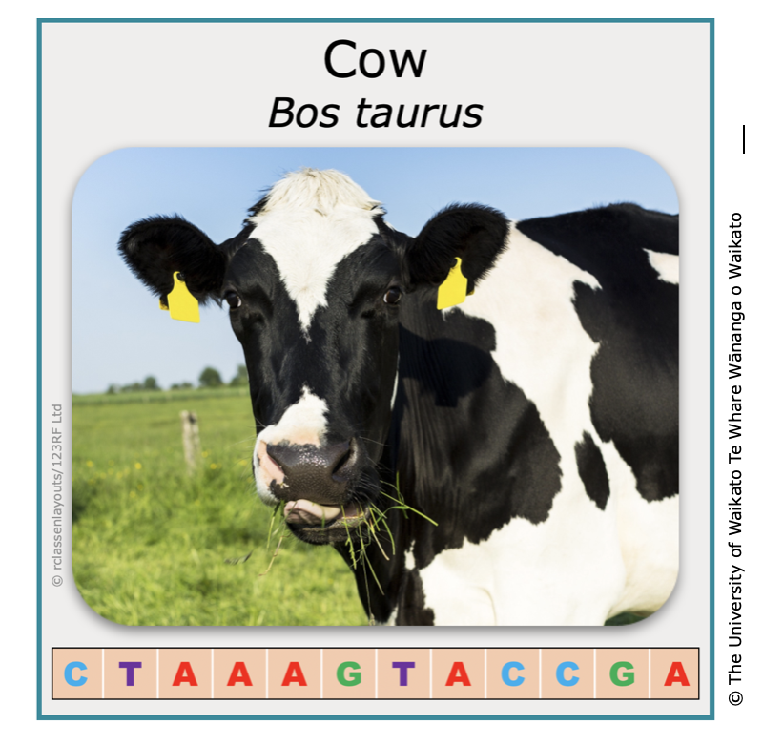
Scenario 2: Unhealthy lake conditions

The scenario simulates an unhealthy lake. eDNA shows that there are very few native aquatic animals living in the lake but there is an abundance of cyanobacteria. Evidence also shows that there are a lot of cows in the catchment area.

Agriculture can lead to nutrient run-off into a lake, which causes cyanobacterial blooms and impacts native aquatic wildlife like tuna, kākahi and kōura.

Riparian planting can help to intercept nutrients before they reach the lake.

Species | Number of eDNA sequence strips
cyanobacteria | 12
tuna | 2
kākahi | 0
kōura | 0
trout | 1
pine | 3
cow | 7

Questions to deepen understanding

- What species did you find?
- Are there any surprises about what you found and what you did not find?
- Why might we find pine tree or cow eDNA in the lake? How did it get there?
- Can you draw any conclusions about what condition the lake is in?
- What evidence do you have to support your conclusions?
- How might the activity in the lake catchment impact the condition of the lake?
- Are there steps we can take to help make this a healthier lake system?
- This activity is a simulation of eDNA sampling. What are some similarities between the way eDNA is actually collected and our simulation? What are some differences?
- In what ways were we working like scientists to collect and record data?
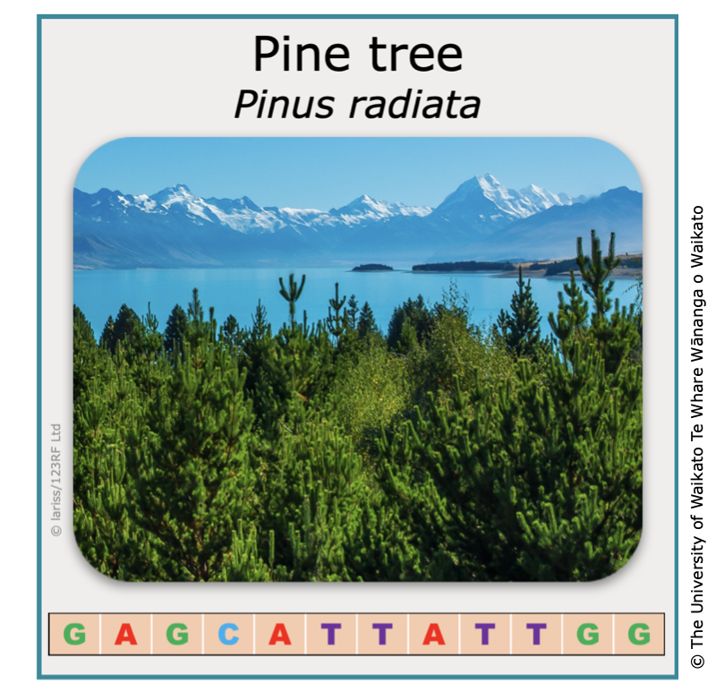
Scenario 3: Effects from plantation pine forests

The scenario simulates the effects that the clear-felling of pine forests can have on a lake ecosystem. eDNA shows that there are a few tuna and trout living in the lake but very few kōura and no kākahi. There is a small amount of cyanobacteria and an abundance of pine DNA. Evidence shows that there are lots of pine trees in the local catchment area.

The clear-felling of trees during harvest can cause lots of sediments to be washed into the lake. Sediments make the lake water cloudy, which can negatively impact native aquatic wildlife – especially kākahi and kōura.

The condition of this lake is somewhat healthy. Riparian planting can help to intercept sediments before they reach the lake.

Species | Number of eDNA sequence strips
cyanobacteria | 2
tuna | 3
kākahi | 0
kōura | 1
trout | 3
pine | 13
cow | 3

Questions to deepen understanding

- What species did you find?
- Are there any surprises about what you found and what you did not find?
- Why might we find pine tree or cow eDNA in the lake? How did it get there?
- Can you draw any conclusions about what condition the lake is in?
- What evidence do you have to support your conclusions?
- How might the activity in the lake catchment impact the condition of the lake?
- Are there steps we can take to help make this a healthier lake system?
- This activity is a simulation of eDNA sampling. What are some similarities between the way eDNA is actually collected and our simulation? What are some differences?
- In what ways were we working like scientists to collect and record data?

