ACTIVITY: Using Magma Drillers Save Planet Earth

Activity idea

In this activity, students work as specialist scientists and engineers to complete two missions as geothermal drilling teams.

By the end of this activity, students should be able to:
- explain some of the science concepts associated with the various challenges of drilling for energy close to volcanoes
- discuss aspects of the geophysics, volcanology, engineering and/or environmental challenges of drilling for energy close to volcanoes
- make use of videos and information booklets to inform their actions as specialist scientists
- work together as a team of scientists to make decisions based on scientific data
- gain insights about the roles scientists play when exploring and finding sustainable energy solutions.

For teachers

Introduction/background

Magma Drillers Save Planet Earth is an activity that uses a team approach to finding environmentally friendly sources of geothermal energy. Ākonga take on the roles of scientists and engineers to learn specialist knowledge and then work collaboratively within teams to complete two missions. The science behind the game is loosely based on the research being done in Krafla, Iceland, and the real-life proposal from scientists to drill into a magma chamber. The goal of the game is to engage students in science and engineering and present ideas about different careers that science and engineering can offer in a light-hearted manner.

The game consists of two missions. The first mission is set in the 1970s and involves selecting an appropriate location to drill for geothermal energy. This mission helps students build knowledge. When they begin their drilling mission, immediate feedback is provided regarding their decisions and choices. The second mission is set in the future and involves choosing a location to drill into a magma chamber and to set up a Magmathermal Environmental Research Centre. Student success is evaluated based on three key criteria of:
- successfully drilling in the right location
- managing risks and hazards
- cost-effectiveness.

Activity resources

Student resources for the game are curated in the interactive Magma Drillers Save Planet Earth – resources. The student resources are grouped under each of the four roles. The teacher resources include Word documents for classroom use and links to online resources that provide background information for educators choosing to take a more in-depth look at geothermal energy. The videos in the interactive resource curation are on YouTube. Non-YouTube links can be found on this University of Canterbury page.

Additional teacher resources

There are additional teacher resources in this document:
- Answers to the questions in Mission 1 – Drilling for geothermal energy PDF/booklet
- Answers to the questions in Mission 2 – Energy from magma PDF/booklet
- Annotated drilling location map: Mission 1 – Drilling for geothermal energy
- Annotated drilling location map: Mission 2 – Energy from magma
- Questions to deepen student understanding

Teaching suggestions

There are multiple ways to use Magma Drillers Save Planet Earth. As a stand-alone activity, the missions can be completed over two teaching periods. It can also form part of a larger study. The resources include a vocabulary activity to familiarise students with content vocabulary used in the game and a key terms activity with context sentences from the LEARNZ Natural Hazards: lessons from Iceland field trip. The article Magma Drillers Save Planet Earth provides pedagogical information, including nature of science and ao Māori perspectives. The activity may also be useful when working with NCEA Science 1.1 Te pūngao puia.

What to do

Prior to the activity

Watch the game introduction for educators to gain an overview of the game and organise the relevant student resources:
- Vocabulary and key terms activities, role-play name tags and mission booklets.
- Devices for each group to watch videos and access online content.

Mission 1 – Drilling for geothermal energy

- Play the introduction videos:
- Part 1
- Part 2

- Briefly outline the four science and engineering roles.

- Show the Geothermal Driller Save Planet Earth drilling location game map on a central screen. An annotated drilling location map is found here with helpful information about the map features, drilling information and expert responsibilities.
- Explain that this is their end goal – where the experts will bring their knowledge to choose a drilling location to extract renewable energy from the ground.
- Discuss the map options.
- Discuss the information in the legend.
- Alert students to the terminology used in the different sections.

- Read Mission 1: Renewable energy (pages 7–8 in the Geothermal Drillers Save Planet Earth booklets) to set the scene.

- Split the students into four groups: drilling engineers, geophysicists, volcanologists and environmental risk managers.

- Hand out name tags to encourage students to engage in role-play (optional). Encourage groups to come up with a funny group name.

- Write group names on a whiteboard and explain you will be recording each group’s scores. to encourage enthusiastic competition. Create a table with columns for all groups’ first and second attempt scores at geothermal drilling and for magma thermal drilling.

- Provide online or hard copies of the Mission 1 – Drilling for geothermal energy booklets.

- Ask students to read the code of conduct and sign their names.

- Ask students to watch the video relevant to their roles and answer questions in the booklet.

- Regroup students into teams of four with an expert from each field. Provide time for each expert to share their knowledge with their team.

- Ask each group to open the map/location where they will plan their drilling operation. Point out that they can overlay the volcanic information (by clicking icons in the corner of the map) from the volcanologist booklet and the geophysics information onto the map. They can zoom in and out.

- Once the team selects all of their options, they click the submit button to see if they have successfully chosen an appropriate location to drill.

- The game will identify how successful the drilling is. If the attempt is unsuccessful, feedback is provided.

- Students have two attempts at drilling. Supervise the first attempt and record the score on whiteboard. Provide prompts for reflection on the choices of factors that were made in the first attempt – for example, drilling depth. A model answer is shown below – students should aim for scores above 8000.

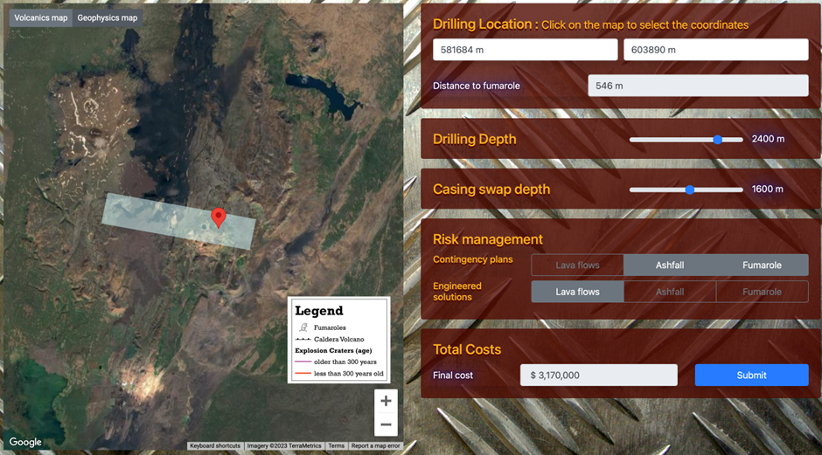
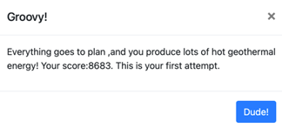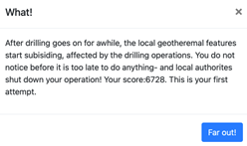

- Encourage sharing between groups to improve student scores for the second attempt. Note that multiple attempts on the same computer will automatically lower the score. If you clear the browsing history, the game will assume it’s the first attempt, the score will reset and it is possible to achieve higher scores.

Improving score based on feedback
Feedback | Reason/solution
Blowout occurs. | The drill hole is too deep or the casing depth is not correct. Minimum drill depth is 2,200 m and the maximum is 2,400 m. Casing depth can range from 800–1,200 m difference from drill depth.
Fumarole stops steaming and features collapse. | Drilling too close to a fumarole, needs to be at least 500 m away.
Hole didn’t produce enough heat. | Increase drill depth.
Hole collapses on itself after casing the hole, engineers reckon shallow clays. | Casing needs to be deeper.
Gotta drill baby! | Need to insert drill.

Mission 2 – Energy from magma

- Play the Introduction to the future – 2030s video.

- Read Mission 2: Energy from magma (pages 3–4 in the Magma Drillers Save Planet Earth booklets) to set the scene.

- Group students into four large groups: drilling engineers, geophysicists, volcanologists and environmental risk managers.

- Ask students to watch the video relevant to their roles and answer questions in the booklet.

- Regroup students into their previous teams of four. Provide time for each expert to share their knowledge with their team. Remind them to think about what they learned from their previous mission and to use prior and new knowledge to complete their present mission.

- Open the drilling location map for Mission 2 and select the options to choose a drilling site.

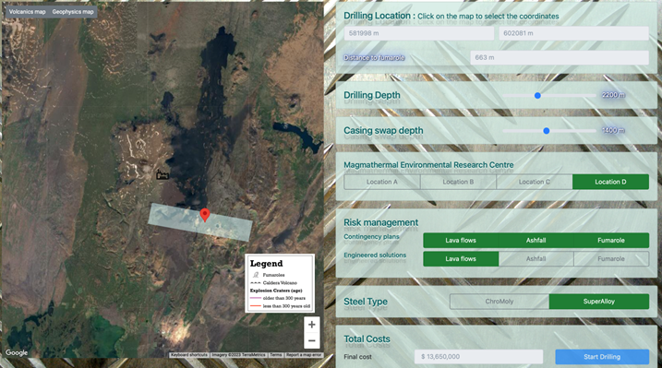

- Click on the start drilling button to see if they have successfully chosen an appropriate location to drill. (An annotated drilling location map is found here.)

- A video and message will pop up to indicate success or not. Teams making an unsuccessful attempt will see a video that shows the magma body and the depth it should have been drilled. Below are the possible outcomes and the reasons for the outcome: For example – too deep for rhyolite therefore explosive, hit basaltic magma, missed magma.

Improving score based on feedback
Feedback | Reason | Solution
Down it goes! | Did not drill deep enough. | Need to drill deeper.
Here we go! | Explosion due to drilling too deep. | Drill shallower.
Hang tight! | Successful drill! | 2,200–2,400 m drill depth.  1,400–1,600 m casing depth.  Want to aim for previous drill sites.

Answers to the questions in Mission 1 – Drilling for geothermal energy PDF/booklet

Drilling engineer

- C. Clay with hot acidic fluids.
- (Top to bottom) cement, solid steel casing, steel casing with holes.
- The clays can collapse into the well and on top of the drill bit. This can get the drill bit stuck and unable to get it out of the well.
- Rock type, temperature, where clay is, where the rock is, pressures.

Geophysicist

- A. Material that conducts electricity.
- (Top to bottom) clay, acid boiling fluids, hot neutral fluids, heat source.
- As geothermal waters rise, they start to boil at a certain depth and become more acidic. causing rocks and minerals around the water to break down into clays. Mark blue areas.
- Image below shows lines where drill lines could go. You want to drill where there are high clay blobs, as this indicates geothermal fluids are present.
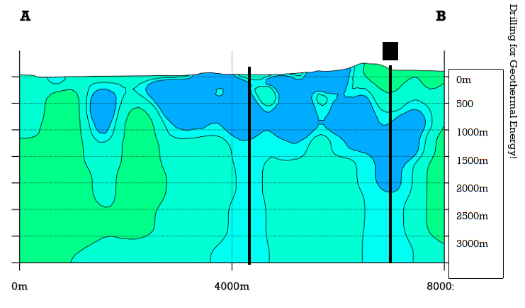

Volcanologist

- Fumaroles, recent explosive craters, old explosive craters, lava flow.
- (Top to bottom) borehole, cracks, hot volcanic water, magma.
- Circles around fumaroles and < 300-year-old craters.
- Near a fumarole.
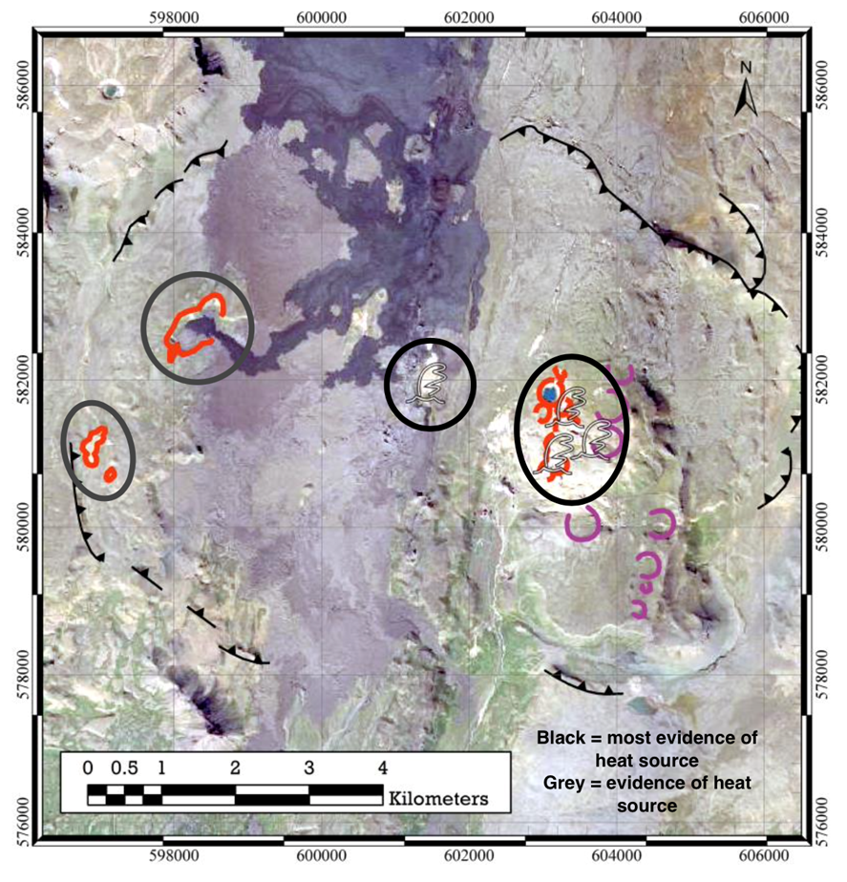

Environmental risk manager

- Measure are structures such as walls, bunds and channels to divert lava flow. With the measures in place, the lava flow should not affect the drill site and the consequences will be marginal.
- Likely.
- Risk assessment:
Hazard | Probability | Consequence | Risk level
Ashfall | Rare | Catastrophic | High
Lava flows (with lava diversion) | Likely | Marginal | High
Fumarole (0–500 m) | Likely | Catastrophic | Extreme
Fumarole (above 500 m) | Rare | Marginal | Low
- If the drill hole is within 500 m, need to have a fumarole contingency plan but would ideally relocate the drill site so it is at least 500 m away from the fumarole. If the drill hole is more than 500 m, need a contingency plan for fumaroles.
- Risk reduction:
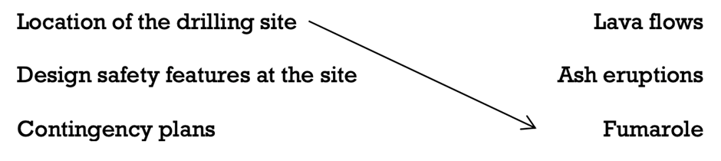
Can use the same method for mitigating risks for multiple hazards.

Answers to the questions in Mission 2 – Energy from magma PDF/booklet

Drilling engineer

- 900°C (rhyolite) – 1300°C (basalt).
- Chromoly steel = 800–900°C, superalloy steel = 1200°C. Superalloy steel could potentially deliver more energy.
- Superalloy steel as it can withstand hotter temperatures.
- You want to target around 900°C to hit rhyolitic magma. Current technology allows steel to resist temperatures up to 770°C. Research into stronger steel alloys needs to be developed or water pumped down the drill hole to cool magma.
- Want to build the research centre close enough to the drill hole but not in the caldera. What temperatures and depths have teams attempted when drilling into magma in the past? (This information is not provided in the video – could be prompted by the teacher).

Geophysicist

- Cracking rocks = earthquake activity, magma = S-wave shadow, acid clay = resistivity.
- Where S-wave shadows are.
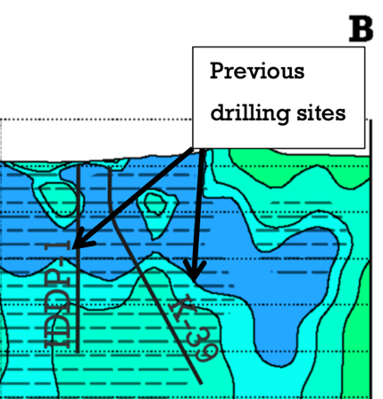
- Previous drilling would have been done there as there is an S-wave shadow below. Magma blocks S-waves, therefore where there is a shadow there could be magma. The IDDP-1 did not expect to find magma at this location based on geophysics. The explanation for this is because S-wave shadows are rough techniques and can miss small bodies of magma.
- Geophysics suggests that there is a large amount of magma associated with the S-wave shadow. It might be unwise to drill into large bodies of magma – better to drill where the previous drill holes have encountered magma without cataphoretic consequences.
- Knowing the geology – rhyolitic magmas are more explosive and basaltic are more effusive, type of steel used as it will melt in higher temperatures, learning more about the geophysical signals when magma was drilled previously.

Volcanologist

- Basaltic – hotter – less, rhyolite – cooler – more
- Drawings of dyke, sill and blob:
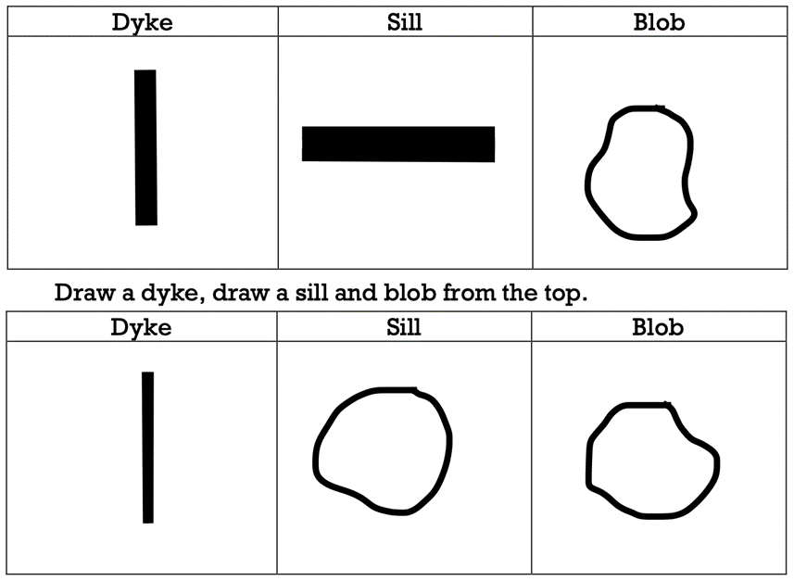
- Basalt and rhyolite magma bodies under Krafla:
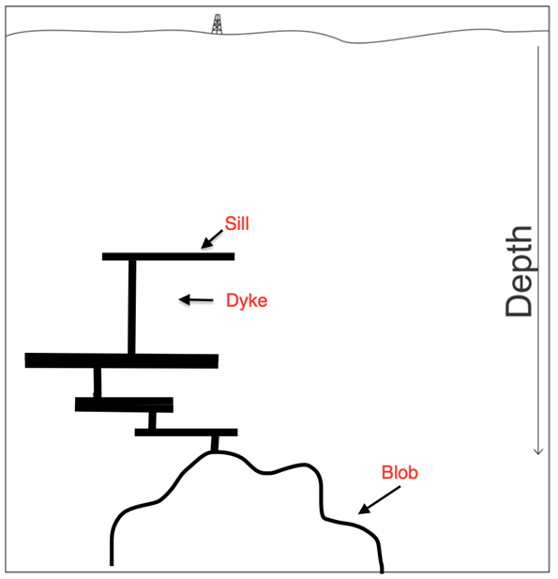
- How magma is stored – hard to know but fieldwork suggests magma is stored in dykes and sills close to the surface and in larger blobs deeper down. Gathering geological information from previous drilling projects that have encountered magma.

Environmental risk manager

- A. Basalt (if you drill into deeper, hotter, gassy rhyolite it is also likely to erupt).
- Consequence of eruption
Magma Type | Hazard | Footprint Size | Consequence
Basalt | Extreme | Low | Catastrophic
Rhyolite | High | Extreme | Catastrophic
- Basaltic magma – extreme, rhyolitic magma – high.
- Locating MERC inside the caldera increases the risk of being damaged by either a lava flow or ashfall, therefore the risk is too high. Outside the caldera, the risk from lava flows is low but risk of ashfall is low to high.
- What has happened previously when drilling encountered magma. Look at volcanic hazards and risks associated with Iceland volcanoes.
Annotated drilling location map: Mission 1 – Drilling for geothermal energy

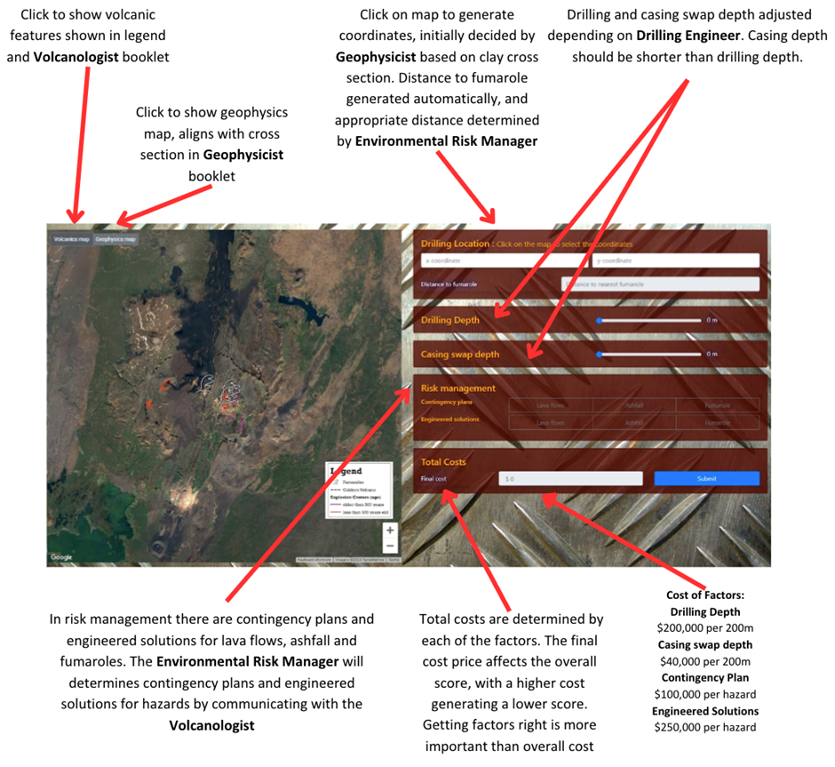

Annotated drilling location map: Mission 2 – Energy from magma

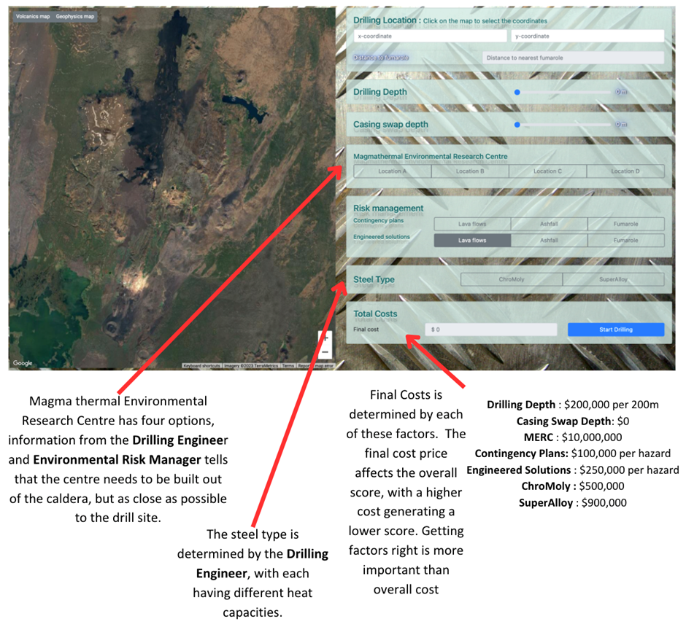
Questions to deepen student understanding

- How does the location of the geothermal energy relate to the magma and why do fumaroles indicate geothermal energy? (The magma underground heats the water, producing fumaroles at the surface. This indicates hot water at a depth that could be used for geothermal energy. In some areas of the world, people use the natural geothermal gradient of the Earth to extract geothermal energy even when there are no fumaroles or magma present.)

- How did collaborating with other scientists benefit the drilling project? (Working together allows all the information to come together and form a better answer for the drilling. No one scientist can work it out on their own. Teamwork helps to make the project work. The goal is to have each person contribute and share their knowledge.)

- How did your score improve between your first and second attempt? What changes were made to your drilling location? Did you drill deeper, change the casing length or change the location of the drill hole? What information in the booklets helped you come to this conclusion?

- Is the investment of money towards the drilling project worth it? How much energy do you think will be produced by this drilling? (Depending on the depth drilled and contingency plans plus the engineering solutions selected, the drilling cost will range in the tens of millions. Encourage students to think about how much money will actually be spent on the project and how much money would be generated by a successful drill site. Geothermal energy is a sustainable, low-carbon energy source. Reducing carbon emissions globally has great benefits to the planet.)

- Are the outcomes from a failed drilling attempt worth the cost and effort of the project? (Failure in a safe way can produce lots of scientific learning that can have benefits in the future that we haven’t imagined yet.)

- Are the hazards that arise from drilling – for example, blowouts that pose risk to people and the environment – worth these hazards? (Drilling and magma can be very dangerous. Drilling calculations and risk management need to be precise to reduce the risk of disaster.)

