**ACTIVITY: Should cats be allowed to roam freely?**

|  |  |
| --- | --- |
| **Activity idea**  In this activity, students discuss statements regarding their personal views as to whether cats should be allowed to roam freely.  By the end of this activity, students should be able to:   * use a graphic organiser to sort statements according to personal values and views * consider how their own relationships with animals influence their perceptions * select and use scientific information and mātauranga Māori to develop and justify their views or explain how the information has shifted their thinking * consider multiple perspectives and respect the views and values of other people. |  |

**For teachers**

***Introduction/background***

Aotearoa New Zealand has a lot of cats! [Forest & Bird](https://www.forestandbird.org.nz/resources/time-talk-about-cats) reports we have:

* 1,134,000 companion cats
* 196,000 stray cats
* millions of feral cats – there’s no data on feral cat abundance but this is a widely accepted estimate.

Should cats be allowed to wander where they choose? Some people believe that it’s a natural behaviour – ethically, cats have the right to roam. Other people argue that invertebrates, birds and other small animals also have the right to be protected from predation by roaming cats.

This activity is designed to initiate discussion about animal ethics using cats as the topic. It encourages students to consider how they perceive their relationships with animals and to discuss differences between their own perceptions and those of others.

Prior to conducting this activity, teachers may find it useful to read the article [Managing classroom discussions](https://www.sciencelearn.org.nz/resources/198-managing-classroom-discussions). It provides helpful tips for creating a positive climate for discussion.

***Teaching suggestions***

The student handout has two images ([cat with a rat](https://www.sciencelearn.org.nz/images/3982-cat-with-a-rat) and [cat with a baby pigeon](https://www.sciencelearn.org.nz/images/3971-domestic-cat)) for observation and discussion. Both images show pet cats in their own properties with what some people consider pest species. Use the images to begin a conversation about cats and their natural behaviours.

Follow this up with [Should cats be allowed to roam freely? – graphic organiser](https://www.sciencelearn.org.nz/drag_and_drops/21-should-cats-be-allowed-to-roam-freely-graphic-organiser) or the paper-based version in the student handout. Students can complete the graphic organiser individually, in small groups or as a whole class activity. There are no right or wrong answers, but students need to be able to justify why they’ve put a statement card in a particular area of the interactive. Encourage students to use the resource links to inform their thinking and responses.

***Extension ideas***

These activities offer a similar premise. The statements contain additional text, which adds context and meaning:

* [Roaming cats – draw the line](https://www.sciencelearn.org.nz/resources/3311-roaming-cats-draw-the-line)
* [Roaming cats – diamond ranking](https://www.sciencelearn.org.nz/resources/3312-roaming-cats-diamond-ranking)

What are some other vexing questions regarding animals? For example, should introduced species like deer or trout continue to be part of our ecosystems? Challenge students to create their own questions and statement cards.

**Acknowledgement**

This activity was developed in collaboration with Professor Georgina Tuari Stewart (Ngāti Kura, Ngāpuhi-nui-tonu, Pare Hauraki), Auckland University of Technology, and Dr Sally Birdsall, University of Auckland, with funding and support from the Ministry for Primary Industries – Manatū Ahu Matua and the Australian and New Zealand Council for the Care of Animals in Research and Teaching (ANZCCART).

**For students**

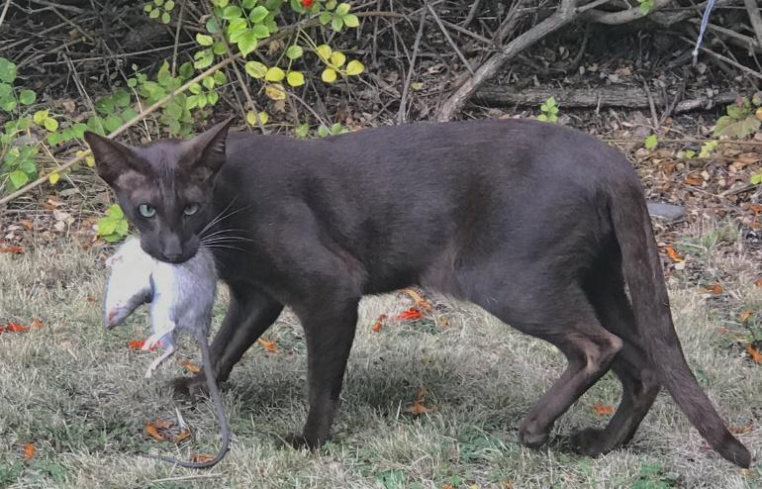 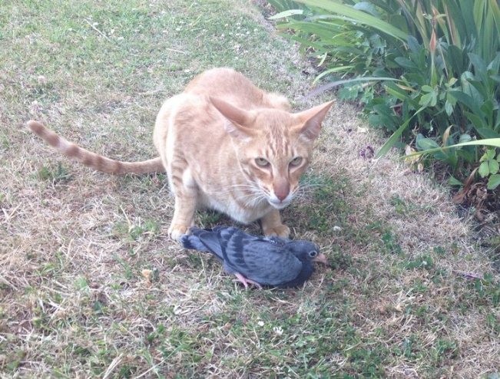

Are these cats friends or foes – heroes or hurtful? Things to consider:

* Both cats are well-fed and well-loved pets.
* Both photos were taken within the owner’s property.
* Both cats are free to roam.

What other factors should be considered?

**Should cats be allowed to roam freely?**

Cut out the statements and place them on the graphic organiser according to your values and views. There are no right or wrong answers.

|  |  |  |
| --- | --- | --- |
| All cats should be kept inside their owner’s home | Cats should be able to roam – it’s a natural behaviour | Unchipped cats should be euthanised |
| Cats should be desexed unless owned by a reputable breeder | Cats should be restricted to their owner’s property | Roaming and feral cats endanger native animals |
| All cats should be registered and chipped | Cats help keep down pest populations | Supervised outdoor cat colonies are good places for feral cats |

**Resource links**

***Cats and impacts***

[Living with nature in an urban world](https://www.sciencelearn.org.nz/resources/2860-living-with-nature-in-an-urban-world)

[Cat fight](https://www.sciencelearn.org.nz/resources/2781-cat-fight)

[Keep your cat inside](https://www.sciencelearn.org.nz/resources/2739-keep-your-cat-inside)

[Time to talk about cats](https://www.forestandbird.org.nz/resources/time-talk-about-cats)

[Feral and stray cats](https://www.bionet.nz/assets/Uploads/A11-Feral-and-Stray-Cats-2018-04-LR.pdf) (National Pest Control Agencies – benefits and negative impacts – page 7)

***Legal perspectives***

[Cats: Care and control of your cat](https://communitylaw.org.nz/community-law-manual/test/dogs-and-other-animals/cats-care-and-control-of-your-cat/)

[Dogs: Care and control of your dog](https://communitylaw.org.nz/community-law-manual/test/dogs-and-other-animals/dogs-care-and-control-of-your-dog/)

***Labels and animal ethics***

[Māori concepts for animal ethics – introduction](https://www.sciencelearn.org.nz/resources/3291-maori-concepts-for-animal-ethics-introduction)

[Māori ethical ideas](https://www.sciencelearn.org.nz/resources/3313-maori-ethical-ideas)

[Do our biases affect what we protect?](https://www.sciencelearn.org.nz/resources/2863-do-our-biases-affect-what-we-protect)

