**ACTIVITY: Roaming cats – diamond ranking**

|  |  |
| --- | --- |
| **Activity idea**  In this activity, students prioritise their viewpoints regarding cats and their freedom to roam. Students begin the activity by making individual rankings and then complete the rankings again as part of a group.  By the end of this activity, students should be able to:   * read a variety of statements about cats and their freedom of movement * rank the statements from highest priority/first choice at the top to the lowest priority/last choice at the bottom * select and use scientific information and mātauranga Māori to develop and justify their views * consider multiple perspectives and respect the views and values of other people * explain if, how or why their thinking has shifted as a result of doing this activity. |  |

**For teachers**

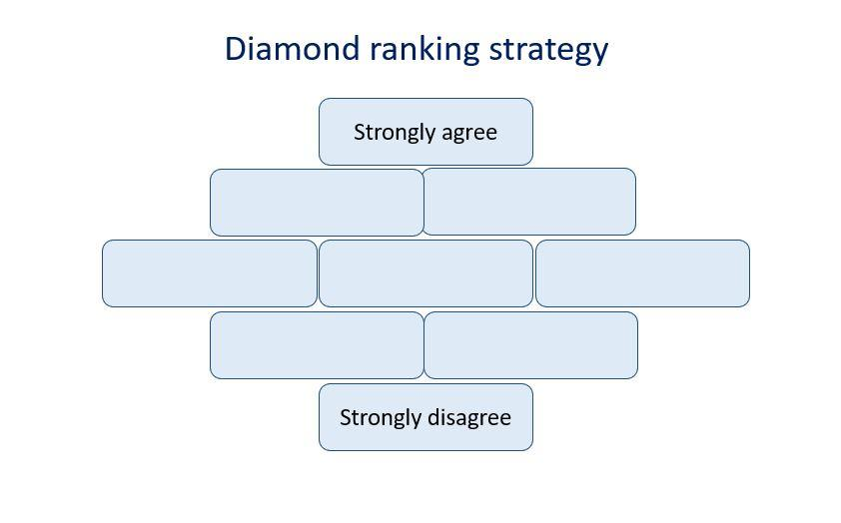

***Introduction/background***

Diamond ranking is a strategy to help learners prioritise viewpoints. Groups or individuals take the statements and order them by putting their first choice at the top (one choice). The next choices are placed underneath – two equal choices. The next three choices go underneath those followed by the next two. The least desirable choice is placed at the bottom. In this way, a diamond shape is formed.

## Teaching suggestions

Consider completing [Roaming cats – draw the line](https://www.sciencelearn.org.nz/resources/3311-roaming-cats-draw-the-line) prior to commencing the diamond ranking strategy. This enables individual students to contemplate and organise their personal views before being asked to work with others.

Instructions for the activity, statement cards, resource links and the diamond ranking template are in the student handout.

***Extension idea***

What are some other vexing questions regarding animals? For example:

* Should introduced species like deer or trout continue to be part of our ecosystem?
* Should animals bred for research and teaching be rehomed after use? All animals or just those who were bred but not used?

Challenge students to create their own questions and nine statement cards and ask their peers to rank them using the diamond ranking strategy template.

**Acknowledgement**

This activity was developed in collaboration with Professor Georgina Tuari Stewart (Ngāti Kura, Ngāpuhi-nui-tonu, Pare Hauraki), Auckland University of Technology, and Dr Sally Birdsall, University of Auckland, with funding and support from the Ministry for Primary Industries – Manatū Ahu Matua and the Australian and New Zealand Council for the Care of Animals in Research and Teaching (ANZCCART).

**For students**

1. Read the statements on the following page and think about:

* how the statements are written and whether there are words that make you feel a certain way
* how your own perceptions and experiences with cats or other animals influence your decisions
* te ao Māori concepts and perspectives like whakapapa, mana and mauri.

1. Cut the statements into the nine individual cards.
2. Prioritise the statements according to how they align with your viewpoints.
3. Use the diamond ranking strategy template to do the following:

* Put the statement you agree with the most or feel is most important at the top.
* Put the next choices underneath – two statements that are still very important and likely carry equal status.
* Put the third set of choices in the middle – three statements that still might resonate with your thinking but not as strongly.
* Put the fourth set of choices in the penultimate row – two statements that are not as important or that you may not agree with.
* Put the statement that you least agree with or support at the bottom.

1. While arranging the statements, mentally justify your decisions for each placement. What does this arrangement show about your perception of animals?
2. Share your decisions with another person or small group.
3. Discuss your choices while considering different points of view.
4. If disagreements arise, use the resource links to help find an answer or to justify why you think the way you do.
5. After the discussion, consider where you’ve placed your statements. Will they stay in the same place or have you modified your thinking?
6. Try and work as a group to create a new diamond ranking using consensus to rank the statements.
7. Look at how other groups have ranked their statement cards:

* What are some similarities or differences?
* How do they explain or justify their reasoning?

## 

**Roaming cats – statement cards**

|  |  |
| --- | --- |
| Cats should be able to roam freely. It’s their natural behaviour and they need to roam to establish and protect their territory around their places. | Cats should be restricted to their owner’s property and not allowed into other people’s places. They have cat fights and dig up plants in people’s gardens. They also use gardens as toilets, and people who do not own cats worry about catching diseases. |
| Cats can be useful as they keep the rodent populations down, meaning that people do not have to put out traps to catch rodents, especially in lifestyle blocks and on farms. These cats could be fed by the owners of these properties. | Roaming cats are a concern for environmental protection and conservation. Some become feral and survive by catching native animals (birds, reptiles and invertebrates). Feral cats are expert ferocious hunters, which is deadly for our native wildlife in parks and reserves. |
| There will always be cats who are not cared for in a home. Organisations should be set up to feed them regularly in a place where they congregate and form a cat colony. People who do this work can check for sick cats and get them treated. | All cats should be desexed unless the owner is running a reputable breeding programme. Enforcing this will mean there are fewer unwanted kittens and cats, reducing the chances of cats being dumped in the countryside or fringes of cities. |
| All cats should be kept inside their owner’s home. If the owner wants to let their cat out, the cat should be on a leash like a dog. | All cats should be kept inside. If people want to own a cat, they need to build a catio and have a litter box for their cat. |
| All cats should be registered and have a chip inserted. Cats that are found outside can then be caught, returned to their owner and their owner fined. Unchipped cats will be euthanised. |  |

**Resource links**

Use these links to find information to support, justify or modify your thinking about cats being able to freely roam.

***Cats and impacts***

[Living with nature in an urban world](https://www.sciencelearn.org.nz/resources/2860-living-with-nature-in-an-urban-world)

[Cat fight](https://www.sciencelearn.org.nz/resources/2781-cat-fight)

[Keep your cat inside](https://www.sciencelearn.org.nz/resources/2739-keep-your-cat-inside)

[Time to talk about cats](https://www.forestandbird.org.nz/resources/time-talk-about-cats)

[Feral and stray cats](https://www.bionet.nz/assets/Uploads/A11-Feral-and-Stray-Cats-2018-04-LR.pdf) (National Pest Control Agencies – benefits and negative impacts – page 7)

***Legal perspectives***

[Cats: Care and control of your cat](https://communitylaw.org.nz/community-law-manual/test/dogs-and-other-animals/cats-care-and-control-of-your-cat/)

[Dogs: Care and control of your dog](https://communitylaw.org.nz/community-law-manual/test/dogs-and-other-animals/dogs-care-and-control-of-your-dog/)

***Labels and animal ethics***

[Māori concepts for animal ethics – introduction](https://www.sciencelearn.org.nz/resources/3291-maori-concepts-for-animal-ethics-introduction)

[Māori ethical ideas](https://www.sciencelearn.org.nz/resources/3313-maori-ethical-ideas)

[Do our biases affect what we protect?](https://www.sciencelearn.org.nz/resources/2863-do-our-biases-affect-what-we-protect)

**Diamond ranking strategy template**