**ACTIVITY: Māori knowledge of animals – crossword puzzles**

|  |  |
| --- | --- |
| **Activity idea**  In this activity, students use information from a range of resources to solve crossword puzzles featuring Māori knowledge of animals.  By the end of this activity, students should be able to:   * use literacy skills to locate information across a range of texts * use content vocabulary in te reo Māori and English. |  |

**For teachers**

***Introduction/background***

This activity supports literacy skills such as reading for meaning, and vocabulary development in both reo Māori and English. It uses information from the following resources:

* [Māori knowledge of animals](https://www.sciencelearn.org.nz/resources/3294-maori-knowledge-of-animals), which includes the interactive [Māori knowledge of animals](https://www.sciencelearn.org.nz/image_maps/131-maori-knowledge-of-animals)
* [Kurī](https://www.sciencelearn.org.nz/resources/3290-kuri)
* [Kiore](https://www.sciencelearn.org.nz/resources/3307-kiore)
* [Ngā manu a Tānemahuta](https://www.sciencelearn.org.nz/resources/3308-nga-manu-a-tanemahuta), which includes the interactive [Ngā manu a Tānemahuta](https://www.sciencelearn.org.nz/resources/3308-nga-manu-a-tanemahuta)
* [Ngā ika a Tangaroa](https://www.sciencelearn.org.nz/resources/3309-nga-ika-a-tangaroa)
* [Ngārara – te aitanga a Punga](https://www.sciencelearn.org.nz/resources/3302-ngarara-te-aitanga-a-punga)
* [Te aitanga pepeke](https://www.sciencelearn.org.nz/resources/3310-te-aitanga-pepeke)

Alternatively, a complete version of the text is available as a [PDF](https://static.sciencelearn.org.nz/documents/files/000/001/261/original/M%C4%81ori_Knowledge_of_Animals_v2.pdf?1709761856).

Use the student handout to complete the activity.

***Puzzle one – answers***

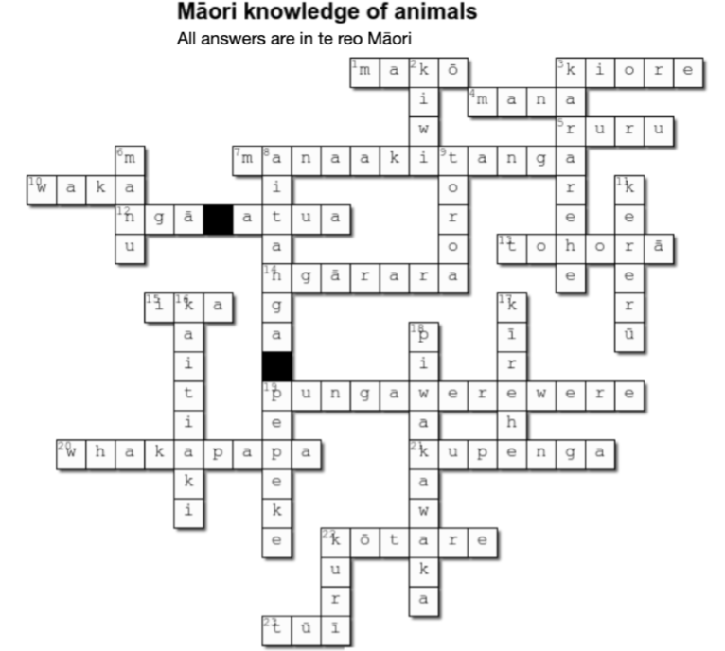

***Puzzle two – answers***

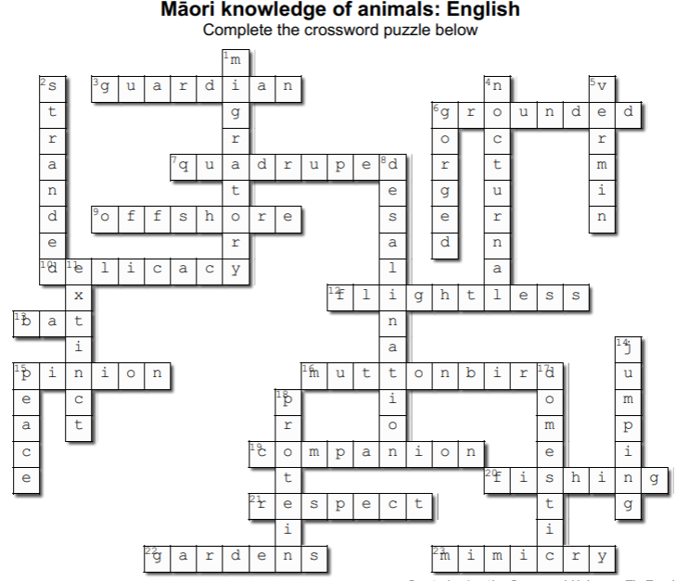

**Acknowledgement**

This activity was developed in collaboration with Professor Georgina Tuari Stewart (Ngāti Kura, Ngāpuhi-nui-tonu, Pare Hauraki), Auckland University of Technology, and Dr Sally Birdsall, University of Auckland, with funding and support from the Ministry for Primary Industries – Manatū Ahu Matua and the Australian and New Zealand Council for the Care of Animals in Research and Teaching (ANZCCART).

**For students**

Use the following resources to locate information needed to complete the crossword puzzles:

* [Māori knowledge of animals](https://www.sciencelearn.org.nz/resources/3294-maori-knowledge-of-animals), which includes the interactive [Māori knowledge of animals](https://www.sciencelearn.org.nz/image_maps/131-maori-knowledge-of-animals)
* [Kurī](https://www.sciencelearn.org.nz/resources/3290-kuri)
* [Kiore](https://www.sciencelearn.org.nz/resources/3307-kiore)
* [Ngā manu a Tānemahuta](https://www.sciencelearn.org.nz/resources/3308-nga-manu-a-tanemahuta), which includes the interactive [Ngā manu a Tānemahuta](https://www.sciencelearn.org.nz/resources/3308-nga-manu-a-tanemahuta)
* [Ngā ika a Tangaroa](https://www.sciencelearn.org.nz/resources/3309-nga-ika-a-tangaroa)
* [Ngārara – te aitanga a Punga](https://www.sciencelearn.org.nz/resources/3302-ngarara-te-aitanga-a-punga)
* [Te aitanga pepeke](https://www.sciencelearn.org.nz/resources/3310-te-aitanga-pepeke)

Alternatively, a complete version of the text is available as a [PDF](https://static.sciencelearn.org.nz/documents/files/000/001/261/original/M%C4%81ori_Knowledge_of_Animals_v2.pdf?1709761856).

***Puzzle one – the clues are in English and the answers are in te reo Māori***

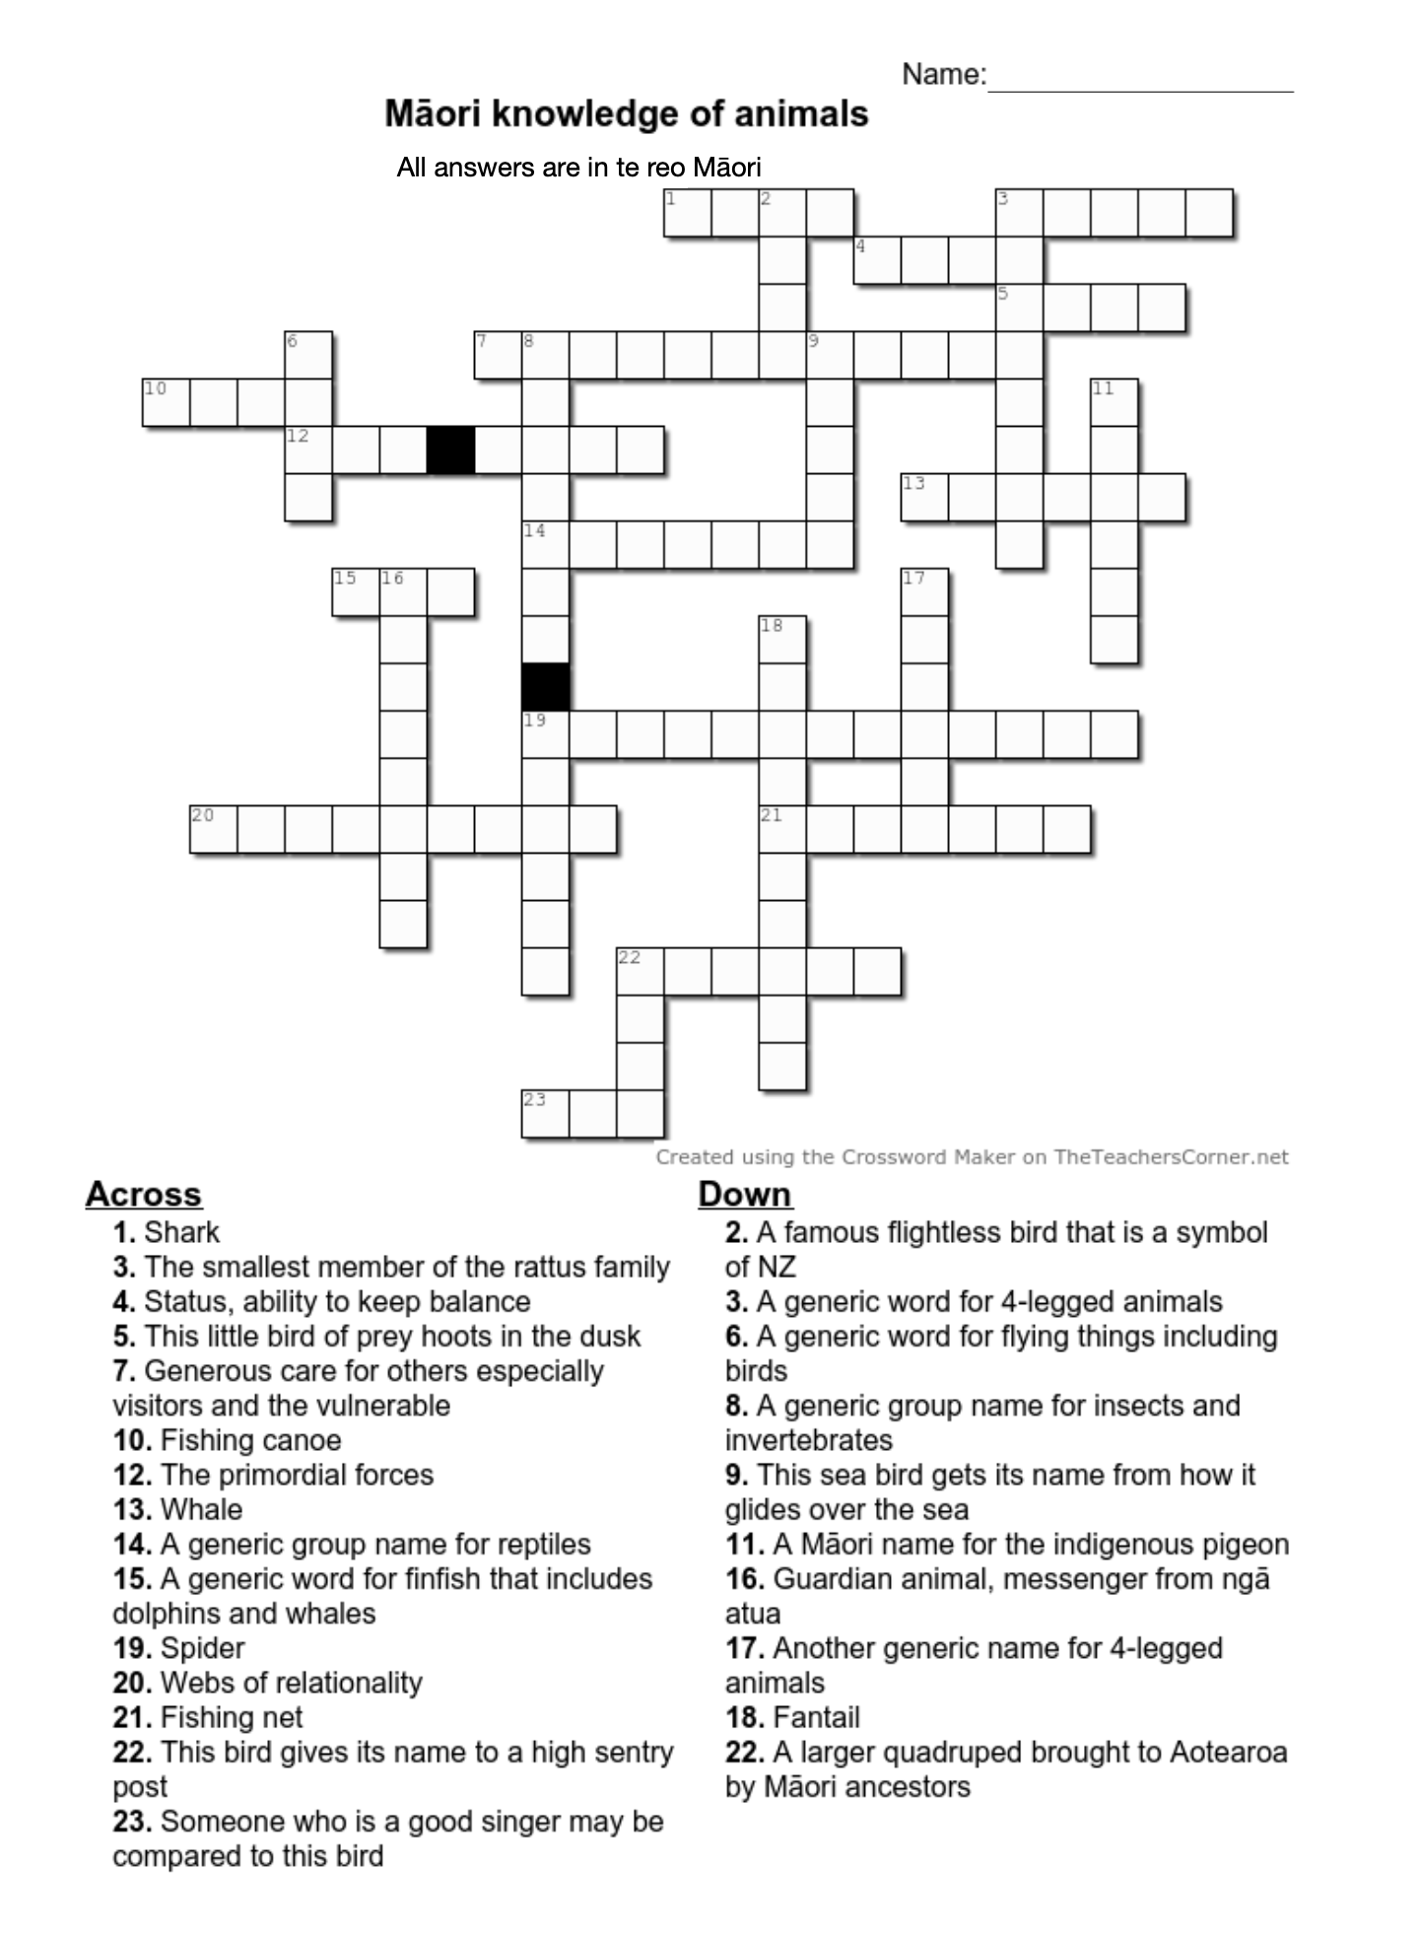

***Puzzle two – the clues and answers are in English***

