**ACTIVITY: The three Rs of animal ethics – crossword puzzles**

|  |  |
| --- | --- |
| **Activity idea**  In this activity, students use information from a range of resources to solve crossword puzzles.  By the end of this activity, students should be able to:   * use literacy skills to locate information across a range of texts * use content vocabulary in te reo Māori and English. |  |

**For teachers**

***Introduction/background***

This activity supports literacy skills such as reading for meaning, and vocabulary development in both te reo Māori and English. It uses information from the following resources:

* [Māori concepts for animal ethics – introduction](https://www.sciencelearn.org.nz/resources/3291-maori-concepts-for-animal-ethics-introduction)
* [Theories of animal ethics](https://www.sciencelearn.org.nz/resources/3317-theories-of-animal-ethics)
* [The three Rs of animal ethics](https://www.sciencelearn.org.nz/resources/3289-the-three-rs-of-animal-ethics)
* [Māori ethical ideas](https://www.sciencelearn.org.nz/resources/3313-maori-ethical-ideas)
* [How do Māori ideas relate to animal ethics?](https://www.sciencelearn.org.nz/resources/3318-how-do-maori-ideas-relate-to-animal-ethics)

Use the student handout to complete the activity.

***Puzzle one – answers***

***Puzzle two – answers***

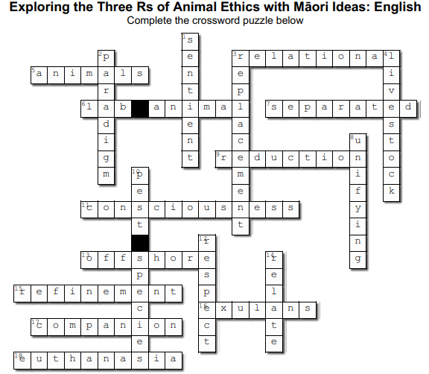

**Acknowledgement**

This activity was developed in collaboration with Professor Georgina Tuari Stewart (Ngāti Kura, Ngāpuhi-nui-tonu, Pare Hauraki), Auckland University of Technology, and Dr Sally Birdsall, University of Auckland, with funding and support from the Ministry for Primary Industries – Manatū Ahu Matua and the Australian and New Zealand Council for the Care of Animals in Research and Teaching (ANZCCART).

**For students**

Use the following resources to locate information needed to complete the crossword puzzles:

* [Māori concepts for animal ethics – introduction](https://www.sciencelearn.org.nz/resources/3291-maori-concepts-for-animal-ethics-introduction)
* [Theories of animal ethics](https://www.sciencelearn.org.nz/resources/3317-theories-of-animal-ethics)
* [The three Rs of animal ethics](https://www.sciencelearn.org.nz/resources/3289-the-three-rs-of-animal-ethics)
* [Māori ethical ideas](https://www.sciencelearn.org.nz/resources/3313-maori-ethical-ideas)
* [How do Māori ideas relate to animal ethics?](https://www.sciencelearn.org.nz/resources/3318-how-do-maori-ideas-relate-to-animal-ethics)

***Puzzle one – the clues are in English and the answers are in te reo Māori***

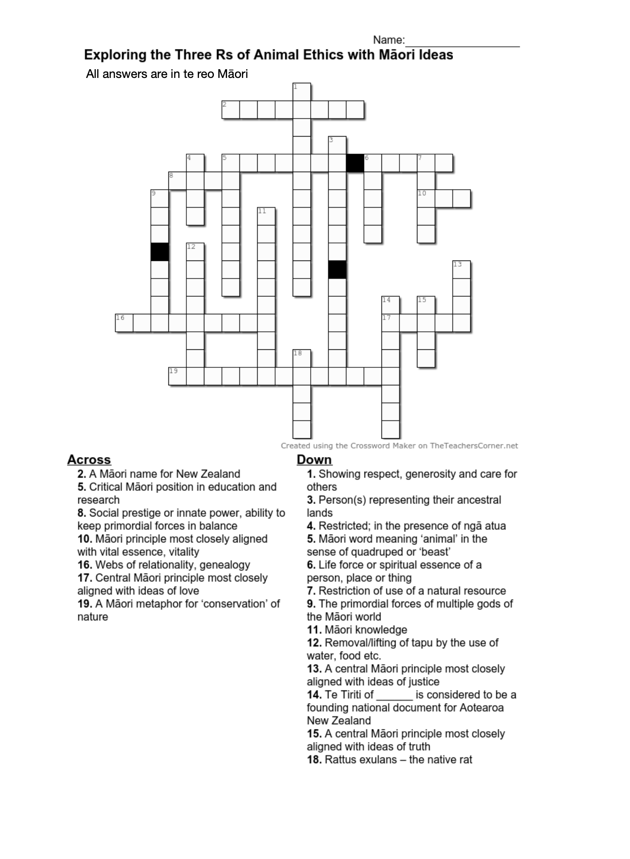

***Puzzle two: the clues and answers are in English***

