**ACTIVITY: Planting kōwhai seeds | Whakatōngia kākano kōwhai**

**Activity idea**

In this activity, students learn about the planting conditions required to successfully grow kōwhai seeds and then plant their seeds.

By the end of this activity, students should be able to:

* use resources to research the conditions needed to grow kōwhai seeds
* identify and take the steps required to plant kōwhai seeds
* justify the decisions they make about how to plant seeds.

**For teachers**

***Introduction/background***

Collecting seeds from outside the classroom and then growing them inside breaks down the perception that learning only happens inside a classroom. It creates an ‘indoor-outdoor flow’ of learning.

Allowing tamariki to make choices about how and where they plant their seeds increases student agency and student engagement.

This activity follows on from the activity [Collecting kōwhai seeds | Kohikohia ngā kākano kōwhai](https://www.sciencelearn.org.nz/resources/3338-collecting-kowhai-seeds-kohikohia-nga-kakano-kowhai).

***About kōwhai seeds***

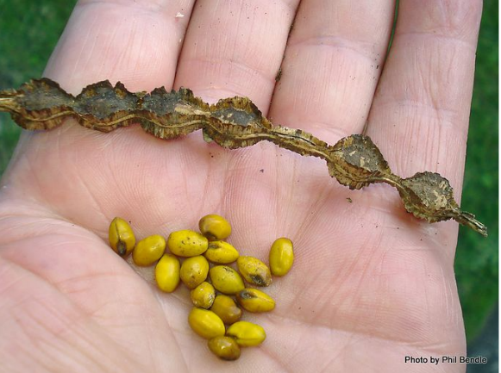Kōwhai seeds have a hard seed coat. Kōwhai trees use water as a means of seed dispersal – one of the reasons why kōwhai trees are commonly found on the banks of streams and rivers. The seeds float away from the parent plant and the hard coat prevents the seeds from absorbing too much water.

Growers recommend rubbing the seeds on sandpaper to break through the seed coat. This allows water to enter the seed and speed up the germination process. Take care not to sand the parts of the seeds with the brown spots – this protects the embryos, which grow into seedlings.

It may help to use needle nose pliers to hold the seed while rubbing it on the sandpaper.

Soaking the seeds in warm water after sanding also speeds up the germination process.

***Kōwhai seeds and safety***

Students can safely handle kōwhai seeds but it’s important to have a safety discussion prior to this activity. Kōwhai seeds are poisonous to humans. The seeds are encased in hard shells – unless they are chewed, they are likely to pass through the digestive system. Humans also need to consume large quantities to be poisoned. However, it’s safest to collect, handle and observe kōwhai seeds using the senses of sight and touch but not taste.

***Potting mix and safety***

Take care when using potting mix. Using damp potting mix helps to stop dust/bacteria from spreading in the air. Wash hands carefully after use.

If the weather is fine, it is preferable to take the potting mix/soil outside for potting. If you stay indoors, work in a well-ventilated space. Put a tarpaulin beneath the bag of soil/potting mix for easier clean-up.

***What you need***

* Kōwhai seeds
* A range of small containers (yoghurt pottles, see-through plastic cups, empty plant containers)
* Potting mix/soil
* Permanent markers
* Sandpaper (optional)
* Needle nose pliers to hold the seeds (optional)

***Teaching suggestions***

The student handout has online resources with information for successful kōwhai seed germination.

Consider which research options best meet your students’ needs:

* Small groups are assigned different resources. Each group takes note of the key steps from their resource. Groups report to the class to share what they’ve learned and, as a class, collate the key steps.
* Individual students choose a resource and create their own steps to plant their seeds.
* You choose the most appropriate resource for your class and work through it together in a shared reading/teacher read format.

Edit the student handout to meet classroom needs.

***What to do***

1. Choose from the following questions to introduce the activity:

* Have you seen kōwhai trees growing in your neighbourhood? On your walk to school?
* Is it possible for a kōwhai seed to grow in the wild without human help? How do you know?
* How did trees on the side of the road or in roundabouts get there?
* When we collected seeds, were the seeds all the same?
* Could all the seeds grow into trees?
* How might the growth of seeds change during different seasons?
* Where does light from the Sun shine in our class in the morning? In the afternoon? Where might the light shine when you’re not here at 5pm?
* Where in our classroom might our kōwhai grow the best? Why?

1. Use the student handout to complete the activity.
2. Once the planting is complete, discuss expectations about:

* touching other students’ kōwhai seeds/seedlings
* when students can/should water their kōwhai seeds
* whether students should water someone else’s seeds.

1. As the seeds grow (or don’t grow) over the coming weeks, have students share what they did or didn’t do to their seeds as a way of reflecting on their choices and finding the ideal growing conditions.

***Extension ideas***

1. Have students record what they did to their kōwhai seeds – using individual logs or a whole class log – to compare/contrast the growth between seeds and to answer questions. For example, are seeds that are soaked overnight more likely to germinate than seeds that are not soaked?
2. Students can create graphs to track the growth of their kōwhai seeds over weeks or months. Consider using NZ Maths’ [The Greenhouse Effect](https://nzmaths.co.nz/resource/greenhouse-effect).
3. Students can make their own video/step-by-step guide about how to grow kōwhai seeds using images from their own work.

***Acknowledgement***

This activity was written by Chloe Stantiall, Silverdale Normal School.

**For students**

Use the following resources to learn how to prepare kōwhai seeds for planting:

* [Grow and care for kōwhai](https://www.doc.govt.nz/nature/native-plants/kowhai/grow-and-care-for-kowhai/) – Department of Conservation
* [Germinating kōwhai seeds](https://www.far.org.nz/schools/germinating-k%C5%8Dwhai-seeds) – Foundation for Arable Research
* [Growing kōwhai part 1](https://www.youtube.com/watch?v=O5kedUWq8JM&ab_channel=redearthnativeplants) – Red Earth Native Plants (YouTube video)
* [Growing kōwhai part 2](https://www.youtube.com/watch?v=9KpM702Yk3I&t=270s&ab_channel=redearthnativeplants) – Red Earth Native Plants (YouTube video)

***Things to think about***

* Should I sand or clip the seeds first?
* Should I soak the seeds in water?
* Which container will be the best – transparent or opaque?
* Should the container have holes in the bottom? How many?
* How deep in the soil should I plant my seed?
* How much water should I add to the soil?
* Where in the classroom should I put my kōwhai to grow?

***Planting your seeds***

* Write your name on your container.
* Add soil to your container.
* Place your seeds on the top of the soil.
* If you want to cover the seeds with soil, decide how much soil to add.
* If you want to water the seeds, decide how much water to use.
* Choose a place in the classroom where you want your kōwhai seeds to grow.

***Think – pair – share***

Talk to another person about the choices you made. Use these sentences:

1. I chose to _____________ before I planted my seeds because _______________.   
     
   (What did you do to your seeds? How does this help them grow?)
2. I chose to plant my seeds about ___ cm below the soil surface because _______________.   
     
   (What conditions do your seeds need to germinate and grow?)
3. I chose to place my container of planted seeds on, near or beneath the _______________ because __________________.   
     
   (What conditions do your seeds need to germinate and grow?)