**ACTIVITY: Observing kōwhai | Āta titiro kōwhai**

**Activity idea**

In this activity, students are introduced to the difference between looking and observing. They will then observe and sketch different parts of a kōwhai tree.

By the end of this activity, students should be able to:

* identify various parts of a kōwhai tree – for example, bark, trunk, seed pods and flowers
* observe the kōwhai tree and make labelled drawings of it.

**For teachers**

***Introduction/background***

Observation is an important skill for students to learn as part of all things ‘science’ as well as life in general. Skills learned and practised in this activity can be transferred across all learning areas such as reading graphs in maths and determining the difference between literal and inferential reading.

In this activity, students learn about observation and are given the opportunity to put their learning in practice. This activity can be taught as part of a wider unit on [kōwhai trees](https://www.sciencelearn.org.nz/resources/3337-exploring-kowhai-matauranga-in-the-classroom).

***What you need***

* Access to the video [Exploring and observing](https://www.sciencelearn.org.nz/videos/2063-exploring-and-observing)
* Accessible to a kōwhai tree
* Paper or individual sketch books
* Pencils
* Hard surface for students to work on (small whiteboards, books, clipboards)
* Magnifying glasses (optional)

***Teaching suggestions***

*Note taking:* This activity uses the video [Exploring and observing](https://www.sciencelearn.org.nz/videos/2063-exploring-and-observing). The video is short – watching it twice is helpful for student comprehension. This is a great video to teach students the skill of note taking or use it for practice if the students already know how to take notes.

*Seeing versus observing:* Students may do a quick sketch and say, “I’m done.” Drawing their attention to ‘what I actually see’ compared to ‘what I think I see’ helps to refocus their attention.

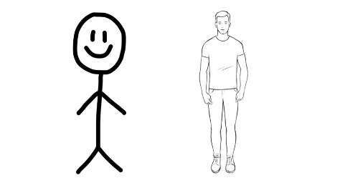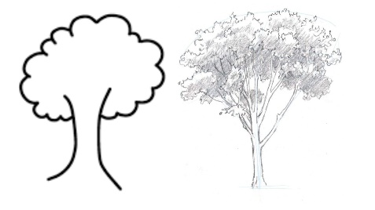

As an example, draw a stick figure of a person on a whiteboard explaining this is how 4-year olds often draw people. As we get older and observe people more closely, we learn that people have substance to their bodies – people are 3D rather than stick figures. Draw a more realistic picture of a person as a comparison.

To reiterate the point, draw a basic ‘cloud’ tree. Discuss how this isn’t actually what trees look like. Then, using a tree all students can see outside, draw more accurately, verbalising your thoughts and actions as you do so. For example, “I can see that that branch is broken so I'm going to include that in my sketch.” or “There’s lots of lichen on this side so I’m going to shade a bit of the trunk here.”

*Managing behaviour:* The more regularly tamariki have the experience of teaching and learning outside, the less behaviour may need to be managed. It may be hard to focus them the first few times, but when it becomes a regular part of their learning, they know the expectations and their behaviour settles in this space too.

***What to do***

1. Explain to tamariki that they are going to be learning about the difference between looking and observing. Discuss students’ prior knowledge of these two words.
2. As a class, watch the video [Exploring and observing](https://www.sciencelearn.org.nz/videos/2063-exploring-and-observing). Discuss any words that students heard that they didn’t understand.
3. Ask students to think-pair-share the question: What is observation? Key words/concepts used in the video: using all our senses, carefully, systematically, examine, drives people into questioning, carefully recording findings, tools extend our senses.
4. Explain to tamariki they will be observing and recording/sketching the different aspects of a kōwhai tree. Set expectations that the focus is on sketching what they can actually see/observe, not what they think they can see.
5. Go outside to identify/discuss the different parts of the kōwhai tree – bark, seeds pods, flowers, leaves, branches – that tamariki will observe and sketch.
6. Once students have had 10–15 minutes to sketch, return to the classroom to discuss the sketches.
7. Use the teaching suggestions above to refocus students to more accurately sketch their observations.
8. Provide copies of the student handout, if desired, or additional paper or sketch books for a second attempt at sketching the kōwhai tree.
9. Support students as they observe and sketch. If they appear stuck or have difficulties observing effectively, encourage them to observe a different type of tree and notice the differences – for example, the bark of a tōtara is very scratchy. Prompt them to notice other features such as broken branches, moss, lichen or dead leaves.
10. Return to class to discuss their observations. Use these questions to prompt discussion:

* What observations surprised you?
* Which senses did you use the most?
* What might you be observing if you are using your sense of smell? Hearing?
* What tools might have allowed you to observe more closely?

***Extension ideas***

As a way of extending students’ scientific writing, they could write short, detailed sentences to describe each part of the kōwhai tree. For example, for the leaves: “Small rounded leaves that are opposite on the stem.” Creating detailed, specific sentences such as these challenges students to be succinct and think carefully about the relevant adjectives. Model examples on pages 30–45 in the Department of Conservation education resource [Experiencing native trees in your green space](https://www.doc.govt.nz/globalassets/documents/getting-involved/students-and-teachers/experiencing-native-trees-in-your-green-space.pdf).

***Acknowledgement***

This activity was written by Chloe Stantiall, Silverdale Normal School.

**For students**

