**ACTIVITY: Using Magma Pop – a virtual magma chamber**

In this activity, students use a virtual game to group elements in a magma chamber to form Earth’s most common minerals.

By the end of this activity, students should be able to:

* discuss the differences between an element and a mineral
* list some of the most common elements and minerals within a magma chamber
* talk about how ions combine to form different minerals as a magma reservoir cools
* observe and discuss how these elements (ions) float in magma and during cooling combine to form minerals and igneous rocks
* observe and discuss the changing compositions of the remaining liquid magma during crystallisation
* discuss how different minerals are formed at different temperatures.

**For teachers**

***Introduction/background***

[Magma Pop](https://pocatella.itch.io/magmapop-webgl-te?secret=dYzHT8izZe7PU0VJOVJI6hpAw4) is an online game with magma, elements, crystals, rocks and erupting volcanoes. The aim is to teach students about common elements and minerals that make up most of the Earth via grouping elements that make key minerals in magma chambers. As students progress through to the Magma Crystallizer, they’re introduced to factors that affect the chemical composition of the magma chamber.

The article [Magma Pop – gamifying volcano geology](https://www.sciencelearn.org.nz/resources/3361-magma-pop-gamifying-volcano-geology) has additional background and pedagogical information.

The game has three levels:

* Magma Academy – learn how to form minerals from elements in the magma. The learning outcome for this level is to become familiar with the most common elements and minerals within the magma chamber.
* Mineral Collector – create and collect minerals from magma. This level introduces various minerals in the magma chamber. The learning outcome is to recognise that charged elements (ions) float about in magma, and during cooling, they combine to form minerals and igneous rocks, which are the building blocks of Earth.
* Magma Crystallizer – as the magma cools, different minerals form, and the magma type changes from basalt to andesite to rhyolite. This level introduces factors related to a magma type – temperature and concentration. Learning outcomes include observing and discussing the changing compositions within the magma melt and the role of temperature on mineral formation and magma type. It also demonstrates how tsunamis can be triggered by (usually rhyolitic) eruptions.

***Suggestions for using Magma Pop in the classroom***

Magma Pop has numerous uses in the classroom:

* Use it as an introductory activity – as a hook for getting students interested in Earth science concepts such as the composition, structure and features of Earth systems, internal processes that shape our surface features and the causes of natural hazards.
* Use it as a hook for getting students interested in the structure of matter and factors that affect chemical processes and how they can use this knowledge to explain aspects of the natural world.
* Use the images [Representations of magma chambers](https://www.sciencelearn.org.nz/images/5497-representations-of-magma-chambers) and [Mineral examples and game icons](https://www.sciencelearn.org.nz/images/5496-mineral-examples-and-game-icons) to build on students’ science capabilities. Discuss their uses as visual representations and how they work as models in science.
* Magma Pop is a fun way to learn and practise the use of scientific symbols and conventions.

Alternatively, use Magma Pop as a context for consolidating student learning after completing these activities:

* [Identifying volcanic rocks](https://www.sciencelearn.org.nz/resources/668-identifying-volcanic-rocks?secret=dYzHT8izZe7PU0VJOVJI6hpAw4) – use information from a video to match the chemical composition and type of volcanic eruption each rock is associated with.
* [Lost – a hot rock](https://www.sciencelearn.org.nz/resources/664-lost-a-hot-rock) – become an igneous rock detective.
* [Making lava fudge](https://www.sciencelearn.org.nz/resources/670-making-lava-fudge) – use different combinations of ingredients to model the different proportions of minerals in basalt, andesite and rhyolite rocks.
* [Tsunamis in the sandpit](https://www.sciencelearn.org.nz/resources/3299-tsunamis-in-the-sandpit) – explore the effects of an expanding magma chamber and how landslides from stratocone volcanoes can generate tsunami waves.

***Differentiated learning***

Magma Pop is an engaging game. Each level comes with a tutorial with clear explanations of game play. It is supported by worksheets for intermediate level students (years 7–10) and for senior students (years 11–13):

* At the intermediate level, students play the Magma Academy and Mineral Collector levels. They can play the Magma Crystallizer level, but the concepts are more complex.
* At the senior level, students play all three components of the game. They focus on the chemical formulae of minerals, the role of temperature on mineral crystallisation, changes to the melt as minerals form and the relationship between types of magma and the volcanic rocks they form.

The worksheets are in Word and can be edited to meet individual classroom needs.

***Game guide***

It is recommended that educators play the game prior to presenting it to students to gain familiarity with the levels. Consider taking screenshots of the game and making notes of content vocabulary that might require further discussion.

The [Magma Pop – game guide](https://www.sciencelearn.org.nz/system/documents/files/000/001/303/original/Magma_Pop_%E2%80%93_game_guide_PDF.pdf?1723070395) includes the written dialogue/speech bubbles of Rua, the volcanologist, who explains the game. It is a step-by-step guide on how to play the game, along with additional background information on mineral crystallisation in cooling magma. The guide has screenshots from the game to aid understanding. The dialogue within each level can only be replayed after completing the level, so students may want to keep the guide handy as they learn to play the game.

***What you need***

* Access to the virtual game [Magma Pop](https://pocatella.itch.io/magmapop-webgl-te?secret=dYzHT8izZe7PU0VJOVJI6hpAw4)
* Using Magma Pop – intermediate level
* Using Magma Pop – senior level
* [Magma Pop – game guide](https://www.sciencelearn.org.nz/system/documents/files/000/001/303/original/Magma_Pop_%E2%80%93_game_guide_PDF.pdf?1723070395) (optional)

***What to do***

1. Choose the approach you will take – as an introductory activity or as part of a larger context for consolidating student learning.
2. Identify content vocabulary that students will need to know to effectively use the game.
3. If desired, demonstrate/play the game with students to identify points of interest or provide opportunities to discuss the science capabilities interpret representations and critique evidence.
4. Alternatively, use the student handout to introduce the game.
5. Provide time for the students to play the game.
6. Provide time for the students to complete the student handout.
7. Discuss how the game operates as a model in science.

* What are the strengths of the model?
* How does it get the messages across?
* How do we know it’s an accurate representation of an actual magma chamber?

***Answers to questions in the student handouts***

**Using Magma Pop – intermediate level**

1. Answers will vary.
2. Oxygen (O) is most common.
3. Silicon (Si) is second most common.
4. Salt (Na), titanium (Ti) and potassium (K).
5. 1 K + 1 Al + 3 Si + 8 O = K Al Si3 O8 (orthoclase).
6. The crystal sinks to the lower part of the magma chamber.
7. The remaining elements continue to float in the magma melt.

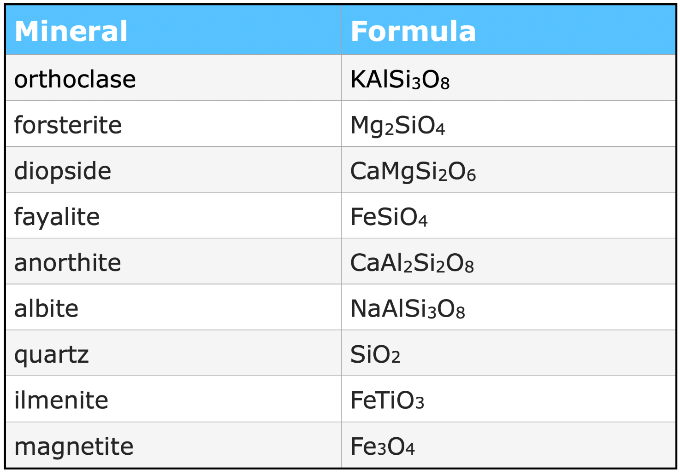

**Using Magma Pop – senior level**

1. Abundant chemical elements in:

* Earth – oxygen, silicon, aluminium, iron, calcium sodium, magnesium.
* magma – oxygen, silicon, aluminium, iron, calcium, sodium, magnesium.
* humans – oxygen, hydrogen, nitrogen, carbon, calcium, phosphorus.
* rocks – oxygen, silicon, aluminium, iron, calcium, sodium, potassium, magnesium.

1. Answers will vary, but oxygen and calcium feature in all four.
2. Oxygen (O) is most common.
3. Silicon (Si) is second most common.
4. Salt (Na), titanium (Ti), potassium (K) are fewest.
5. 1 K + 1 Al + 3 Si + 8 O = K Al Si3 O8 (orthoclase)
6. The magma is cooling.
7. The crystals sink to the lower part of the magma chamber.
8. They are minerals and are heavier than single elements/ions.
9. The remaining elements continue to float in the magma melt.

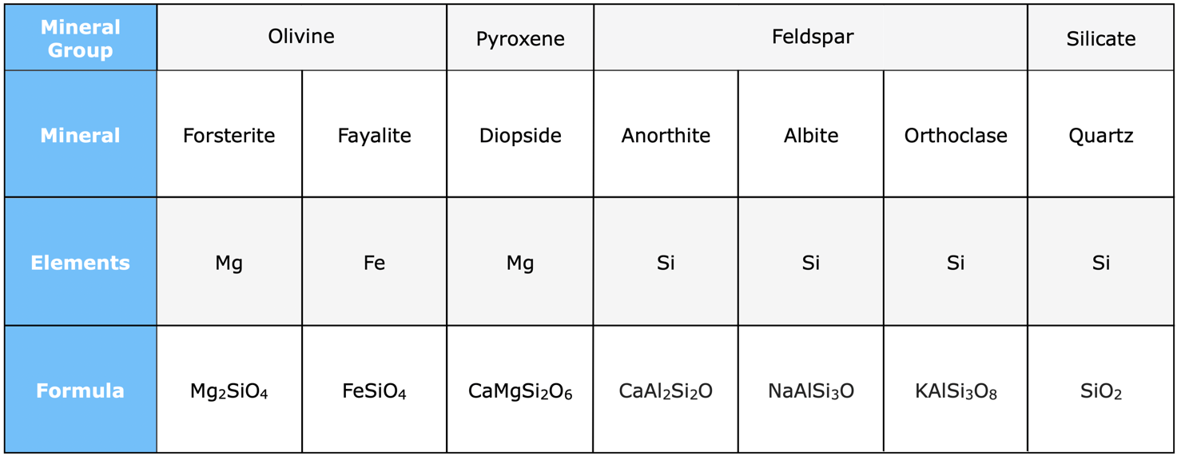

1. Basaltic rocks are primarily composed of the following mineral groups: feldspar, pyroxene and olivine.
2. Mg, Fe and Si are the most common elements that make up the minerals in the mineral groups.
3. Rhyolitic rocks are associated with low temperatures in the magma chamber. The magma is often thick, which means gases cannot escape.
4. Concentrations of silica and magnesium at stages 2 and 6. Answers will vary according to game play, but concentrations should be lower at stage 6 due to mineral formation.
5. Temperatures for mineral crystallisation:
   * anorthite: 1200–1300°C
   * diopside: >1300°C
   * quartz: >900°C
6. Fayalite stops crystallising at level 7: >1000°C
7. Diopside and anorthite are the only minerals that are formed in both in basaltic and rhyolitic magma.
8. Via cooling temperatures within the magma chamber.
9. The magma chamber in a volcano can expand and break its flanks, causing a collapse and creating a landslide. The debris can displace a large volume of water and generate tsunami waves.
10. The volcano tends to erupt during the latter stages when rhyolitic magma is present.
11. There are visual and auditory cues during the game. In real-life, volcanologists can read cues that volcanoes are close to eruption but they are not able to make precise predictions.

**For students: Using Magma Pop – intermediate level**

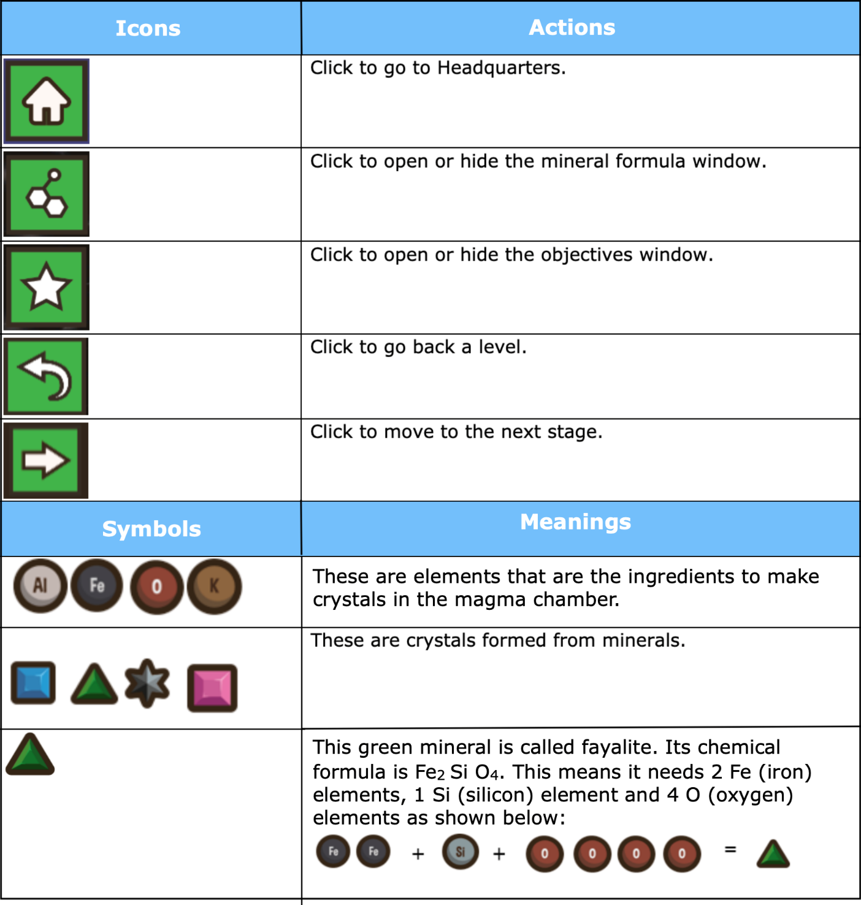

***How to form minerals***

Check the formula window to see what elements are required to form a crystal – in this case, forsterite. The chemical formula is Mg2 Si O4 – 2 magnesium ions, 1 silicon ion and 4 oxygen ions. To make a forsterite crystal, click on 2 Mg ions, 1 Si ion and 4 O ions.

***Getting started***

Use this [link to access Magma Pop](https://pocatella.itch.io/magmapop-webgl-te?secret=dYzHT8izZe7PU0VJOVJI6hpAw4). Start the game and use the Continue button to view the introductory text from Rua, the volcanologist.

**Magma Academy**

The Magma Academy shows you how to form minerals from elements in the game. Use the tutorial to learn more about minerals and magma and how to play the game.

1. Are there any words that you’re not sure about? Write them down here:

***Observing the magma chamber***

Look at the elements in the magma chamber pictured above.

1. What is the most common element in the magma chamber?
2. What is the second most common?
3. Which element(s) are there not many of?

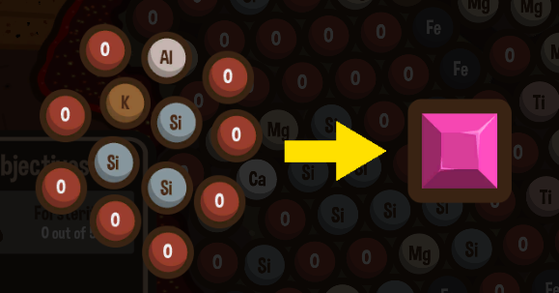

1. An orthoclase crystal is shown above. How many minerals do you need in each element to form orthoclase? Fill in the blanks below:

____K + ____ Al + ____Si + ____ O = K Al Si3 O8 (orthoclase)

1. Crystals are heavier than the elements that surround them. When a crystal forms, what happens to the crystal in the magma chamber?
2. What are the remaining elements doing?

**Mineral Collector**

Great observations! You are ready to move on to Mineral Collector. There are three types of minerals to create in each of the three levels. Good luck!

**Extras for expert volcanologists**

Challenge yourself – how many formulas can you remember without looking at the game?

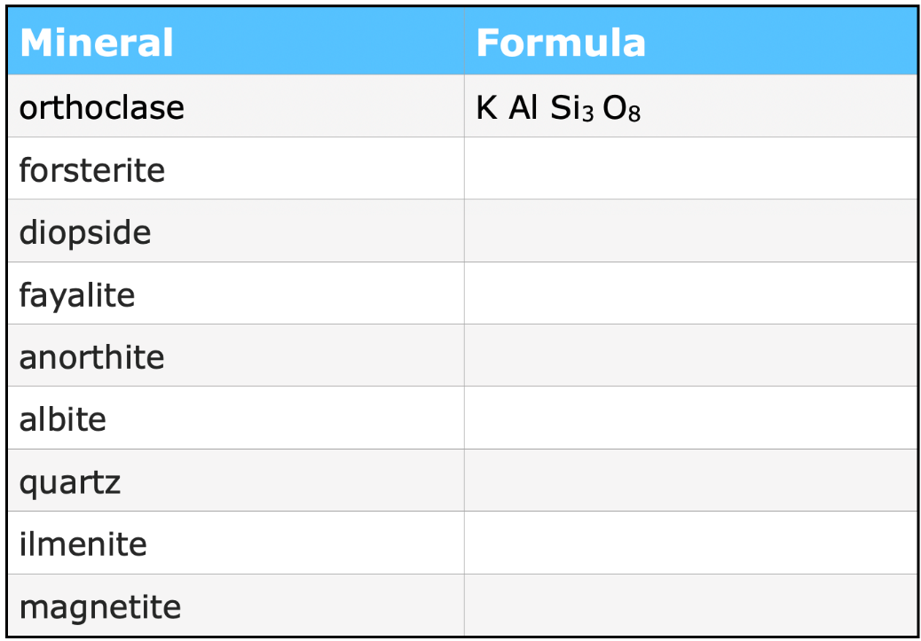

**For students: Using Magma Pop – senior level**

***Background information***

Magma Pop is a game designed to help players learn about the chemistry of magma chambers beneath volcanoes, what the key elements and minerals are and what factors affect how a magma chamber crystallises.

Magma chambers are made of a mixture of crystallised minerals and liquid molten rock. Magma chambers can have a different chemical composition depending on how many minerals have already formed. The three types of magma chambers addressed in this game are basalt, andesite and rhyolite, but magma chambers are not limited to these three. The type of magma chamber is determined by the temperature, pressure and chemical composition of the magma chamber. You will learn more about this when playing Magma Crystallizer.

***About chemical elements***

1. Before you begin playing the game, do an internet search to find out the abundant chemical elements in:

* Earth:
* magma:
* humans:
* rocks:

1. What do you notice about the similarities and differences of elements and the concentration of elements for the four? Write your ideas below.

***Game Information***



***How to form minerals***

Check the formula window to see what elements are required to form a crystal – in this case, forsterite. The chemical formula is Mg2 Si O4: 2 magnesium ions, 1 silicon ion and 4 oxygen ions. To make a forsterite crystal, click on 2 Mg ions, 1 Si ion, and 4 O ions.

***Getting started***

Use this [link to access Magma Pop](https://pocatella.itch.io/magmapop-webgl-te?secret=dYzHT8izZe7PU0VJOVJI6hpAw4). Start the game and use the Continue button to view the introductory text from Rua, the volcanologist.

**Magma Academy**

The Magma Academy shows you how to form minerals from elements in the game. Use the tutorial to learn more about minerals and magma and how to play the game.

***Observing the magma chamber***

Look at the elements in the magma chamber, pictured above.

1. What is the most common element in the magma chamber?
2. What is the second most common?
3. Which element(s) are there not many of?

 

1. An orthoclase crystal is shown above. How many minerals do you need in each element to form orthoclase? Fill in the blanks below:

____K + ____ Al + ____Si + ____ O = K Al Si3 O8 (orthoclase)

Magma Pop is a visual representation of a hot magma chamber. When the magma is hot, the elements in the magma melt are free-floating charged ions.

1. What do you think changes in the magma to cause the charged ions to form stable minerals? (This will become more obvious when you play the Magma Crystallizer level.)
2. What happens to the crystals/minerals when they form in the magma?
3. Why do you think they do this?
4. What are the remaining elements doing?

**Mineral Collector**

The Mineral Collector has three levels. There are different types of minerals to create in each level. Use the game’s formula window to fill in the table below. For the elements row, write in the most common element: Mg, Fe or Si. Learning the formulae helps you score points much faster in the Maga Crystallizer part of the game.

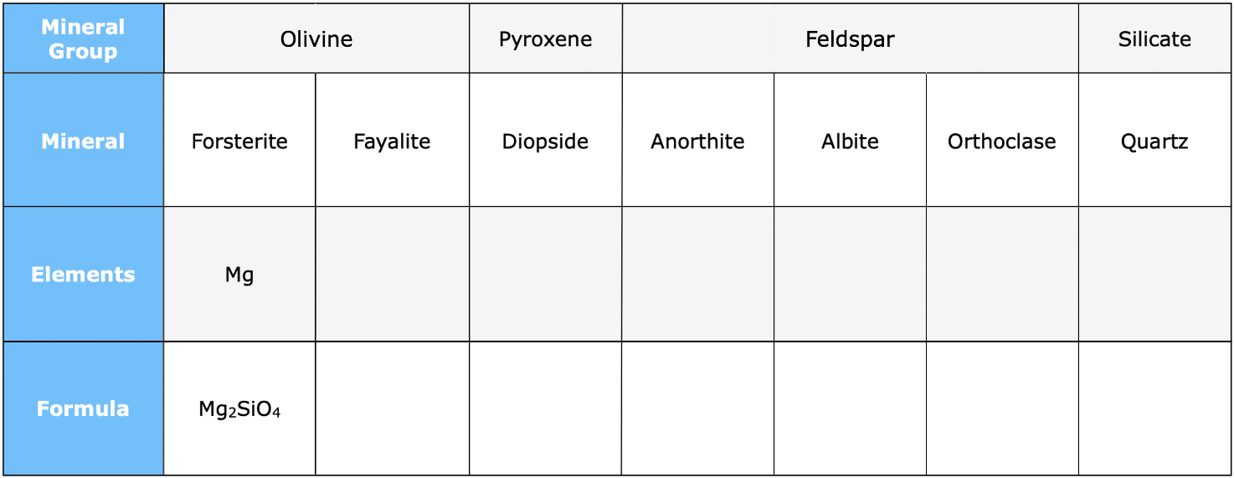

**Magma Crystallizer**

Magma differentiation is where a single magma can crystallise to produce different types of magma. You will notice that, as you play this part of the game, the magma type changes from basalt (stages 1–4) to andesite (stages 5–6) to rhyolite (stages 7–10). This is how different volcanic rocks form.

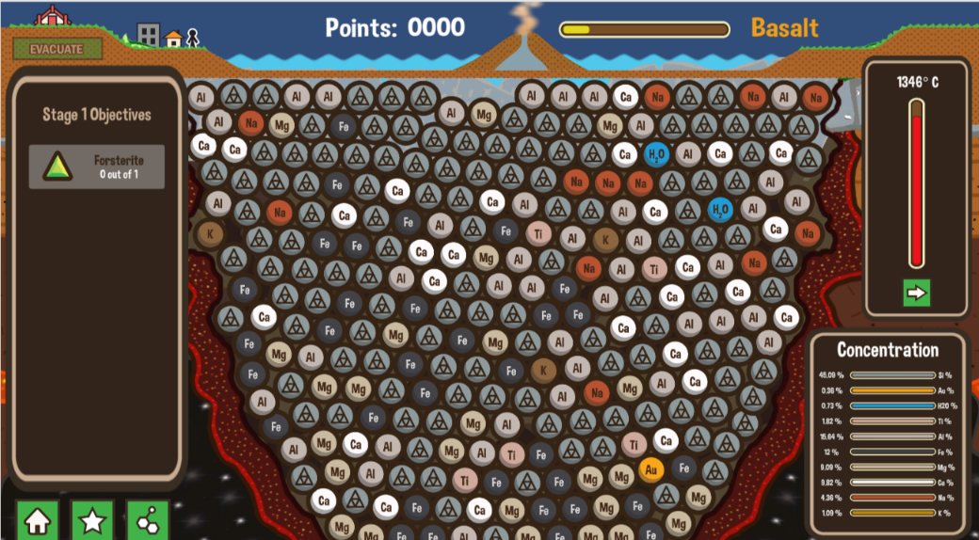

The Magma Crystallizer section of the game has new features – including temperature and mineral concentration. Keep an eye on these as you move through the stages and objectives.

You will also see that the landscape above the magma chamber has changed. In this section of the game, players will need to be aware of volcanic rumblings and hit the evacuate button to alert local residents about a possible tsunami.

Play the game and record your score.

**Extras for expert volcanologists**

Once you’ve played the game and become an expert, see if you can answer the following.

1. Which minerals do you expect to find in basaltic rocks?
2. How does this relate to the common elements in basaltic rocks?
3. Why do you think basaltic rocks are usually heavier than rhyolitic rocks?
4. Take note of the concentrations of silica and magnesium in the liquid magma at:
   * Stage 2:
   * Stage 6:
5. At what temperatures do the following minerals start crystallising?
   * anorthite
   * diopside
   * quartz
6. At what temperature does fayalite stop crystallising?
7. Compare minerals formed in basaltic magma compared to rhyolitic magma. Note the similarities and differences.
8. How do you think a basaltic magma chamber evolves into a rhyolitic magma chamber?
9. What happened when the volcano erupted?
10. Did the volcano erupt at the same point in the game during each attempt?
11. How easy is it to predict within this game? Do you think that this reflects what happens in real life?