**ACTIVITY: Drive it Down! – climate change discussions**

**Activity idea**

In this activity, students use cards to explore the complexity of climate change issues, some solutions and the connections with our places and professions.

By the end of the activity, students should be able to:

* use the discussion cards to match an issue to a corresponding place along with a solution and the professionals who work towards this solution
* use literacy skills to find additional information about issues and solutions
* discuss why they’ve chosen these cards to make a set
* begin to understand that climate change issues are not linear – they impact multiple places and habitats
* begin to understand that climate change issues often require/involve several solutions
* consider a range of careers.

**For teachers**

***Introduction/background***

This activity has been adapted from resources created for the [Drive it Down! Measuring and mitigating school-gate emissions](https://www.gns.cri.nz/research-projects/drive-it-down/) project. It is intended to raise awareness and discussion about the complexity of climate change issues, some solutions and the connections with our places and professions.

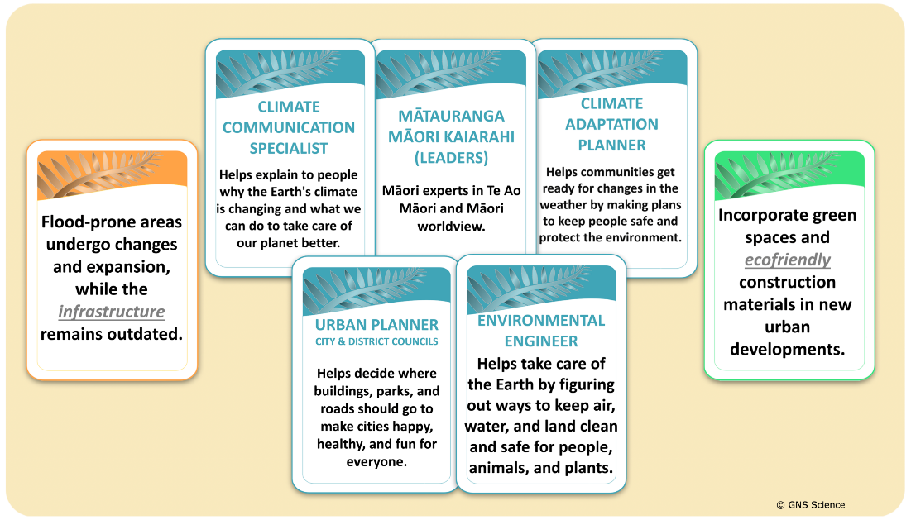

The activity uses cards organised into four categories of:

* issues
* solutions
* places/habitats
* professions.

Students select cards from each category to make sets – matching an issue with a place along with a solution and the people who provide information and help to create change.

There are no right or wrong answers – reflecting the complexities and challenges presented by climate change. This shows there is often more than one solution to an issue or more than one profession that is needed to work on a solution.

It includes blank cards. These are intended for use as open/safe spaces for ākonga to propose their own ideas – fostering their relationship with places/habitats, issues and solutions as well as exposing them to possible careers in this field.

There are also glossary cards to help develop scientific literacy. The complete set of category and glossary cards is available in [Drive it Down – climate change discussion cards – PDF](https://static.sciencelearn.org.nz/documents/files/000/001/321/original/Drive_it_Down_%E2%80%93_climate_change_discussion_cards_.pdf?1739666235).

Access a list of resources that provide background information on several of the issues.

***Helpful hints***

* It might be easier to start a set with an issue card. Look for similar or matching words to begin to group issues with solutions.
* Consider highlighting appropriate glossary terms – scientific as well as those related to the professionals prior to beginning the activity.
* Keep the focus on solutions and potential avenues for local student or community agency.
* The PDF contains a key for teachers with suggested sets across the four categories.

***What you need***

* Sets of discussion cards for small groups
* Access to additional resources

***What to do***

*Prior to the activity*

If you want to print additional cards, use these print settings:

* Size: A4
* Full page slides (if asked)
* Colour (suitable for printing in black and white)
* Print both sides

*During the activity*

1. Split the class into small groups.
2. Ask each group to combine a place/habitat, issue, solution and profession card to make a set.
3. Check that groups have an understanding of the vocabulary and/or concept(s) under discussion.
4. Refer groups to the glossary cards or background information resources as needed.
5. Encourage ākonga to use blank cards to propose their own ideas based on local knowledge or experiences.
6. Bring the groups back together and ask each group to present what they have found.
7. Encourage critical thinking and discussion about why the groups placed sets together.
8. Discuss potential overlaps between the sets to highlight the complexity of the issues – across systems and professions.
9. Guide the discussions toward solutions to encourage an optimistic view of the future.

**Additional resources**

***Rising sea levels caused by melting glaciers***

* [Climate change, melting ice and sea level rise](https://www.sciencelearn.org.nz/images/3617-melting-ice-and-sea-level-rise) – article
* [Glaciers provide global climate puzzle](https://www.sciencelearn.org.nz/resources/1554-glaciers-provide-global-climate-puzzle) – article
* [Rising seas](https://www.sciencelearn.org.nz/resources/2796-rising-seas) – *Connected* journal article
* [Science and partnership with a Sāmoan village](https://www.sciencelearn.org.nz/resources/2915-science-and-partnership-with-a-samoan-village) – student activity using a *Connected* journal article
* [Investigating sea level rise](https://www.sciencelearn.org.nz/resources/2278-investigating-sea-level-rise) – student activity

***Acidification of ocean***

* [Carbon dioxide in the ocean](https://www.sciencelearn.org.nz/resources/682-carbon-dioxide-in-the-ocean) – article
* [Ocean acidification](https://www.sciencelearn.org.nz/videos/30-ocean-acidification) – video
* [Our role in ocean acidification](https://www.sciencelearn.org.nz/videos/734-our-role-in-ocean-acidification) – video
* [Bryozoans and ocean acidification](https://www.sciencelearn.org.nz/resources/135-bryozoans-and-ocean-acidification) – article
* [Ocean acidification and eggshells](https://www.sciencelearn.org.nz/resources/159-ocean-acidification-and-eggshells) – student activity

***Flooding***

* [Waipunarangi – rains, frosts and climate](https://www.sciencelearn.org.nz/resources/3126-waipunarangi-rains-frosts-and-climate) – article
* [Extreme weather](https://www.sciencelearn.org.nz/resources/2188-extreme-weather) – article
* [Annual rainfall is changing](https://www.sciencelearn.org.nz/images/5293-annual-rainfall-is-changing) – resource curation

***Deforestation and soil erosion***

* [Deforestation](https://www.sciencelearn.org.nz/resources/1456-deforestation) – article
* [Trees, seas and soil](https://www.sciencelearn.org.nz/resources/3044-trees-seas-and-soil) – *Connected* journal article

***Droughts and climate change***

* [Evidence of climate change in Aotearoa](https://www.sciencelearn.org.nz/resources/2957-evidence-of-climate-change-in-aotearoa) – article
* [Climate change implications for dairy farming](https://www.sciencelearn.org.nz/resources/3026-climate-change-implications-for-dairy-farming) – article
* [Droughts](https://niwa.co.nz/hazards/droughts) – NIWA
* [Drought in a changing climate](https://www.mpi.govt.nz/dmsdocument/133-drought-in-a-changing-climate) – Ministry for Primary Industries

***Wildfires***

* [Wildfire](https://www.sciencelearn.org.nz/resources/3048-wildfire) – *Connected* journal article
* [Rural fire risk](https://www.sciencelearn.org.nz/image_maps/49-rural-fire-risk) – interactive
* [Fire behaviour in the outdoors](https://www.sciencelearn.org.nz/resources/742-fire-behaviour-in-the-outdoors) – article
* [Low-flammability garden saves home](https://www.sciencelearn.org.nz/resources/2658-low-flammability-garden-saves-home) – article

***Urban city heat pockets unfairly impact on economically poorer communities***

* [Urban heat islands – what they are and why they matter](https://sustaintrust.org.nz/blog/urban-heat-islands) – Sustainability Trust
* [Research reveals who’s been hit hardest by global warming in their lifetime – and the answer may surprise you](https://theconversation.com/research-reveals-whos-been-hit-hardest-by-global-warming-in-their-lifetime-and-the-answer-may-surprise-you-211108) – The Conversation
* [Climate change hits low-income earners harder – and poor housing in hotter cities is a disastrous combinatio](https://theconversation.com/climate-change-hits-low-income-earners-harder-and-poor-housing-in-hotter-cities-is-a-disastrous-combination-180960)n – The Conversation

***El Nino-Southern Oscillation and threats to food availability***

* [Climate oscillations](https://www.sciencelearn.org.nz/videos/1995-climate-oscillations) – video

***Methane***

* [Methane – a greenhouse gas](https://www.sciencelearn.org.nz/resources/3132-methane-a-greenhouse-gas) – article
* [Methane emissions – cow burps, not farts](https://www.sciencelearn.org.nz/videos/2058-methane-emissions-cow-burps-not-farts) – video

***Intensification of hurricanes and cyclones***

* [Extreme weather](https://www.sciencelearn.org.nz/resources/2188-extreme-weather) – article

***Carbon dioxide and warming atmosphere***

* [Carbon dioxide and climate](https://www.sciencelearn.org.nz/resources/2231-carbon-dioxide-and-climate) – article
* [Carbon dioxide in the atmosphere](https://www.sciencelearn.org.nz/resources/684-carbon-dioxide-in-the-atmosphere) – article

***Loss of taonga species***

* [Climate change impacts on biodiversity](https://www.sciencelearn.org.nz/resources/3275-climate-change-and-impacts-on-biodiversity) – article
* [Why climate change matters to Māori](https://www.sciencelearn.org.nz/resources/2960-why-climate-change-matters-to-maori) – article

***Culturally significant places at risk of damage***

* [Why climate change matters to Māori](https://www.sciencelearn.org.nz/resources/2960-why-climate-change-matters-to-maori) – article